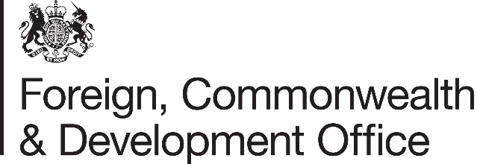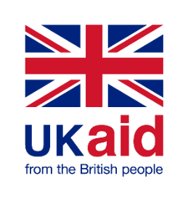

Memorandum of Understanding Amendment Letter

Project Name: Support to the International Committee of the Red Cross (ICRC)
Project Number: 300978-102
PO Number: PUR1064229

- I refer to the Memorandum of Understanding between the Government of the United Kingdom of Great Britain and Northern Ireland acting through the Foreign, Commonwealth & Development Office (FCDO) and The International Committee of the Red Cross (ICRC) signed on 22 August 2022, including subsequent amendments signed on 6 March 2023 & 22 May 2023.

- Following recent correspondence, FCDO proposes to increase the amount made available to ICRC by GBP 4,000,000 (four million pounds sterling).

- I propose that the figures and words £11,200,000 (Eleven Million, Two Hundred Thousand Pounds Sterling) in paragraph 3 of Amendment 02/2023 be deleted and replaced with the figures and words £15,200,000 (fifteen million, two hundred thousand pounds sterling).

- This letter of amendment will place on record our common understanding of the above change(s) and will come into operation on the date you sign your confirmation below. This note will be known as Amendment No. 03/2023.

- Please sign both copies of this letter; return one to me and retain the other for your own records.

Signed on behalf of FCDO:
Position: | Somalia Development Director
Date: | 25 October 2023
Signed on behalf of the Partner:
Position: | Head of Resource Mobilization Division
Date: | 30 October 2023
Signed on behalf of the Partner:
Position: | Senior Country Manager, Resource Mobilization Division
Date: | 30 October 2023

