ADDENDUM TO BUSINESS CASE

INCLUDING FOR BRIDGE FUNDING AND SCALE-UP COST EXTENSIONS

SUMMARY INFORMATION
Project Name | Kenya Portfolio Monitoring, Evaluation and Learning Programme
Country or region targeted | Kenya
Type of cost extension (if applicable) | Cost extension
Original project budget | £4,810,000
Original project start and end dates | January 2025 & January 2028
Cost extension value | £83,000
New total budget | £4,893,000
New project end date (if applicable) | NA
Business Case Quest Document No.

INFORMATION
What is the project’s purpose?
The Portfolio Monitoring and Evaluation (PMEL) programme will provide assurance and evidence on what is working in our programmes and across all our goals and the portfolio. It will help to verify that implementing partners are delivering what they say they are, achieving results and using the most effective and efficient approaches. It will provide a picture of what is happening within and beyond programmes, and across the portfolio as a whole, enabling better understanding and communication of successes, as well as reacting and adapting to challenges or bottlenecks. It will improve assurance on value for money across the portfolio.
What is the objective of the cost extension or other changes?
We are proposing a revised Theory of Change (see below) and a small cost extension to cover the cost of a Programme Funded Post (see Annex A for Value for Money case for the Programme Funded Post).

The purpose of this addendum and cost extension is to:
- Incorporate knowledge management as part of the Theory of Change
- Add a Programme Funded Post as a Knowledge and Information Specialist, to deliver knowledge, information and data management services, at EO grade and as a Country Based Staff (CBS) position.

The PMEL programme is currently under procurement, and the Terms of Reference include three components:
- Programme monitoring support: providing technical and objective support through assurance visits in insecure regions, value for money assessments, data quality assessments, quality assurance of results frameworks / theories of change, option for programme funded audits.
- Independent, evaluative programme evidence: learning across and beyond the life of programmes, including drawing lessons on what works across a portfolio, measuring longer term impacts and sustainability, conducting rigorous evaluations of high risk or strategically important interventions, conducting bespoke, thematic learning on key topics.
- Strategic evidence and learning: evidence-based strategic insight, assessing the country plan goals and informing senior decision-making at the portfolio level, supporting measurement of diplomacy, influence and soft power, generating evidence on cross-cutting thematic areas (such as GESI, climate change, science and technology).
However, a gap has been identified in our resources and skills to effectively manage information and knowledge, which is critical to the success of our outcomes. Information and knowledge management are a corner stone to use of evidence and data, and to ensure we learn, develop and change our approaches. The Programme Funded Post would be responsible for developing data dashboards; managing trackers and updating databases on our programme information, compliance and results; and improving knowledge and document management and accessibility across the BHC. They will support the demand for and uptake / use of products produced by the PMEL supplier. Though this could be included in the remit of the PMEL supplier, we assess that it will be more efficient and effective to have this post in-house: they will have better access to both the knowledge and the users of that knowledge, and will be able to respond to internal demands faster and with more efficiency. Further details are explored in Annex A.

What is the additional and total support the UK will provide?
The UK will supply an additional £83,000. The full economic cost of a CBS EO at the time of writing is £26,307 per year. The addendum request includes room for inflation and pay uplifts over three years.

In addition, this position will require line management resources within the Strategy, Assurance and Results team. Additional roles in the team mean that this will be feasible: it is expected that the PFP will report to the incoming MEL Adviser, enabling coherence across the monitoring, evaluation and learning pieces. The MEL Adviser will also act as PRO for the PMEL Programme, again ensuring consistency, join up and maximum value from both the supplier and the PFP.

What are the expected results?
It is expected that the PFP and related costs will improve our likelihood of achieving the PMEL outcomes, as outlined in the revised Theory of Change, which are:
- Compliance: Better accountability on use of our resources; better control, identification and management of risk.
- Learning: Insights inform programme and policy design and adaptation, strategic direction, country planning, forecasting and budgeting.
Specifically, this role will:
- Improve access to and use of data on our programmes and ODA portfolio, which in turn improves high quality discussions and learning;
- Provide better controls and assurance over our portfolio and wider interventions in Kenya (e.g. CMPs), by compiling compliance data and programme information in a clear and accessible way;
- Increase the demand and use of PMEL services and products, improving the quality of our evidence base and use in decision-making;
- Improve access to key documents, knowledge and information for all BHC staff, improving coherence and alignment with strategic objectives.
What is the approach to implementation?
A job description will be developed based on the revised PMEL Theory of Change and in consultation with potential users of the service (senior leaders, team leaders, programme teams). The job description will be subject to Jobs Evaluation and Grading (JEGS) to ensure the grade is correct. It will then be advertised externally and internally to ensure the best skills match for the role.

This proposed extension is consistent with the assurances provided in the Business Case on Gender Equality and Inclusion, Countering Terrorism, Climate and Environment and Partnership Principles.

Describe any key changes to the original business case including the theory of change or new evidence from ongoing monitoring, evaluation or learning work?
The impact and outcomes statements remain from the original Business Case remain valid:
- Impact: BHC Nairobi’s approach is grounded in evidence, ensuring our resources have a greater impact and accelerating our progress towards the goal outlined in the Country Business Plan.
- Outcomes:
  - Compliance: Better accountability on use of our resources; better control, identification and management of risk.
  - Learning: Insights inform programme and policy design and adaptation, strategic direction, country planning, forecasting and budgeting.
However, the addendum and addition of a Programme Funded Post will create a new component, which will strengthen the pathways to those outcomes and increase the chance that the assumptions will hold. A visual representation of the theory of change is below; the new component is in grey.
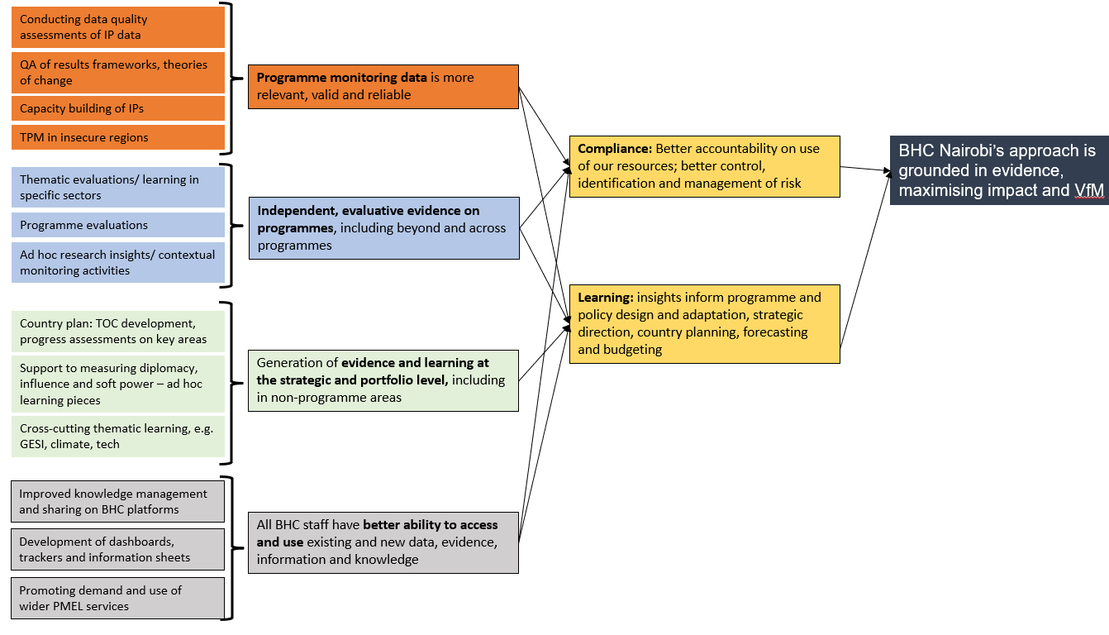
The problem, context and stakeholder analysis outlined in the Business Case remain valid.
Causal chain and assumptions:
We have updated the programme logic, as follows (new clauses in italics):
- If external expertise is provided to a) support/improve/ verify programme monitoring, b) generate new research and evaluative evidence on programmes and c) generate learning across our country plan and non-ODA work, and we have better management of our data, knowledge and information,
- Then we will have better evidence and ability to use that evidence, to ensure we are compliant in our activities, and learning on what is working or is not working. This will allow us to be accountable, to adapt and to improve.
- Then BHC Nairobi will have an approach that is grounded in evidence, maximising impact and value for money.

Assumptions outlined in the Business Case remain valid. The key assumption is that there will be demand for and capacity to use evidence across all teams and senior leadership; seniors, teams and partners have capacity to absorb and act upon findings. The likelihood that this assumption will hold is increased by the addition of this new role: a Knowledge and Information Specialist will ensure data is packaged appropriately for the audience. The post-holder will have dedicated time to engage with teams to help increase demand and use of evidence generated by the PMEL supplier.

Annex A: Value for Money of a Programme Funded Post
This annex presents a Value for Money assessment for recruiting the Knowledge and Information Specialist, as a Programme Funded Post, compared to the alternative of solely using external consultants.

Economy
The principal cost driver of a Programme Funded Post is staff salary and (existing) staff time in management and administration. The principal cost driver for external consultants providing this work are fee rates.

Table 1 outlines the estimated costs of in-house experts vs consultants. We have increased the current estimated annual EO costs by 5% to allow for inflation. Even when considering time of other staff in management and administration, junior experts (Grade EO) in-house are considerably cheaper than external experts in Africa – we estimate the cost of a consultant is almost double an in-house position.

Table 1: Comparison of estimated costs for in-house FCDO staff versus external contractors for technical expert. Based on CBS staff, based in Kenya, EO grade or equivalent; compared to fee rates for country-based Knowledge Management Assistant Experts

 | Estimated cost of in-house FCDO staff | Estimated costs of external roles (fee rates) | Cost difference (%)
Annual rate | £26,307 + 5% = £27,623 | £58,400 | 112%
Total cost over prog life | £27,623 x 3 years = £82,868 | £58,400 x 3 years = £175,200 | 112%

Efficiency
Efficiency measures how well inputs are converted to outputs. The output for this component is: All BHC staff have better ability to access and use existing and new data, evidence, information and knowledge.

We assess that a Programme Funded Post would have the following benefits:
- FCDO would have greater control in terms of recruitment and line management of staff, selecting a candidate with the most appropriate skillset to deliver the programme’s objectives and ensuring staff time is directed towards the most important tasks and driving performance.
- As an internal staff member, they would have better access to and understanding of the FCDO’s systems and organisational resources and structures, improving ways of working and make it easier for them to support programme teams and work collaboratively together.
- As an internal staff member, they would have more opportunity to engage with teams, understanding their information needs and tailoring products accordingly.

These benefits would result in information being produced more quickly and being more relevant and useful. The post-holder would also be in a position to flex or adapt approaches based on constant feedback, engagement and management, with no additional cost to FCDO.

A supplier providing the same service would likely charge for any adaptations or changes, and would have less internal knowledge of the needs, systems and demands in the first place. Further, providing access to the data systems and information required would be difficult and time consuming for FCDO staff, and there may be barriers to access due to security constraints.

Effectiveness
Effectiveness measures how well outputs are converted to outcomes. As outlined above, we are confident that the addition of the Programme Funded Post increases our chances of attaining the outcomes on compliance and learning. The post-holder will complement and enhance the work of the PMEL supplier by generating better understanding of programmes and related data, as well as better access to knowledge and information across the whole platform. This is foundational to both compliance and learning. On compliance, better data communication will help senior leaders hold teams to account on their commitments to the UK taxpayer and under the Business Country Plan and UK-Kenya Strategic Partnership. On learning, it will enable better collaboration within and across teams as they increase their access and use of evidence and knowledge.

This recruitment may also be of benefit to FCDO in the long term, with more potential to embed and maintain institutional knowledge and data skills developed throughout the programme.

The effectiveness of the Programme Funded Post would be tracked over time, and will form part of the programme logframe and monitoring processes. Contribution towards outcomes will be assessed as part of the Annual Reviews.

Equity
Equity measures the extent to which the poorest people and marginalised groups are benefitting from our intervention. The case for PMEL in improving the equity of our strategy and programmes is outlined in the Business Case, and the addition of the Programme Funded Post would be aligned to that. In addition, the role would play an important part in ensuring disaggregated data, beneficiary feedback and gender markers were correctly applied in our programming work, by providing reporting on dashboards and trackers.

Using rates supplied by Corporate Services for a CBS EO member of staff, plus 5% for inflation and pay uplifts.
Using rates from the commercial fee rate database for similar roles across multiple programmes, with all overheads included.

