DFID, 22 Whitehall, London SW1A 2EG | www.gov.uk/dfid | +44 (0)20 7023 0000
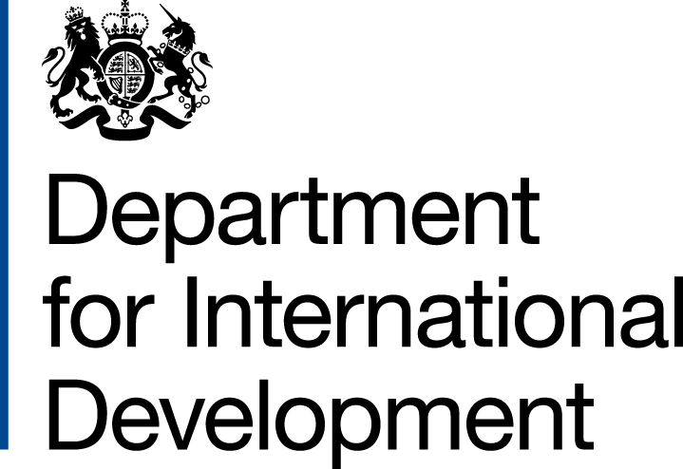 |  |  | 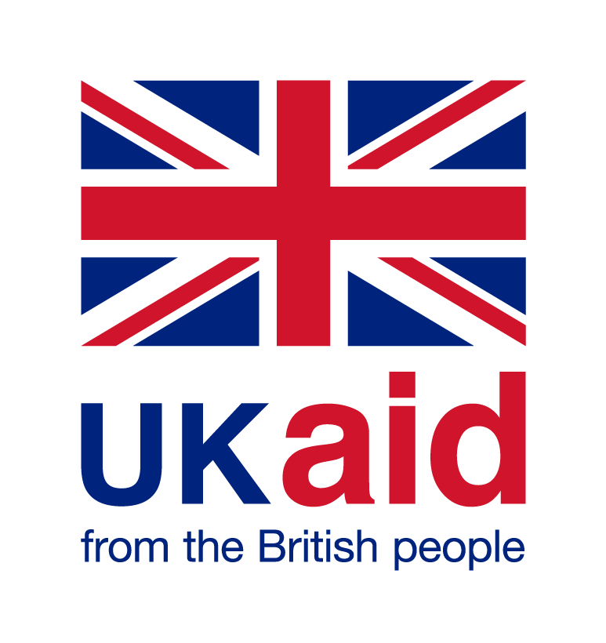
 | Comic Relief  89 Albert Embankment  London  SE1 7TP | T  F  B-latto@dfid.gov.uk  Our ref: 203873
 | 14 March 2019

Project Name: RED NOSE DAY 2013 – IMPROVING THE LIVES OF WOMEN AND GIRLS IN SUB SAHARAN AFRICA

Project Number: 203873 (PO40067273)

- I refer to the Memorandum of Understanding between the Government of the United Kingdom of Great Britain and Northern Ireland acting through the Department for International Development (“DFID”) and Comic Relief signed on 15th March 2013.

- Following recent discussions, DFID proposes to increase the amount made available to Comic Relief by £5,000,000 (five million pounds sterling).

- I propose that the figures and words £16,800,000 (sixteen million, eight hundred thousand pounds sterling" in paragraph 1 (one) of the original MoU be deleted and replaced with the figures and words £21, 875, 000 (twenty-one million, eight hundred and seventy-five thousand pounds sterling).

- In addition, I propose that the end date of 31 March 2020 in paragraph 2 (two) of the original MOU be deleted and replaced with 31 March 2024.

- This letter of amendment will place on record our common understanding of the above change and will come into operation on the date you sign the confirmation below. This note will be known as Amendment No. 2, 2019.

- Please sign both copies of this letter; return one to me and retain the other for your own records.

Signed on behalf of DFID:

Name:
Position: | Head Civil Society Team
Address/Contact Details: | 22 Whitehall  London  SW1A 2EG
Date:
Signed on behalf of the Partner:

Name:
Position: | Executive Director of Impact and Investments
Address/Contact Details: | Comic Relief  89 Albert Embankment  London  SE1 7TP
Date:

