Business Case
Summary Sheet

Portfolio/ Business/Country Plan Summary:

The HMG Caribbean Strategy goal is to work hand-in-hand with the region on our shared interests and support the region to become increasingly resilient, inclusive and better able to manage the COVID-19 pandemic and its repercussions, economic shocks, serious and organised crime, natural disasters, the impact (and existential threat) of climate change, and the particular challenges Small Island Developing States (SIDS) face in responding to these.

The Humanitarian and Migration Department’s goals are to meet the UK’s enduring commitment to prepare and respond to humanitarian crises and famines, deliver the FS Call to Action on famine prevention and position the UK as a Force for Good through:
- saving lives, alleviating suffering and protecting the dignity of affected people in humanitarian crises (including those who are disproportionately impacted such as the poorest, women and girls and people with disabilities);
- projecting our influence and values through the humanitarian system and institutions; and driving improved collective approaches to humanitarian crisis and famine prevention, anticipation and response.

Title: UK Humanitarian Support to Belize following Hurricane Lisa on 3 November 2022
Programme summary:
The UK is providing non-budget support financial aid, of up to £60,000, for humanitarian support to Belize following the passage of Hurricane Lisa covering urgent shelter/home repair needs for displaced and vulnerable persons.
What is the rationale for UK Aid spending?
In November 2022 Hurricane Lisa made landfall in Belize creating significant humanitarian needs. The impact compounded the existing socio-economic effects on the people of Belize from the COVID-19 crisis as well as supply chain disruptions due to Russia’s invasion of Ukraine. The UK responded to a direct request from the Belize government to assist with shelter repairs for 200 displaced vulnerable families. Since humanitarian assistance is a Foreign Secretary priority and the disaster met the UK threshold criteria for a response, an appropriate contribution, considering ODA constraints, was made.
Programme Value:  £60,000 |  | Country/ Region or Sector:  Belize, Caribbean
Department/Country Office confirmation of review processes  Developed in collaboration with Humanitarian Response Group (HRG) |  | Malcom Geere (Caribbean Development Director);  Nicole Davison (Head of Mission Belize)
Contact names |  | Simone Banister (SRO)  Ingrid Lavine (PRO).
Threshold for final approval of Business Case:
Funding allocations were approved at Minister level at the time of the response, and prior to the approval of the Business Case, in line with humanitarian exemptions. The Business Case can be approved at Development Director Level.
Date of Approval of Submission: | 21/11/2022 | Minister Rutley (Minister for Americas and the Caribbean)
Date of Approval of Business Case: | 27/06/2023 | Malcolm Geere (Caribbean Development Director)
Programme Code:  400008 | AMP Start Date:  10 March 2023 | AMP End Date:  31 March 2023
Overall programme risk rating: | Moderate

Strategic Case
Context:
- Belize was hit by Category 1 Hurricane Lisa on 2nd November 2022. The Belize National Emergency Management Office classified this as a Level 2 event (handled nationally but requiring some international assistance) and reported close to 39% of the population affected (approximately 172,000 persons) with 3,500+ households or 12,000 persons directly impacted and requiring immediate humanitarian relief. Stancreek, Cayo, Orange Walk and Corozal were some of the worst affected areas.
- Based on the initial damage assessments, the Government of Belize made a direct request to the UK High Commission in Belmopan on November 8, 2022 (Diplomatic Note) for UK support for 200 families displaced. The estimated cost for urgent shelter/home repairs (zinc, lumber and wall supplies) based on the damage identified was £381,388.64, and a contribution of £60,000 or just over 15% of the total ask was proposed and agreed by Minister Rutley as a proportionate UK response (refer FCDO-submissions-template - Humanitarian Support to Belize.docx). This was also consistent with other donor response levels (see Annex 2).
Vulnerability:
- The Caribbean Region is one of the most prone globally to a range of natural hazards, including hydro meteorological hazards, such as hurricanes and floods. The UK Caribbean support strategy focuses on disaster response and management assistance and this hurricane disaster met the UK intervention threshold criteria for a response (Refer Annex 1).
- Belize is ODA eligible (34.7 % Multidimensional Poverty in Belize based on 2021 Multidimensional Poverty Index (MPI) data and 45% Poverty level based on 2018 Income data).
Needs assessment:
- The Belize National Emergency Management Organization (NEMO) commenced initial rapid assessments of the impacts of Hurricane Lisa after the all-clear on 3 November 2022 with the various NEMO Committees, Government Ministries and Departments as well as partners. The NEMO relief supply subcommittee of Belize for example works with the Red Cross, Rotary, and Belize Council of Churches. Following their initial assessment, they categorized the level of impact or damages resulting from the passage of the hurricane.
- Further assessments were conducted in 12 of the worst affected communities by the Belize Damage and Needs Assessment (DANA) team. The information gathered was then forwarded to a technical team led by The Ministry of Infrastructure Development and Housing (MIDH) to determine the quantity and type of material needed to repair homes or shelters based on the damages identified.
- A national post disaster needs assessment (PDNA) was prepared with the support of international partners such as the EU, the UN and the IADB with the technical facilitation of UNDP. The preliminary findings of the PDNA showed that the social sector accounted for the largest damage (BZD 67m) with housing being the hardest hit. See Figure 1 below for more details of the initial PDNA results.

Figure 1: Damage, Loss and Need by sector from Hurricane Lisa (BZD)
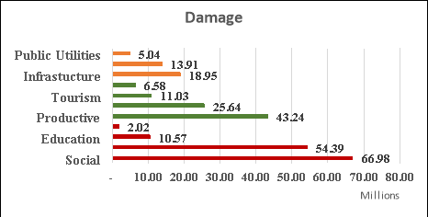

- Theory of change:
By meeting the immediate shelter needs of vulnerable families in the days or weeks following a disaster - keeping households together, increasing personal safety and security of possessions,
reducing displacement, stress & anxiety and improved privacy as well as retained dignity- we anticipate that our actions to improve physical protection and psychological wellbeing would contribute to faster recovery at the household, community, and national level. The expected outcome is improved resilience &/or capacity for self-recovery (vulnerable households/ communities).

Inputs are primarily:- Materials, Human and Financial resources, and Information. The realisation of outputs and outcomes described above is time critical and assumes ‘do no harm’ principles followed, local leadership structures in place, beneficiaries willing to participate, shelter items are used for their intended purpose and of good quality, robust and relevant needs assessment undertaken as well as functional and effective logistics, security, coordination, communication and monitoring/learning.

Figure 1: Theory of change diagram

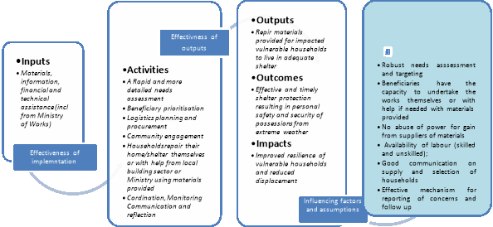

- Compliance Assurance:
This emergency response programme is compliant with legal (Development Act, Gender Equality, Public Sector Equality Duty, Counterterrorism) and best practice requirements as follows:

  - Public Sector Equality Duty, Gender and Disability: The programme is designed with a consideration of gender issues and is compliant with the Gender Equality Act. Priority for shelter/home repair assistance will be given to single parent households, persons with disabilities, and the elderly. Reporting will include disaggregated data by sex and age where possible. Beneficiaries of supplies, number of households, and a list of emergency shelters or other facilities that benefited from supplies will be provided. Implementing partners are expected to uphold standards and principles relating to non-discrimination and no harassment or victimisation, as well as international human rights provisions.
  - Counter Terrorist Financing: The risk of UK aid being diverted to support terrorist groups or activities is low. The due diligence assessment and reporting evidence will provide assurance that funds were used for intended purposes and there is low fiduciary risk.
  - Safeguarding: The crisis context limits FCDO’s ability to engage directly on the ground and therefore does pose some safeguarding risks to potential beneficiaries, which the programme team will manage to ensure observance of the ‘do no harm’ principle. Gender-based violence is likely to increase, as is the case after many natural disasters. People in positions of authority providing lifesaving services, information, and goods pose high risk to the most vulnerable. In line with FCDO’s policy and memorandum of understanding, the government of Belize is required to have appropriate safeguarding policies and procedures in place as well as communication channels to raise concerns related to our programme. FCDO will assess and discuss safeguarding risks/mitigation with Belize government and ask them to monitor their local agents' compliance on these issues.
  - Climate and Environment: There is limited scope and time in this emergency response programme and with the nature of repairs proposed to steer a path that better tackles climate change directly (e.g. transition to low carbon use or growth and more resilient infrastructure). Much of Belize’s northern half and a large portion of the southern third of the country, as well as the coastal areas and islands, are flat and low lying, being highly vulnerable to sea level rise, erosion, storm surges, and flooding. The Belize government is strengthening its National Housing Policy and Building Codes for resilient habitation as part of its climate adaptation efforts.
  - Partnership Principles: The programme is consistent with the four partnership principles being a commitment to reduce poverty, respect human rights, strengthen financial management and public accountability.
  - Risk: The humanitarian INFORM country risk profile for Belize is rated as ‘medium’. The FCDO programme team will identify, mitigate and manage risks in accordance with a risk management framework. Early identification of risk was done in consultation with the HRG advisers and our Due Diligence hub. These risks are within the risk appetite of FCDO Caribbean and an initial risk table outlining key concerns or factors that could hinder effective implementation is shown below. They are all ranked as moderate risk. The due diligence and risk appetite statement will go into more detail.

Key Risks
- Needs assessments robust & needs of vulnerable groups accounted for
- Selection of recipients robust (clear and simple), transparent and fair
- Shelter items purchased of good quality
- Delivery plan that is communicated and understood by all stakeholders
- Items used for intended purpose
- Effective safeguard and concern /whistleblowing reporting system in place
- Adequate financial, technical and/or material assistance

B. Appraisal Case

- The most urgent relief needs following Hurricane Lisa were identified as those related to housing/ shelter restoration/rehabilitation (roofing and construction materials), food, hygiene items, and household items, including bedding.
- The selection of feasible options for UK support was shaped by the direct request from the Government of Belize to the UK and situation reports from the Caribbean Disaster Emergency Management Agency which also captured what others were doing to support the response efforts.
- The Ministry of Foreign affairs formally requested UK support for the 200 families displaced – specifically with mattresses, tarpaulins, zinc sheeting, plywood, nails and generators. The estimated total cost of the shelter items requested for persons displaced and most in need (outlined in the Dip Note 2066 of 8 November 2022) was US$434,863.65 or £381,388.64 and this was only part of the overall ask of USD11m by Belize government for immediate needs.
- Two options for support were assessed since FCDO does not have any existing programmes or arrangements in Belize that could be used:
  - Option 1: Provide a contribution directly to Belize government to reimburse them for shelter/home repair supplies purchased locally.
  - Option 2: Provide shelter/home repair supplies using UK stocks in Panama given closest in proximity to Belize.
- For Option 2, the Humanitarian and Stabilization Operations Team (HSOT) investigated procurement from Panama-based suppliers and produced a supply chain plan which considered transport via road or sea to Belize. Road haulage represented better VFM based on significantly reduced transit time.
- Option 2 was however discounted given the high costs and logistical challenges. For example, while the UK has available stocks for one of the requested relief items (shelter tarpaulins) in the Panama warehouse, the HRG team advised the volume only covered about a quarter of the ask, would need cutting to size and required 6-8 days to transit by road at £11,550 /truck.
- A cash donation was therefore deemed most appropriate and cost effective since shelter relief items requested were confirmed as locally available. This approach also aligns with our Grand Bargain commitments to support the reactivation of local businesses and the economy following disasters.

- Vfm statement:
Option 1 is recommended as it offers the best result and value for money in this situation. Cash allows for maximum flexibility given needs on the ground can change rapidly in emergencies and transporting physical items in from another country is expensive.
- A non-budget support financial aid grant of £60,000 (approximately 15% of the total amount needed) was submitted to Minister for approval. This factored in ODA budget constraint considerations, was based on UK’s relative contribution level for emergency situations as well as information received on proposed support by other donors and organisations like the Red Cross (see Annex 2 for details of relief contributions by others).

C. Commercial Case

- The standard MOU arrangement is in place for use in channelling funding to the Belize government.
- The Ministry of Foreign Affairs will act as the primary focal point for FCDO for the duration of the grant.
- Since the beneficiary is a partner government the proposed funding arrangement would be Non-Budget Support Financial Aid. This normally requires a Fiduciary Risk Assessment (FRA) but given that it was an emergency grant and would involve payment in arrears to the Government of Belize for shelter emergency relief supplies, the programme team approached the Due Diligence (DD) Hub for further guidance. The DD Hub indicated that following a Due Diligence Assessment (DDA) process rather than conducting an FRA would be more appropriate and proportionate given that the programme was a humanitarian response and for a value of up to £60,000.
- The main risks would likely to be around the procurement process as our funding is earmarked to specific materials. The DD Hub advised to focus the DDA around the following:
- Fraud governance.
- Fraud risk assessment process and related training and awareness raising.
- Detection / whistleblowing and investigation process, systems and controls.
- Reviewing procurement fraud risks and documenting what measures are in place.
- Delivery and humanitarian principles – independence, impartiality etc. Government may politicise where resources will go (i.e. not independently needs assessed but for political gain). Try to understand process for needs assessment and beneficiary selection.
- Quality of materials – making sure there are adequate checks that distribution is done safely in the circumstances.

D. Financial Case
- Funds for this programme will be made available from the Caribbean & SIDS Department. The humanitarian allocation is ODA-eligible up to a total of £60,000.
- FCDO’s funding is directed to support the first 6-months of the response only. This funding is programmed in a single disbursal based on reimbursement to government for receipts from approved activities conducted to meet immediate humanitarian needs.

Management Case

- The Caribbean Climate Resilience and Disaster Risk Reduction Adviser will act as Senior Responsible Officer for the programme, with programme management capacity provided from within the Caribbean Development Team and advisory support from the Humanitarian response group (HRG) and the UK High Commission team in Belize.
- We have an eager risk appetite for the programme given that it is humanitarian support, although we judge that the programme is moderate risk only. Funds will be channelled to the Ministry of Foreign Affairs with a clear response mandate in this context and whilst there remain areas of access and security risk, we assess partners to have adequate capacity to mitigate these risks. There remain potential residual risks around fraud, corruption and Prevention of Sexual Exploitation and Abuse (PSEA) issues. Further details are included in the programme risk register, but we consider that the delivery partner has adequate systems, procedures and mitigation measures in place.
- We do not anticipate challenges in use of our funding for this emergency operation, although the country is at risk of further extreme weather events in the future.
- Some visits to the beneficiary sites will be taken by FCDO staff to carry out spot checks given our limited ability to influence relief provided.
- Throughout the life of the programme, risks will be overseen in the first instance by the SRO. When necessary, risks will be escalated up the chain of command to the Development Director. In circumstances regarding suspicions of fraud, terrorism financing, money laundering/corruption, and safeguarding the incident would be reported to the Head of Internal Audit Department who will escalate the issue as appropriate. Reviewing the risk register and appropriate mitigating actions will be part of regular monitoring.
- The Belize government will be required to flag any major changes and risks through ongoing engagement.

Annex 1: UK humanitarian intervention criteria framework:

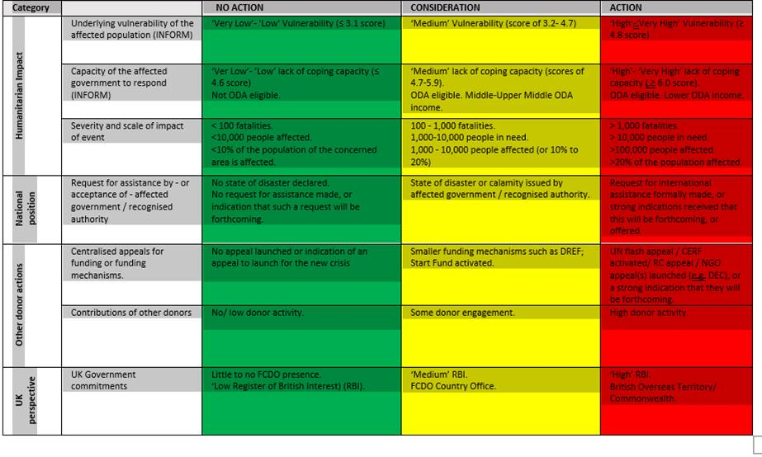

Annex 2: Partner relief contributions to the Hurricane Lisa response
Partner | Pledge | Comment
Bilateral
European Union | $100,000 USD | Through ECHO (European Civil Protection and Humanitarian Aid Operation) to WFP (World Food Programme)
Japan | Disaster Relief Supplies
Mexico | Disaster Relief Supplies | Chetumal Chamber of Commerce
Panama | Hygiene Kits
(ROC) Taiwan | $200,000 USD | To Government of Belize (GOB)
USA | $237,000 USD | Cash Transfer WFP/Relief Supplies
Republic of Korea | $100,000 USD | To WFP
United Kingdom | £60,000.00 | To Ministry of Works (Home and shelter repairs)
Non- State Actors
Cabei | $1,000,000 USD | To GOB
IADB | $200,000 USD | To Red Cross
Norwegian Cruise Line | $200,000 USD | To GOB
UNDP- UNRCO | Technical Support | Training/Conduct (Post Disaster Needs Assessment)
UNICEF | Disaster Relief Supplies
Individual Donors
Build Belize Inc | $100,000 USD | Relief Supplies (Diaspora Initiative)
Consulate of Belize in Chicago | $8,000 USD | Build Belize Inc

Programme initially was approved December 1, 2022, as AMP ID 400000 but due to required change in Accountable Department a new programme had to be created on AMP- ID 400008
UK intervention criteria reflects the humanitarian impact (underlying vulnerability, coping capacity and severity of event); national position and if an official request made, other donor action and the UK govt country commitment. The threshold for considering response action was met since at least four criteria fall in the yellow range in intervention table (refer Annex 1).
INFORM > INFORM Risk > Country Risk Profile (europa.eu)
https://reliefweb.int/report/belize/belize-hurricane-lisa-situation-report-no1-4..

