Annual Review Template

Title: EQUAL (Ensuring Quality Access and Learning for Mothers and New-borns in Conflict-affected Contexts)
Programme Value £ (full life): £7.95m |  | Review date: 05/2022
Programme Code: 301135-101 | AMP start date: 06/2020 | AMP end date: 05/2026

Summary of Programme Performance
Year | 2022
Overall Output Score | A
Risk Rating | Moderate

DevTracker Link to Business Case: | Not yet published
DevTracker Link to results framework: | Not yet published

A. SUMMARY AND OVERVIEW [1-1 ½ pages]

Description of programme

There is a lack of evidence on the delivery of high-quality maternal and newborn health services in low-income, conflict-affected contexts (LI-CACs), where nearly half of all newborn deaths and more than 60% of all maternal deaths occur. EQUAL (Ensuring Quality Access and Learning for mothers and newborns in conflict-affected contexts) is a multi-country consortium conducting research on the most effective approaches to ensure health services are high quality, accessible and responsive to the unique needs and challenges of delivering healthcare in these settings.

EQUAL is led by the International Rescue Committee (IRC), working with the Institute of Human Virology in Nigeria (IHVN), Johns Hopkins Center for Humanitarian Health, the Somali Research and Development Institute (SORDI) in Somalia, and the Université Catholique de Bukavu (UCB) in DRC. Each organisation brings expertise in health research with the knowledge and relationships needed to ensure research is contextually relevant. EQUAL works in countries with the highest burden of maternal and neonatal deaths worldwide. It focuses on approaches to provide quality care during the day of birth and the first week of life, the period when the most maternal and new-born deaths occur. Research focuses on the political economy of maternal and new-born health and strategies to improve the quality of care at health facilities while also supporting methods to improve care in communities when the formal system may be disrupted or inaccessible.

Note on delayed start: EQUAL planned to start in April 2020 but has faced a number of delays: as a result of COVID-19, the FCDO portfolio review over the summer of 2020, the spending review, business planning and budget allocations in the first few months of 2021. The contract was signed and the programme commenced in July 2021, with a soft launch including a press release and tweets by Minister Morton. Further information is available on the EQUAL website.

Summary supporting narrative for the overall score in this review

This review covers a nine-month inception period. EQUAL has scored an A, fulfilling all outputs in the inception year and contractual requirements, despite a 30% reduction in funding. This has included establishing the consortium partnership, strong governance structures and the systems for financial and project management. EQUAL has delivered a strong inception report which meets all FCDO requirements, with a clear research framework and strategies for capacity sharing and research uptake. The report (available online) was reviewed by the SRO and advisers from humanitarian research, country offices and Sexual and Reproductive Health and Rights policy teams. The RPC has only just moved into implementation, early outputs include technical guidance on inclusion of marginalised people in health research in humanitarian settings (published online in February 2022). The programme remains highly relevant, complementary to bilateral programming, and is a strong contribution to Pillar 4 (Research) of FCDO’s Ending Preventable Deaths Approach Paper.

Major lessons and recommendations for the year ahead [1/2 page]

EQUAL has had a strong inception year, in the context of great uncertainty, including budgetary pressures and the need to build a consortium and management systems virtually in the context of Covid-19.

The programme has drawn interest within FCDO and from global and country-based experts in maternal and newborn health. EQUAL has engaged with country advisers in all countries and should build on this to continue to work closely with FCDO missions where there are synergies, drawing on existing political economy (PEA) analysis where these exist, sharing early research findings, and working with FCDO and programme implementers delivering maternal and newborn health (MNH) programmes in those countries.

Recommendations for the year ahead

- EQUAL should formalise changes to programme outputs (logframe) and partners in South Sudan by the end of September 2022. Due to unforeseeable circumstances, EQUAL paused the preidentified partnership in South Sudan. EQUAL are re-visiting possible partnerships and considering a reduced scope of work, proposing to combine workstream two on community surveillance with workstream three on community-based maternal and new-born care (back in line with original proposal submitted at ITT stage). The scope of engagement with partners should be set out in writing, with a proposal for moving towards a South Sudan consortium partner over the RPC duration. The workstream changes have been agreed by the SRO in principle, and as these do not significantly affect the outcome and impact, can be captured in revised workplans and the logframe.

- Further refinement to methods for workstream five on quality of care: The research framework highlights challenges with tools and approaches in measuring QoC at facilities, including how to effectively capture women’s experiences in assessments and respectful maternity care. This is more complex in the absence of supplies, equipment or functioning referral systems. Further discussions with FCDO SRHR and research teams to discuss methods and approaches would be beneficial to this research and wider MNH programming.

- M & E: The Logframe and Theory of Change has been approved in principle by the SRO and should be further reviewed by the FCDO health research team results adviser when in place. We recommend EQUAL review the programme ToC as the RPC moves to implementation, providing a greater level of detail on pathways of change.

B: THEORY OF CHANGE AND PROGRESS TOWARDS OUTCOMES [1-2 pages]

Summarise the programme’s theory of change, including any changes to outcome and impact indicators from the original business case.

Of the countries most at risk of missing the Sustainable Development Goal (SDG) targets for neonatal mortality, 39% are fragile and conflict-affected. These rates, and those for stillbirth and maternal mortality, are likely to rise as some estimates anticipating two-thirds of the world’s poor population will live in fragile states by 2030.

EQUAL’s goal is to reduce maternal and perinatal mortality and morbidities in low-income and conflict-affected contexts (LI-CACs). To contribute to that goal, EQUAL will generate evidence on maternal and newborn health, ensure contextual relevance and evidence translation, and engage in research uptake activities at local, national, regional and global levels. EQUAL will strengthen the capacity of all partners to support research and uptake activities leading to the following outcomes:

- better evidence-based policy and implementation of maternal and new-born service delivery in LI-CACs;
- improved quality and greater operational relevance of research produced by consortium partners;
- increased research literacy of, and demand from, stakeholders.
In designing the programme, EQUAL partners committed to strengthening the evidence-base in low-income, conflicted-affected contexts in Sub-Saharan Africa, an intentional decision to narrow the geographic focus rather than broadly targeting “humanitarian contexts” and the wide variables that would bring.

The Theory of Change proposed in the inception report remains is valid. The consortium’s ambitions will help to advance FCDO call to “generate evidence on how to address the toughest challenges in the hardest places” to leave no one behind, as well as FCDO’s commitment Ending Preventable Deaths Approach Paper.

The ‘Network of Champions’ and the wish to elevate MNH on the political agenda are important and interesting additions to the RPC. Figure 1 presents a snapshot of the Theory of Change, to be read with the more detailed research uptake strategy (Section C).

Describe where the programme is on/off track to contribute to the expected outcomes and impact. What action is planned in the year ahead?

The year under review was the inception period and this review assesses a logframe specifically for the inception period. The planned outcome was ‘Develop a fully functioning Research Programme Consortium (RPC)’. The project has fulfilled all of the objectives of this first year and on track to conduct research to contribute to the expected outcomes and impact. The programme’s inception report, submitted in February 2022, is the culmination of the work for the inception period, and includes all deliverable required for the contract. EQUAL took great care to draft a theory of change and subsequent logframe, which was discussed with their internal and external advisory bodies as well as with the FCDO SRO. Full responses to FDCO feedback and a revised inception report were submitted, and discussions held with research, policy and country based advisers. A logframe for implementation has been designed in line with the theory of change and will be the basis of future monitoring.

Justify whether the programme should continue, based on its own merits and in the context of the wider portfolio

The project has met all necessary outputs during the inception period, as reflected in an excellent inception report and accompanying annexes. The programme adds value to and aligns with FCDO’s approach paper Ending Preventable Deaths. It will provide an important contribution to gaps in evidence in humanitarian settings – with critical research questions on politics and financing’ community-based care; and facility based care - outlined in the figure below. The programme has delivered all outputs against a reduced budget and showing Value for Money across areas of economy, effectiveness, efficiency and equity. Overall, work to date provides a solid foundation for implementation going forward.

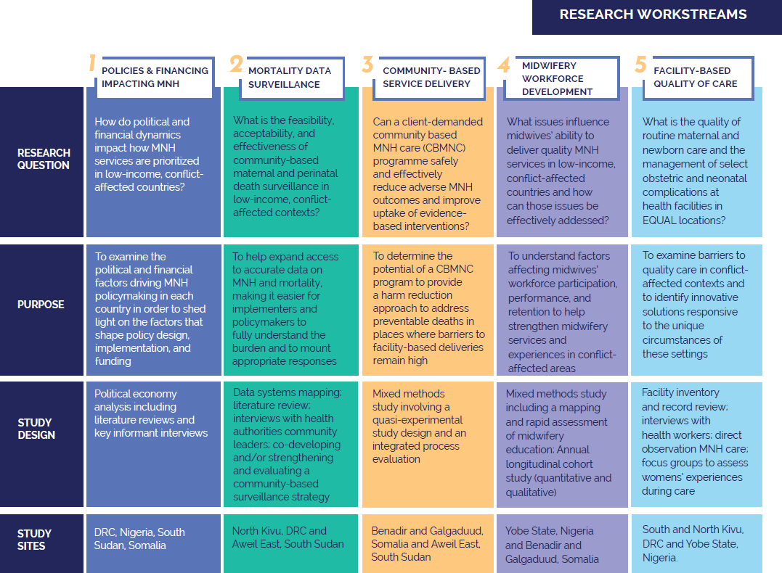

C. DETAILED OUTPUT SCORING

Output Title | Delivery of satisfactory inception report
Output number: |  | 1 | Output Score: | A
Impact weighting (%): |  | 100% | Weighting revised since last AR? | N/A

Indicator(s) | Milestone | Progress
1.1 Detailed research framework, including research approach and hypotheses, and research methodologies to be used | Satisfactory in inception report | Met expectations, clear and suitable approach and methods, agreed by Consortium Advisory Group (CAG) and reviewed by FCDO
1.2 Capacity building framework, including realistic and achievable plans for developing southern-led research | Satisfactory in inception report | Met expectations - strategy submitted in Feb 2022 with detailed workplan
1.3 Communications and research uptake strategy, including plans for dissemination and influencing policy makers and practitioners, and engagement with civil society/ beneficiaries of research | Satisfactory in inception report | Moderately exceeded expectations -  strategy submitted in Feb 2022 with detailed workplan. Participation of CSOs and beneficiaries core to programme
1.4 Outline of approach to Open Access publishing and data sets | Satisfactory in inception report | Met expectations
1.5 Monitoring and evaluation framework, including Theory of Change and logframe | Satisfactory in inception report | Met expectations, developed & revised with SRO
1.6 Approach to mainstreaming gender and equity | Satisfactory in inception report | Met expectations, strong GESI framework submitted Feb 2022
1.7 Management and finance framework | Satisfactory in inception report | Met expectations
1.8 Payment by Results proposal | Satisfactory in inception report | Not required - consistent approach across all RPCs introduced by FCDO
Briefly describe the output’s activities and provide supporting narrative for the score.

Nearly all milestones required from the inception phase of an RPC have been met, and in some cases, exceeded. EQUAL has delivered an excellent inception report, the culmination of work conducted during the inception period including all deliverables promised. The RPC governance structures, and systems for financial and other project management are in place. Stand-alone strategies outlining plans have been provided on: the research framework; communications and research uptake; capacity sharing; Management, Risks; monitoring and evaluation, and Gender Equality and Social Inclusion (GESI). These strategies and frameworks will serve as the foundation for the consortium and its research implementation

Each component of the report was created in collaboration with the EQUAL management team and consortium members. When appropriate, external stakeholders and IRC experts outside of the core EQUAL team were consulted. FCDO met EQUAL twice to discuss the inception report, EQUAL responded to feedback in writing and submitted a slightly revised inception report, taking on board FCDO comments (including questions for clarity on W/S 3 and W/S 5).

Indicator 1.1 Research Framework: Met

  - EQUAL has prepared a clear research framework to identify the best approaches for ensuring high-quality health services are accessible and responsive to the unique needs and challenges of delivering healthcare in conflict-affected settings. This is at health facilities while also supporting methods for delivering care in communities when the formal system may be disrupted or inaccessible. The framework is context specific and includes some outputs (e.g. global synthesis on MNH in humanitarian contexts) with wider relevance. There is a clear contribution to FCDO’s health and humanitarian priorities, notably ending preventable deaths.

There are three broad strands of work:
- Theme 1: EQUAL’s theory of change acknowledges the need to lay the foundation for the research by identifying realistic opportunities for change in maternal and newborn health prioritisation and provision via Political Economy Analyses (PEA) in each context. Methods include literature reviews and key informant interviews in all four countries. Integrating learnings from the PEA, EQUAL will examine key research gaps for both community-based and facility-based MNH services recognising the need for both systems to function effectively and interact with each other to end preventable deaths.

- Theme 2: focuses on community systems recognising the need to invest in community systems to deliver some, life-saving interventions and capture vital statistics, and the mixed evidence base in this area. There are two workstreams:
- Assessment of the feasibility, acceptability and effectiveness of community-based maternal and perinatal mortality surveillance. Methods include formative research, followed by community-based surveillance system strengthening and evaluation in DRC, South Sudan.
- Design and evaluate community based MNC programme. This will be a mixed methods study, with quasi experimental and process evaluations in Somalia and South Sudan.

- Theme 3: focuses on facility-based quality of care including emergence obstetric care and inpatient care. This also include two workstreams:
- Midwifery workforce development, gaining insight into issues influencing midwives ability to deliver quality services. A mixed methods study will include an assessment of the quality of pre-service education and a longitudinal cohort study to identify factors that affect participation and performance (Nigeria, Somalia).
- Assessment of quality of care at facility (DRC, Nigeria).
Indicator 1.2 - Capacity Building Strategy: Met
EQUAL’s approach to capacity sharing and continuous learning framework includes realistic and achievable plans for developing southern-led research and emphasises equitable partnerships, with multi-directional learning. This strategy was developed by a consortium wide working group on capacity strengthening. A proposed ‘just in time approach’ will ensure that new skills can be put into practice.

Indicator 1.3 - Research Uptake Strategy: Met
The communications and research uptake strategy outlined is strong, outlining plan for how EQUAL will maximise the likelihood that research findings achieve impact through the uptake of evidence and learnings generated. There are well-developed with indicators of success, which will show how EQUAL is contributing to changes in programmatic and professional practice and expanding evidence and learning. EQUAL partners have defined country and research workstream specific uptake strategies.

Indicator 1.4 - Open Access: Met
The project has demonstrated compliance with open access publishing and data sets and detailed their approach in the inception report.

Indicator 1.5 - M & E framework: Met
The project has developed a comprehensive monitoring framework, theory of change and a good, draft logframe. M & E will take place at different levels - consortium wide, within each research project and within each cross-cutting pillar of the project. This examines the factors in humanitarian contexts that might prevent or lead to uptake. There is some work to be done on bringing together the overall programme Theory of Change, Research Uptake strategy and logframe. This may be further reviewed based on findings from the political economy analysis.

Indicator 1.6 – GESI: Met
The project has provided a clear strategy and approach to gender, equity and inclusion. In conflict settings, exclusion and barriers to access may be exacerbated for already disadvantaged groups. Identities such as gender, age, disability, ethnicity, and others may be intersecting and layer numerous challenges for accessing quality maternal and newborn healthcare. EQUAL’s strategy for gender and social inclusion attempts to address disparities and provide guidance to the consortium on how to research more inclusive both for researchers and participants. While this strategy is not limited to the following groups, and the programme will take an intersectional lens, the consortium will pay particular attention to women and girls, people with disabilities, displaced people, ethnic minorities and people with chronic conditions, who routinely face issues in receiving adequate maternal and new-born care in conflict-affected contexts. The strategy includes context specific analysis of issues (including institutions and laws) with activities planned to remove attitudinal, communication and physical barriers, promote participation, and make data actionable. There is also focused action within the consortium. EQUAL have reviewed technical guidance on inclusion of marginalised people in health research in humanitarian settings and produced recommendations on this (published online in February 22).

Indicator 1.7 Governance - Met
Good governance and management arrangements have been put in place. The finance framework is comprehensive and well laid out. It covers contractual obligations and has good monitoring and reporting systems in place for partners. Risk and safeguarding strategies are in place. There is more detail in Section E.

Indicator 1.8 A common approach to payment by results for the implementation phase has been introduced for all RPCs, including EQUAL to help incentivise programmes to complete programme activities to a satisfactory standard and to deliver against the workplan in a timely manner. In the event that delivery of key outputs is not satisfactory or timely, FCDO can retain 10% of fees.

Assess the VfM of this output compared to the proposition in the Business Case, based on performance over the past year [1 paragraph]

Achieving VfM starts with choosing the right problems to be addressed and using the best methodology to tackle them. The key cost drivers of implementation research are the people required to carry out the research, including their travel and subsistence. VfM was assessed through the competitive tender exercise and the evaluation of the proposed budgets to ensure costings were proportionate and in line with the rest of the market. EQUAL has created a VfM measurement strategy with IRC’s Best Use of Resources team - based on logframe indicators and proactive budget set-up and spending tracking to have efficient measurement that accounts for the ‘four Es’ (economy, efficiency, effectiveness, and equity). In implementing this strategy, consortium partners will better understand how spending and results are interrelated and build their capacity for developing VfM strategies in other projects. There is a strong focus on equity built into this programme, as outlined above.

D: RISK [½ to 1 page]

Overview of risk management [1/2 page]

As lead partner, the IRC has a comprehensive approach to risk management ranging from due diligence processes to continuous contextual analysis in its Partnership Excellence for Equality and Results System (PEERS). PEERS provides the overall framework for collaborating with partners in all aspects of programming, including risk management. All EQUAL consortium members have extensive experience of operating in conflict-affected settings and planning for risk mitigation in these contexts. The risk register is updated every quarter and changes in contexts are monthly. The Capacity Strengthening plan outlines several other activities to ensure harmonised systems and management of potential risks. This includes training on safeguarding and research ethics and technical support to partners on compliance issues like annual environmental reporting and information security.

The FCDO team have reviewed the EQUAL risk register and we highlight key risks from below. The overall risk remains moderate and all risks are within FCDO risk appetite, by category.

Strategy & Context | Policy & Programme Delivery | Public Service Delivery and Operations | People | Safeguarding | Financial & Fiduciary | Reputation | Overall
Moderate | Moderate | Minor | Moderate | Moderate | Minor | Moderate | Moderate

- Strategy and Context – Moderate. The project works in countries at risk of political social and economic crises, facing direct and indirect impacts of COVID-19, and rising global food prices likely to affect research activities well into 2022/23. This is closely monitored by partners and activities are being adapted to the extent possible. EQUAL are mitigating against these risks through careful planning, drawing from their vast experience of working in these countries. One example of this is the strict security assessments and protocols which are in place for all countries, including provision of itinerary, emergency numbers and pre-arrival security context information. Further mitigation strategies can be found on the Risk Register on AMP. Close watch on escalating crisis in Horn of Africa.

- Programme Delivery – Moderate. As EQUAL is a new consortium, there is a risk that there will be a lack of trust and balance between partners. Risks to programme delivery and partnerships are being closely monitored by EQUAL and feedback mechanisms and partner discussion time has been allocation during partner review meetings. The risk in not identifying a suitable partner in South Sudan is being mitigated through a proposed consultancy/affiliate strategy, to be finalised within three months of this review.

- Public Service Delivery and Operations – Minor. EQUAL have reported stringent requirements of working with FCDO commercial contracts present a moderate/major risk. FCDO expects that this is easing as the programme progresses, partners become more familiar with these processes. The SRO and DPM are available to respond to any questions as they come up and will draw on support from PCD as needed. Unforeseen future cuts to ODA, and weakened trust in FCDO contracts, may also affect the programme and trust between the two parties.

- People – Moderate. Threats to participants and researchers when in country has been covered in Strategy and context. Various mitigation tactics to ensure safety of everyone involved in project work. These include providing back up locations when in country along with basic security management training for all researchers. This is however a real risk which may delay/alter activities.

- Safeguarding – Moderate. EQUAL are working on sensitive topics with vulnerable populations in conflict areas which pose a risk to the programme. International Rescue Committee (IRC) has a robust up to date safeguarding policy and whistleblowing service to mitigate these risks and has shared these with FCDO for review.

- Financial and Fiduciary – Minor. The consortium comprises of new partners but has demonstrated that good governance and financial systems are being put in place to help protect from fraud or misuse of funds. Financial narrative reports and audits are up to date and downstream checks have been done. IRC have tried and tested methods for fiduciary oversight and FCDO programme management will oversee the fiduciary transactions and reporting. EQUAL have flagged that the high complexities of FCDO's commercial terms & conditions which could result in confusion or non-compliance. Regular monthly meetings have been put in place to support EQUAL where necessary.

- Reputational – Moderate. Associated with safeguarding concerns – unknown association with terrorist groups working in focal countries. Mitigation as above, with strong communication, up to date safeguarding policies and monitoring of activities and situation on the ground. If any of the other risks were to materialise then this would have reputational repercussions as well for FCDO.

E: PROGRAMME MANAGEMENT: DELIVERY, COMMERCIAL & FINANCIAL PERFORMANCE [1 - 1 ½ pages]

Summarise the performance of partners and FCDO, notably on commercial and financial issues, and including consideration of VfM measures of economy and efficiency. [max 1 page]

The EQUAL Research Programme Consortium (RPC) contract started on 2nd July 2021 after a delayed procurement competition, and has just completed a nine month inception phase. EQUAL is led by the International Rescue Committee (IRC) as main recipient of FCDO funding, alongside the following Consortium partners. IRC has signed contracts with the following partners which outline expected deliverables, reporting and other requirement in line with FCDO commercial and financial requirements and IRC best practice.
- The Institute of Human Virology, Nigeria (IHVN)
- Johns Hopkins Bloomberg School of Public Health (JHU)
- Centre for Humanitarian Health
- Somalia Disaster Resilience Institute, Somalia (SORDI)
- The Université Catholique de Bukavu, Democratic Republic of Congo.

Note on South Sudan: EQUAL had initially planned to contract with SUDD Institute, in South Sudan. Due to unforeseeable circumstances during the inception phase, EQUAL paused the preidentified partnership in South Sudan and are re-visiting partnerships. This is likely to be an affiliate partnership, working with researchers on a consultancy basis and funding data collection costs through the IRC South Sudan. EQUAL should set out in writing the scope of engagement with proposed partners for FY 2022/23, and a proposal for moving towards an independent research partner in South Sudan over time.

The team has successfully completed its inception phase. Throughout this period, the FCDO Health Research Programme Team has collaborated closely with IRC Chief Executive Officer, Research Director and Research Programme Coordinator to manage contractual terms and conditions, develop workplans and provide links to other FCDO advisors and research programmes. There were regular meetings (monthly, and more frequently where needed) between the consortium and FCDO to discuss progress on partner agreements, country research project development, ethical implications, project risk, finance and forecasting.

EQUAL is governed by the Consortium Leadership Committee (CLC), which meets monthly (included the CEO, Research Uptake Advisor, and two representatives from each consortium partner organisation, including the co-Research Directors). The global Consortium Advisory Group (gCAG – below, which meets regularly) has eleven external members, including the FCDO SRO, this provides technical advice and support to the Research Directors and the consortium as a whole. Additionally national or subnational advisory groups are being established in each of the EQUAL countries. Systems are in place for financial management, processes and tools to ensure proper budget management and spending, and correct clear reporting and forecasting. There are also working groups for capacity sharing to provide strategic direction and leadership within EQUAL to improve the ability of individuals, organisations, and institutions to undertake and disseminate high-quality research effectively.

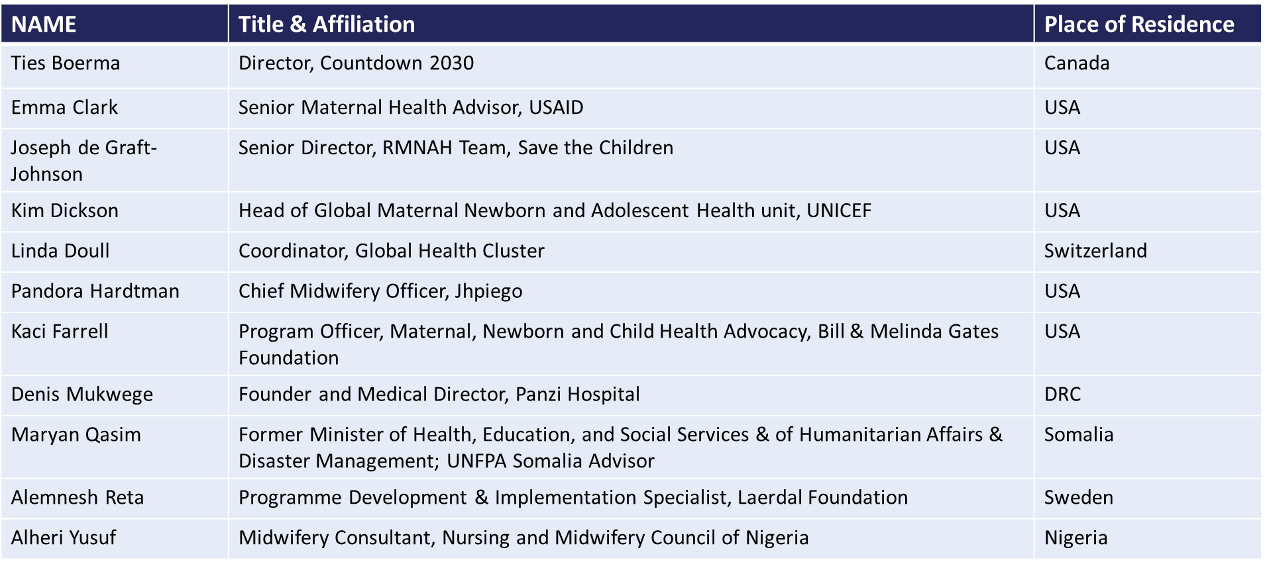

Due to the impact of COVID-19 on the UK economy, the EQUAL programme started late in the year. The budget was lower in year 1 due to this, with spending deferred into later years. A contract amendment is being issued to reflect the successful move from inception to implementation, revised workplan activities, budget changes and revised commercial proformas. The ongoing impact of the pandemic continues to be closely monitored and appropriate mitigations put in place.

A strong, effective governance framework has been developed as part of the inception report, detailing management structures and functionality roles with delivery partners. All partner contracts include established IRC standards and mechanisms for reducing risk of corruption and fraud, and systems are in place for monitoring and assuring accountability to funds used in the programme.

Invoicing is paid quarterly in arrears. Regular, efficient forecasts were received in Q1, Q2 and Q3 from IRC Consortium Coordinator. Financial reports are submitted quarterly in advance of invoice payments, and narrative reports will be provided quarterly going forward now that the programme has moved to implementation. Monthly forecasts are provided as close monitoring of budgets is a high priority, ensuring effective delivery, accountability and transparency of funds.

Date of last narrative financial report | May 2022 | Date of last audited annual statement | May 2022

The scope of engagement with partners in South Sudan are being reviewed
The seismic impact of the Covid-19 pandemic on the UK economy forced the UK government to take tough but necessary decisions. As announced in 2020, the UK moved to a target of spending 0.5% of GNI as Official Development Assistance (ODA) in 2021 and allocated in accordance with UK strategic priorities.

