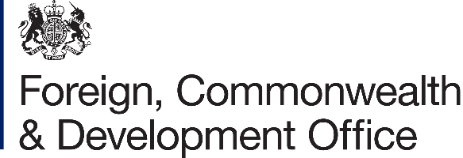 | 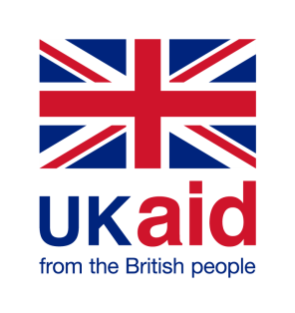

Contribution Arrangement Amendment

Project Name: Building Resilience through Asset Creation and Enhancement Phase II (BRACE II)
WFP Project Activity 4 (Interim Country Strategic Plan)

Project Number: 204888-102

- I refer to the original Contribution Arrangement between the Government of the United Kingdom of Great Britain and Northern Ireland acting through the Department for International Development (“DFID”) and the World Food Programme (WFP) signed on 16 December 2015, including subsequent amendments signed on 6 January 2017, 16 November 2017, 11 April 2018, 19 December 2018, 30 May 2019 and 25 May 2020.

- When the Foreign, Commonwealth & Development Office (“FCDO”) was established on 2 September 2020 the awarding body of the Contribution Arrangement referenced above automatically transferred from DFID to FCDO. The FCDO therefore proposes to delete all references to “Department for International Development” and “DFID” in the original Contribution Arrangement and all subsequent amendments, and replace them with “Foreign, Commonwealth & Development Office” and “FCDO”.

- Following recent discussions, FCDO proposes to increase the amount made available to World Food Programme by £1,108,181 (One million, one hundred and eight thousand, one hundred- and eighty-one-pounds Sterling).

- I propose that the figures and words £19,639,571.42 and Nineteen Million, Six Hundred and Thirty Nine Thousand, Five Hundred Seventy One pounds and Forty Two pence) in paragraph 1[e] of the original Contribution Arrangement be deleted and replaced with the figures and words £20,747,752.42 (Twenty Million, Seven Hundred and Forty Seven Thousand, Seven Hundred fifty Two and Forty Two pence).

- I propose that the payment schedule in paragraph 1(g) in the original Contribution Arrangement be replace by the following;

 | Payment due date | Payment amount (£)
1. | January 2016 | £1,674,695.00
2. | April 2016 | £3,110,147.00
3. | June 2017 | £582,520.00
4. | November 2017 | £1,340,289.00
5. | April 2018 | £1,301,759.00
6. | October 2018 | £1,301,759.00
7. | April 2019 | £2,946,401.05
8. | October 2019 | £2,622,297.14
9. | April 2020 | £3,712,465.11
10. | June 2020 | £1,047,239.12
11 | April 2021 | £1,108,181.00

- Following recent correspondence, FCDO proposes to change the end date of the Contribution Arrangement.

- I propose that the end date of 31 March 2021 in paragraph 2 of Contribution Arrangement 1/2020 be deleted and replaced with 30 June 2021.

- This letter of amendment will place on record our common understanding of the above change(s) and will come into operation on the date you sign your confirmation below. This note will be known as Amendment No.1/2021.

- Please sign both copies of this letter; return one to me and retain the other for your own records.

Signed on behalf of FCDO:

Name: | Helen Lewis
Position: | Country Director
Address/Contact Details: | British Embassy Juba  European Union Compound  Juba, South Sudan
Date:
Signed on behalf of the Partner:

Name:
Position:
Address/Contact Details:
Date:

