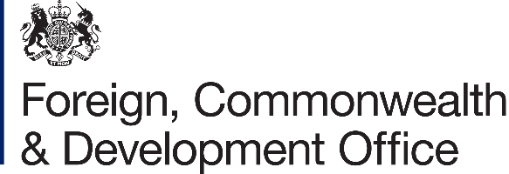 | 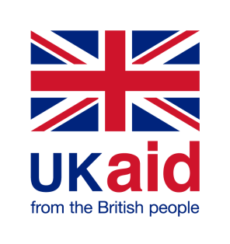

Contribution Arrangement Amendment

Project Name: Building Resilience through Asset Creation and Enhancement Phase II (BRACE II)
WFP Project Activity 4 (Interim Country Strategic Plan)

Project Number: 204888-102

- I refer to the Contribution Arrangement between the Government of the United Kingdom of Great Britain and Northern Ireland acting through the Foreign, Commonwealth & Development Office (“FCDO”) and the World Food Programme (WFP) signed on 16 December 2015, including subsequent amendments signed on 6 January 2017, 16 November 2017, 11 April 2018, 19 December 2018, 30 May 2019, 25 May 2020, 25 March 2021 and 29 June 2021.

- Following recent discussions, FCDO proposes to increase the amount made available to World Food Programme by £1,662,908.33 (One Million Six Hundred and Sixty-Two, Nine Hundred- and Eight-Pounds Sterling Thirty-three pence).

- I propose that the figures and £21,729,071.42 (Twenty-One Million, Seven Hundred and Twenty-Nine Thousand, Seventy-One and Forty-Two pence) in paragraph 1[e] of the original Contribution Arrangement be deleted and replaced with the figures and words £23,391,979.75 (Twenty-three Million, Three Hundred Ninety-One thousand and Nine Hundred and Seventy-Nine Pounds Seventy-Five pence).

- I propose that the payment schedule in paragraph 1(g) in the original Contribution Arrangement be replace by the following;

 | Payment due date | Payment amount (£)
1. | January 2016 | £1,674,695.00
2. | April 2016 | £3,110,147.00
3. | June 2017 | £582,520.00
4. | November 2017 | £1,340,289.00
5. | April 2018 | £1,301,759.00
6. | October 2018 | £1,301,759.00
7. | April 2019 | £2,946,401.05
8. | October 2019 | £2,622,297.14
9. | April 2020 | £3,712,465.11
10. | June 2020 | £1,047,239.12
11 | April 2021 | £1,108,181.00
12. | August 2021 | £981,319.00
13. | January 2022 | £1,662,908.33

- The end date of 31 March 2022 remained unchanged.

- This letter of amendment will place on record our common understanding of the above change and will come into operation on the date you sign your confirmation below. This note will be known as Amendment No.3/2021.

- Please sign both copies of this letter; return one to me and retain the other for your own records.

Signed on behalf of FCDO:

Name: | Zoe Hensby
Position: | Deputy Country Development Director
Address/Contact Details: | British Embassy Juba  European Union Compound  South Sudan
Date:
Signed on behalf of the Partner:

Name: | Mathew HOLLINGWORTH
Position: | WFP Representative & Country Director, South Sudan
Address/Contact Details: | WFP South Sudan  Jebel Kujur  Juba
Date:

