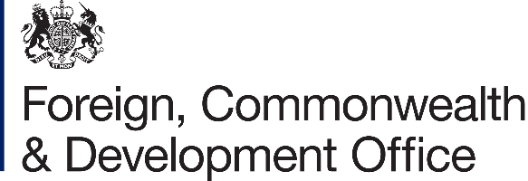 | 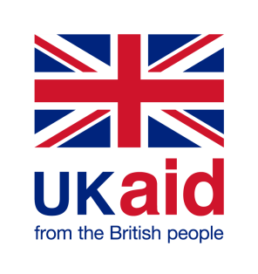

Accountable Grant Amendment Letter

Project Name: Building Resilience through Asset Creation and Enhancement Phase II (BRACE II)

Project Number: [204888-107]

- I refer to the Accountable Grant between the Government of the United Kingdom of Great Britain and Northern Ireland acting through the Foreign, Commonwealth & Development Office (“FCDO”) and World Vision Australia signed on 26 January 2018, including subsequent amendments signed on 23 October 2018, 20 March 2020, 16 April 2020, 26 March 2021 and 29 June 2021.

- Following recent discussions, FCDO proposes to increase the amount made available to World Vision Australia by £624,416.67 (Six hundred Twenty-four thousand, Four Hundred- and Sixteen pounds sterling Sixty-Seven pence).

- I propose that the figures and words £10,386,953 (Ten million, Three Hundred Eighty-Six Thousand, nine hundred Fifty-three pounds sterling) in paragraph 3 of Accountable Grant Amendment 2/2021 be deleted and replaced with the figures and words £11,011,369.67 (Eleven million, Eleven Thousand, Three Sixty-Nine hundred Fifty-three pounds sterling sixty seventy pence).

- I proposed that the payment schedule contained in the original accountable grant arrangement signed on 23 October 2018, and subsequent amendments No.1/2020 signed on 20 March 2020, No.2/2020 signed on 16 April 2020, No.1/2021 signed on 26 March 2021 and No.2/2021 signed on 29 June 2021 be deleted and replaced with the following payment schedule:

FCDO Financial Year | Annual Allocation (GBP)
1st April 2017 to 31st March 2018 | £230,721
1st April 2018 to 31st March 2019 | £3,344,932
1st April 2019 to 31st March 2020 | £2,619,569
1st April 2020 to 31st March 2021 | £2,691,731
1st April 2021 to 31st March 2022 | £2,124,416.67
Grant Total | £ 11,011,369.67

- There is no change in the end date of 31 March 2022.

- This letter of amendment will place on record our common understanding of the above change(s) and will come into operation on the date you sign your confirmation below. This note will be known as Amendment No. 3 / 2021.

- Please sign both copies of this letter; return one to me and retain the other for your own records.

Signed on behalf of FCDO:
Name: | Andre Koelln
Position: | Country Development Director
Address/Contact Details: | British Embassy Juba  European Union Compound  South Sudan
Date: | 15/11/2021
Signed on behalf of the Partner:
Name: | Patrick Thomas
Position: | Head of Humanitarian and Fragile Contexts
Address/Contact Details: | World Vision Australia  1 Vision Drive, Burwood East, Victoria, Australia
Date: | 11 November 2021

