
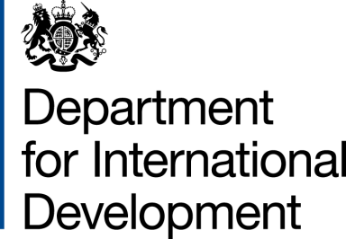
Memorandum of Understanding
Between
The Department for International Development (DFID), United Kingdom of Great Britain and Northern Ireland
And
The National Crime Agency

Regional Facility for Strengthening Transnational Responses to Countering Illicit Financial Flows, Corruption and Organised Crime in Africa (CIFFs Facility for Africa)
Component Number: 204227-102
Purchase Order: 40117834

1. The Department for International Development (DFID) will make available to The National Crime Agency (NCA) a sum not exceeding, £1,915,000 (one million, nine hundred and fifteen thousand pounds sterling) (“the Contribution”) for the above project (“the project”).

2. The arrangements for the project and the purpose for which the funds will be used are set out in the attached partner document.

3. The project will commence on 1 May 2020 and will end on 31 March 2021.

4. The Contribution will be administered by the NCA on behalf of DFID in accordance with its financial regulations, procedures and practices.

5. Payment schedule

 | Period Report Covers | Date Report Due
Statement of Expenditure | Q1-Q2 – 01/05/2020 to 30/09/2020  Q3-Q4 – 01/10/2020 to 31/03/2021 | 14/10/2020  03/04/2021

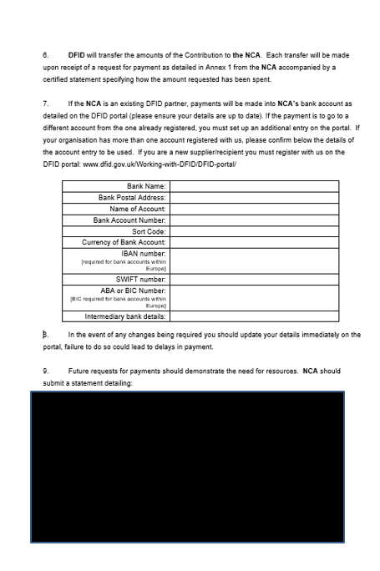
Quoting the name of the programme, DFID ARIES project identification code (204227-102) and NCA programme reference.

12. Reporting Requirements

 | Period Report Covers | Date Report Due
Statement of Expenditure | Q1-Q2 – 01/05/2020 to 30/09/2020  Q3-Q4 – 01/10/2020 to 31/03/2021 | 14/10/2020  03/04/2021
Narrative Report | 01/05/2020 – 30/09/2020 | 31/10/2020
Annual Report | Will cover activity between 01/10/2020 – 31/03/2021 and key reporting requirements from the entire year. | 14/04/2021

13. If any changes occur which, in the opinion of DFID, impair significantly the developmental value of the project; our two Departments will normally consult on measures to resolve the problem and possible courses of action. In the event of such changes DFID reserves the right to modify or terminate its financial contribution to the project by giving 3 months notice in writing. All remaining funds other than those irrevocably committed in good faith before the date of termination and those decided as being required to finalise activities in a sensible manner will be returned to the DFID bank account detailed at paragraph 11.

14. DFID will not be responsible for the activities of any person or third party engaged by the NCA as a result of this Memorandum, nor will DFID be liable for any costs incurred by the NCA in terminating the engagement of any such person.

Fraud and Corruption

15. The NCA will immediately notify DFID of any event which interferes or threatens to materially interfere with the successful implementation of the project, whether financed in full or in part by DFID, including credible suspicion of or actual fraud, corruption or any other financial irregularity or impropriety.

16. DFID have an expert fraud investigation unit, that should be contacted in the first instance at fraud@dfid.gov.uk or +44 (0)1355 84 3747. All suspicions will be treated with the upmost confidentiality.

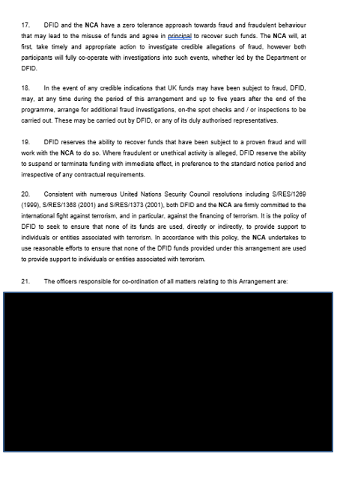
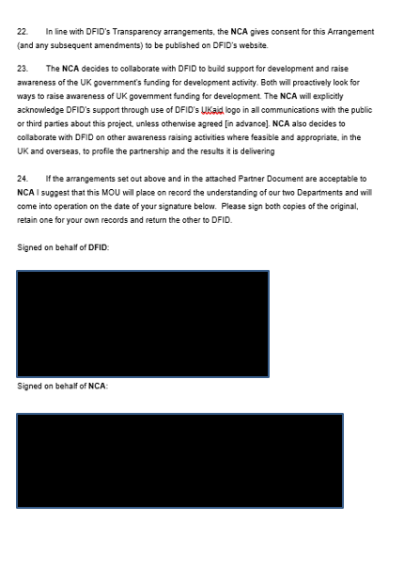

ANNEX 1: REQUEST FOR PAYMENT

To: | [DFID Project Manager Country X]
Cc: | FMG, DFID, Abercrombie House, East Kilbride, Scotland
 | UK Government Department

[UK Government Department] requests payment of [AMOUNT IN FIGURES [AMOUNT IN WORDS]] on [DATE] into [UK Government Department] account as detailed in the DFID portal. If the payment is to go to a different account from the one already registered, you must set up an additional entry on the portal. If your organisation has more than one account registered with us, please confirm below the details of the account entry to be used.

Bank Name:
Bank Postal Address:
Name of Account:
Bank Account Number:
Sort Code:
Currency of Bank Account:
IBAN number:
[required for bank accounts within Europe]
SWIFT number:
ABA or BIC Number:
[BIC required for bank accounts within Europe]
Intermediary bank details

In the event of any changes being required you should update your details immediately on the portal, failure to do so could lead to delays in payment.

in respect of [PROJECT NAME and DFID CODE) and [UK Government Department] project reference [INSERT REFERENCE]

[UK Government Department]
Name:
Position:
Address:
E-mail:

ANNEX 2: NOTIFICATION OF PAYMENT BY DFID

To: | [UK Government Department]  Address:
Cc: | FMG, DFID, Abercrombie House, East Kilbride, Scotland
 | [UK Government Department ]

DFID [INSERT DEPARTMENT DETAILS] has authorised the payment of £ [AMOUNT IN FIGURES [AMOUNT IN WORDS]] on [DATE] into [UK Government Department] account as detailed in the DFID portal. If your organisation has more than one account registered with us, confirmed below are the details of the account to which the payment has been made.

Bank Name:
Bank Postal Address:
Name of Account:
Bank Account Number:
Sort Code:
Currency of Bank Account:
IBAN number:
[required for bank accounts within Europe]
SWIFT number:
ABA or BIC Number:
[BIC required for bank accounts within Europe]
Intermediary bank details

in respect of [PROJECT NAME and DFID CODE] and [UK Government Department], [PROJECT REFERENCE]

[DFID DEPARTMENT]
Name:
Position:
E-mail:

