Annual Review Template

Title: Climate Adaptation Water and Energy Infrastructure Programme (CAWEP)
Programme Value £ (full life): £19,550,000 |  | Review date: February 2022
Programme Code: [AMP ID#]300164 | AMP start date: 10 November 2019 | AMP end date: 30 November 2023

Summary of Programme Performance
Year | 2021 | 2022
Overall Output Score | B | B
Risk Rating | Major | Moderate

DevTracker Link to Business Case: | https://devtracker.fcdo.gov.uk/projects/GB-GOV-1-300164
DevTracker Link to results framework: | https://devtracker.fcdo.gov.uk/projects/GB-GOV-1-300164

A. SUMMARY AND OVERVIEW

A.1 Description of programme
The Climate Adaptation Water and Energy Programme, hereinafter referred to as CAWEP is a FCDO funded programme in Zimbabwe. It seeks to enhance vulnerable communities and institutions’ adaptation and resilience capacity to climate shocks. Through this programme FCDO is supporting the development of climate resilient, multiple use water and renewable energy infrastructure in vulnerable communities of Zimbabwe to enable (i) continued access to water for productive and household use, including during droughts and floods, and (ii) improved access to clean and affordable energy to support economic activities with the intention of supporting more sustainable livelihoods outcomes. The project will provide technical assistance to the government and other non-state actors to support the wider use of climate science in designing and delivering resilient water and energy infrastructure. Evidence generated through this programme will be used to influence climate policy reforms and support national climate adaptation plans. And as such aims to build and demonstrate an understanding of what works and what challenges must be overcome for a resilient and sustainable outcome.

The programme has three delivery components which are briefly explained below:

A.1.1 Feasibility Study
This component is designed to consolidate & analyse available evidence to determine the technical, financial, social, and environmental feasibility of a FCDO proposed climate adaptation programme through establishing community owned and managed multiple use water & renewable energy infrastructure. This component is being led by the Pegasys consulting firm and ending in February 2022.

A.1.2 Adaptive & Flexible Water supply
Given the increased exposure to extreme climate or weather-related events in Zimbabwe, this component is designed to flexibly respond to emerging water & clean energy priorities including providing infrastructure support to avert the impact of potential climate or weather-related disasters. This is currently being implemented by UNICEF, providing sustainable basic water supply using climate resilient infrastructure, through the installation of solar powered water schemes. The intention is to reach 53,600 people across nine vulnerable districts in Zimbabwe by March 2022.

A.1.3 Climate Adaptation - Community water & renewable energy infrastructure & Early Warning Systems (EWS)
This is the main CAWEP component that seeks to contribute towards community and institutional climate change resilience in Zimbabwe. Work under this component is designed to boost climate change adaptation through enhanced climate proofing and development of climate resilient community water and renewable energy infrastructure and strengthening Early Warning Systems (EWS) and response in selected vulnerable districts.

In this review, programme performance will be assessed against progress made in delivering outputs in each of the above-mentioned components and as set in the original high level Logical Framework (January 2021).

A.2 Summary supporting narrative for the overall score in this review
This review rates the overall performance of this programme at B, implying the outputs moderately did not meet expectations as set in the programme Logical Framework. The main expectation at this stage of the programme was to complete Output one (1) on the feasibility study. At the time of this review, only a draft feasibility report was completed with other related deliverables such as technical designs and the M&E framework still outstanding, pending FCDO approval of projects. Delays were mainly due to COVID related restrictions affecting some activities and demands from the 26th Climate Change Conference (COP26) which took a significant amount of time from the FCDO programme team and key government personnel in the Climate Change Management Department. However, the review notes good progress on meeting all key performance indicators under this output. Therefore, this output is on track to be delivered by end of February 2022. In the coming year, the programme results framework is being updated which the programme team will start delivering against. With the feasibility studies being concluded, the team will prioritise engaging the main delivery partner to implement selected projects. This is expected to improve the programme score in the coming year.

A.3 Major lessons and recommendations for the year ahead
A.3.1 Key high-level lessons learnt over the past year are:
- It is critical for the programme team to invest more time and effort on ways to work closely with the Government of Zimbabwe (GoZ) using the programme to influence and support the strengthening of the climate change policy environment in order to achieve climate change resilience. The situation analysis and proposed projects to be delivered through the feasibility study require closer collaboration, shared responsibility and accountability between the government and development partners to achieve the desired outcome on getting communities and institutions adapt to effects of climate change and become more resilient.
- When determining the programme delivery timeframe, it is very important to have a deep understanding of the operating context, analysing deeply the existing and anticipated risks such as COVID-19, upcoming elections and extreme weather events that are likely to slow down progress. The programme team needs to factor in the potential time losses in addition to the likely implementation time when everything is equal.
- Community water and renewable infrastructure should be developed holistically, taking care of local livelihoods priorities and environmental sustainability. This increases community ownership and enhance resilient outcomes.
A.3.2 In the coming year, the following recommendations are being made in this review to ensure the programme successfully deliver its objectives and desired outcome. These recommendations are also being made based on lessons learnt in the past year and from engaging widely with other partners.
- In view of the limited financial and delivery space, the programme team needs to work with relevant FCDO teams and key stakeholders to prioritise projects that FCDO can support in the next three years from those recommended by the feasibility study. Priority should be given to projects that have the greatest impact in enhancing resilience and climate change adaptation through access to climate resilient community water and clean energy infrastructure and systems. Other key considerations in the process are sustainability, value for money and alignment with Government of Zimbabwe climate change Adaptation priorities.
- Update the programme Theory of Change (ToC) and Logical Framework to reflect specific work identified by the feasibility study.
- The programme team recommends a programme implementation time extension of at least 24 months to enable smooth implementation of projects coming out of the feasibility study. A significant time of programme implementation was lost due to the impact of COVID-19. The programme was cleared to start by Her Majesty Treasury (HMT) in November 2019. This was followed by onset of COVID-19 Pandemic which worsened in the first quarter of 2020. The pandemic had a severe economic impact on the UK’s Official Development Assistance (ODA) which resulted in suspension on spending through some programmes including CAWEP. Between then and August 2020, CAWEP implementation was on hold, awaiting the outcome of ODA spend prioritisation and country allocations. The programme procurement process resumed in September 2020, leading to signing of the feasibility contract with Pegasys in November 2020. In addition to this, other COVID-19 restrictive measures slowed down initial engagement with key stakeholders due to (i) remote working which was affected by connectivity challenges for most government stakeholders, (ii) illness and (iii) more deployments to respond to the pandemic. In addition, the programme spent two months before it was allocated a procurement specialist by the commercial unit. The time extension being recommended is meant to compensate for this lost time and anticipated future time losses due to the existing COVID-19 risk and upcoming 2023 general elections in Zimbabwe.
- Use the programme to support the delivery of UK climate commitments, including those made at the United Nations Framework Convention on Climate Change 26th Conference of Parties (COP26).
- Share findings and lessons learnt from the feasibility study with other donors and the government of Zimbabwe and present available opportunities from implementing CAWEP where they can learn from to improve the country’s climate change policy framework. The review period has heightened the need to use FCDO programme tools in influencing climate policy in Zimbabwe.

B: THEORY OF CHANGE AND PROGRESS TOWARDS OUTCOMES

B.1 Theory of Change Description
Figure 1 below illustrates the Theory of Change (ToC). FCDO funding is supporting a programme feasibility study, leading to the development of community water and renewable energy infrastructure that is expected to help vulnerable communities and essential services to adapt to climate shocks and become more resilient. Expected changes from these interventions are (i) more households and essential services in health and education have sustainable access to water and clean renewable energy, (ii) diversified livelihoods options and improved agriculture productivity. The ToC has not changed from what was proposed in the Business Case. The feasibility studies are expected to provide evidence and recommendations on whether it should change or not and whether it still presents good value for money as expected when the project was designed.

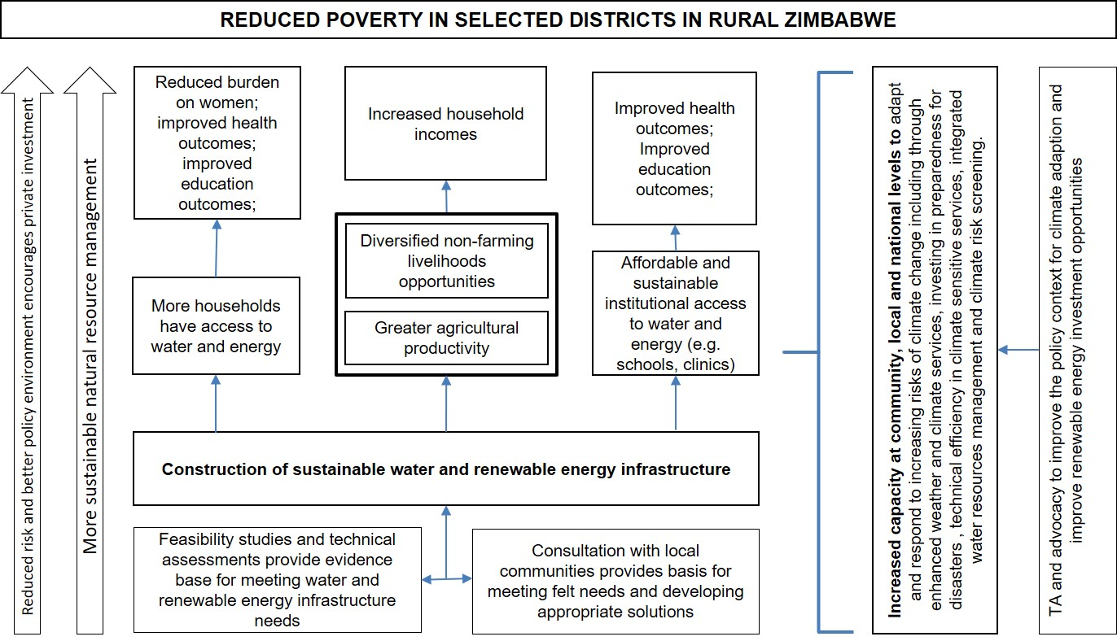

B.2 Describe where the programme is on/off track to contribute to the expected outcomes and impact. What action is planned in the year ahead?
The expected overall programme outcome is improved capacity at community, local and national levels to adapt to increasing risks of climate change. This will be achieved through improving access to climate resilient community water & renewable energy infrastructure & enhanced weather & climate services or Early Warning Systems (EWS). The programme is still working towards delivering this high-level outcome. This is despite a more than twelve-month long delay caused by COVID-19 and late allocation of the procurement specialist which resulted in the late start to the feasibility study. The programme feasibility study, one of the key programme outputs as shown in the Theory of Change (ToC) above is however, near completion and has identified several climate adaptation project options that FCDO can support in the coming three years. In the year ahead, FCDO will focus on engaging a programme delivery partner to prepare and start implementing prioritised projects in line with the available budget allocated to FCDO Zimbabwe portfolio. There will be close collaboration with key government ministries in project preparation and implementation. In the coming year, the programme team will also focus on securing a programme no-cost extension of at least twenty-four months to compensate for the delays experienced in the past two years and other anticipated delays due to (i) COVID-19, (ii) Upcoming 2023 general elections in Zimbabwe that are likely going to restrict access to project sites. If the extension is not granted, planned works to deliver the projects, and therefore the desired outcome will not be achieved. This is unavoidable and necessary to safeguard the investment made so far and deliver as envisaged in the CAWEP BC.

B.3 Justify whether the programme should continue, based on its own merits and in the context of the wider portfolio
This programme is very relevant to Zimbabwe and aligns with the UK’s global commitments on climate change and therefore should continue. Specific arguments for this programme to continue are:
- Zimbabwe is vulnerable and often experiences severe impacts of climate change at an increasing rate. Vulnerable communities and institutions need access to sustainable water, clean energy and accurate weather and climate information to be able to adapt and be resilient.
- The programme is a direct UK support to Zimbabwe, helping to deliver climate change national adaptation priorities on Climate Resilient Infrastructure and Early Warning Systems (EWS). This is in fulfilment of the UK commitment to help financing for adaptation in developing and vulnerable countries.
- This programme is likely to be delivered at good Value for Money (VfM). The feasibility study is providing a range of projects with different levels of VfM, helping the programme to make an informed decision that will enable the delivery of a successful programme at the right cost with maximum return on investment.
The programme should continue as originally designed, although with modifications, based on the findings of the feasibility study, changing operating environment, factoring in the impact of COVID-19. The modifications will likely include more focus on low investment projects, still with long-term sustainable benefits. The programme will invest more in linking up with Government of Zimbabwe systems and policy priorities on climate change. It will work with relevant departments, including in Climate change, Meteorological Services, Water resources and natural resources management, providing technical assistance in areas that enhance climate resilience outcomes, use of evidence, reporting and accountability.

C. DETAILED OUTPUT SCORING

Output Title | Feasibility study providing evidence and recommendations for transformative climate adaptation and resilience interventions in Zimbabwe.
Output number: |  | 1 | Output Score: | B
Impact weighting (%): |  | 100 | Weighting revised since last AR. | [If yes, up, or down?]

Indicator(s) | Milestone(s) for this review | Progress
1.1 Feasibility supplier engaged with Terms of reference agreed | 1 | 1
1.2 Feasibility study inception report with clearly laid out scope of work and methodology | 1 | 1
1.3 Interim feasibility report with preliminary findings. | 1 | 1
1.4 Final feasibility report with clear delivery options and recommendations backed with evidence. | 1 | 0
1.5 Results framework for the recommended option | 1 | 0
1.6 Detailed budget for the recommended option | 1 | 0
1.7 No. of priority water & renewable energy projects identified to respond to immediate needs | 3 | 3
1.8 CAWEP Fund Manager engaged | 1 | 0
C.1 Briefly describe the output’s activities and provide supporting narrative for the score.
The expected output by December 2021 was a completed and signed off feasibility study with clear project options, full costs, designs and results framework for a climate change adaptation programme through improved access to climate resilient community water, renewable energy, and early warning systems. However, a draft feasibility report was shared with FCDO in December 2021, hence the reason for rating this output as moderately missed. The remaining activities which are finalising the feasibility report, the results framework, technical designs, and activity costing are all above 50% complete and expected to be fully completed by February 2022, signalling the completion of the feasibility study. It is against this that this review rates the output performance in the past year at B.

C. 1.1. Assess the VfM of this output compared to the proposition in the Business Case, based on performance over the past year
There has not been any shift on the output VfM from the Business Case proposition. The purpose of this output, more specifically the feasibility study is to make sure the overall programme delivered at good value for money. Embedding this output under this programme is based on lessons learnt from other programmes that underscored the importance of investing in programme delivery preparation, understanding the needs and identifying the right interventions to get more sustainable and inclusive outcomes. Below is an analysis and explanation on how this output will contribute towards Economy, Effectiveness, Equity and Efficiency:

C.1.1.1 Economy: Having a choice of costed community water & renewable energy projects with scope of works defined is helping FCDO to make informed choices and decisions on where to invest appropriately. In the year under review, this has already been put into practice on project prioritization. In delivering this output FCDO has maximized on the economies of scale, getting the project baseline studies, detailed scope of works with technical designs, the Gender, Equity & Social Inclusion (GESI) analysis and the programme results framework in one contract.

C.1.1.2 Effectiveness: The feasibility study has identified deserving communities in districts vulnerable to effects of climate change and have very limited capacity to adapt. FCDO support with multiple water and renewable energy investments will make a positive difference to their lives through improved access to clean water and energy for health and productive use. The study has also shown emerging opportunities to influence government policies and strengthen community-based management to enable sustainability.

C.1.1.3 Equity: The Gender Equity & Social Inclusion (GESI) analysis done in this feasibility study has provided options for the programme to ensure equity in access to climate resilient community water, renewable energy, weather, and climate information services.

C.1.1.4 Efficiency: Determining specific scope of works to be delivered through this feasibility study is helping to decide on the best delivery mechanism including implementing partners, opportunities link and compliment Government of Zimbabwe Systems including contributing towards delivering the Climate change Adaptation Plan priorities.

C.1.2 Describe any changes to this output during the past year, and any planned changes as a result of this review.
There were no major changes to this output in the past year. The feasibility study proceeded as intended. However, the programme team envisage removing this output from the programme Log Frame, to focus on delivering direct programme results from prioritised interventions and in line with the recommended results framework coming out of the feasibility study. This will be achieved within six months after this review.

C.1.3 Progress on recommendations from the previous AR (if completed), lessons learned this year and recommendations for the year ahead

C.1.3.1 Recommendation from the Previous Annual Review (AR)
The previous AR recommended the following:

Recommendation 1: Contractor (Pegasys) to work out effective mitigation measures that will prevent or minimise the impact of COVID-19 on the feasibility study.

Progress: Contractor managed to put in place mitigation measures to reduce the impact of COVID-19 on the feasibility study. These included working virtually where possible, working with the government’s Climate Change Management Department (CCMD) to get exemptions to travel to project sites and front loading some activities that needed physical presence whenever a lockdown was anticipated. The mitigation measures used managed to avoid a complete stop to the process although in some cases there were unavoidable delays that cumulatively took up close to three months during this contact.

C.1.3.2 Lessons learnt
Key lessons learnt from delivering this output in the past year are:
- Feasibility studies, even at smaller scale help to make informed choices of project interventions that are appropriate to a particular community, give good value for money and will be sustainable. The preliminary findings of this feasibility study have been widely used in FCDO and with government in project prioritisation discussions. This includes technical, financial, political, social, and environmental feasibility.

- Adequate time must be given for internal and external stakeholder processes to select projects which are both of national importance, and programmatic importance to FCDO. The scale and cost of projects such as CAWEP demand that extra due diligence and consultation be undertaken to make critical decisions, therefore more time must be factored into project design processes to allow for these key steps.
C.1.3.3 Recommendations for the year ahead
- Share the findings of feasibility widely across partners, fellow donors & government as a resource for planning and selecting related projects, potentially picking up those that FCDO is not funding.

- Ensure that the institutional capacity and institutional models developed in the studies are adequately and sufficiently set up to ensure that the projects can institutionally, financially, and technically sustained by the local communities and project owners.
Output Title | Development of climate resilient multiple use water and energy infrastructure
Output number: |  | 2 | Output Score: | N/A
Impact weighting (%): |  |  | Weighting revised since last AR. | [If Yes, up or down?]

Indicator(s) | Milestone(s) for this review | Progress
2.1 No. of infrastructure developed with special technical designs and feature that respond to climate risks. It could be mini grids, small dams rehabilitated and supported with solar systems | 0 | N/A
2.2 % of functional water and renewable energy infrastructure with a community management structure and business model for maintenance | 0 | N/A
C.2 Briefly describe the output’s activities and provide supporting narrative for the score.
In this review, no score was assigned to this output because there were no expectations to deliver on this in the year under review. Specific deliverables under this output are largely dependent on the outcome of the feasibility study, which is now being finalised. However, in July 2021, through the programme’s Adaptive & Flexible Water supply component, FCDO engaged UNICEF to deliver urgent basic water supply infrastructure in drought and flood prone communities in nine districts. The target is to deliver twenty-five solar powered piped water schemes across these districts, reaching 53,600 people including in schools and health centres. The approach entails using climate resilient infrastructure through the installation of solar powered water schemes and strengthening built WASH infrastructure to avert damages by flooding. At the time of this review, UNICEF has rehabilitated two piped water systems with embedded water kiosks at those water points. Other sites are at various stages of construction. As at end of January 2022, UNICEF reported completion of fundamental preparatory work enabling the commencement of physical works. This work includes implementing partner contracting, procurement, site selection and designing. UNICEF has an updated plan to deliver this work by March 2022.

C.2.1. Assess the VfM of this output compared to the proposition in the Business Case, based on performance over the past year
The choice and approach to deliver this output is still expected to be delivered at good value for money. Evidence show that water supplied through piped water to a tap stand is cheaper per user than a stand-alone handpump as well as providing better quality service. In global comparisons investment per capita was about US$65 for piped water scheme versus US$85 for handpump for a population of 2500 (IRC, 2013). Whilst solar technology has high capital costs, investment return over time is much higher than the use of conventional energy, hence providing a cost-effective alternative. Life cycle costs are low irrespective of high initial costs.

The water supply infrastructure designs have considered the needs of people living with disability, children – especially girls, and the elderly. Also considered are multiple uses such irrigation and livestock. If delivered to plan, the solar powered water systems will be effective and contribute to equity. Below are some of the beneficiary feedback on the programme.

Beneficiary feedback:
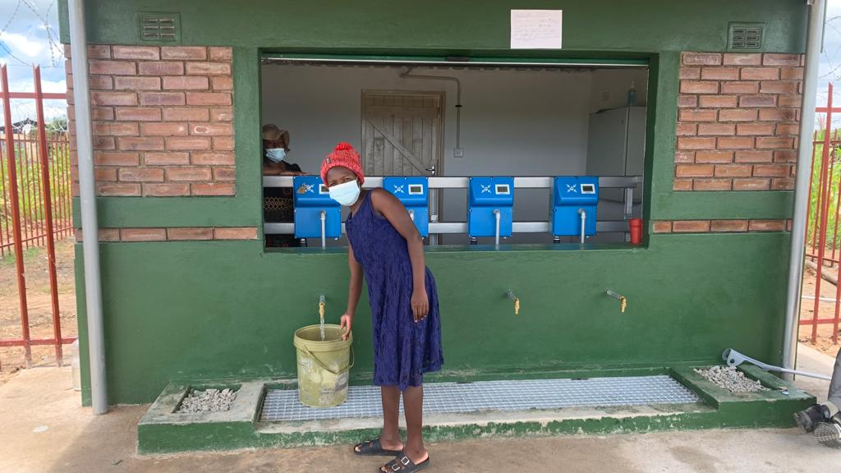
‘Illegal gold panners used to give us a hard time at the borehole, they would forcefully skip queues. Now we access clean water faster; the taste is good; due to affordability we can even use it for laundry and bathing. The system is very transparent on the litres one gets. We used to expend so much energy at the bush pump, but now it is very easy. We used to fetch water at night due to the high demand at the borehole and girls feared being abused but now we no longer have to walk at night to fetch water.”

On the cost of inputs, no increase was noted. UNICEF and partners opted for competitive bidding for contractors to work on the schemes which in fact enabled lower unit costs than anticipated. Partners utilized national and local newspapers to advertise the tenders to ensure they not only got the best price on the market but were able to increase their pool of suppliers. Thus, UNICEF and partners have been able to achieve more with the provided resources, an increase from the 25 planned water schemes to 35 water schemes.
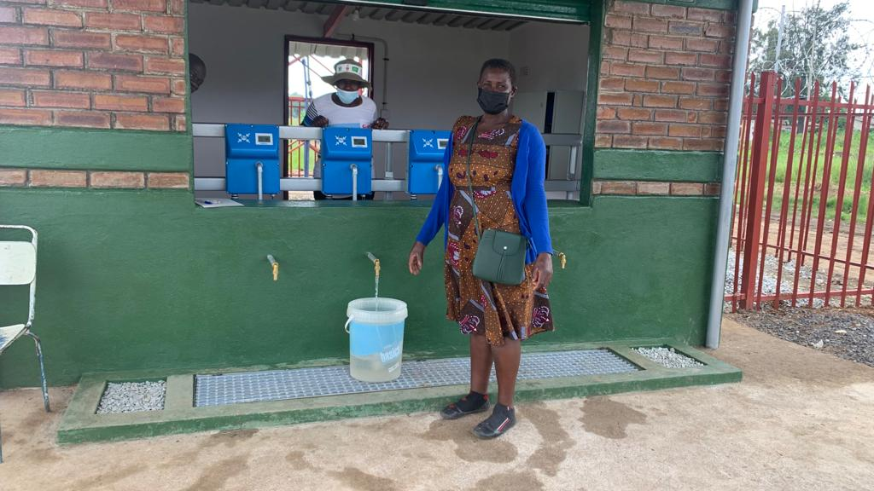
Beneficiary feedback:
“This is a beautiful initiative, I have been surviving from vending, and with water being charged at ZWL$10 (USD10cents) for 20 liters of water nothing can hinder me from affording water, and I will surely no longer fail to do my gardening. The water is clean and of good quality, diarrheal diseases and other conditions will be a thing of the past in this area.”

C.2.2 Describe any changes to this output during the past year, and any planned changes as a result of this review.
There were no changes to this output in the past year. However, the programme expects to make changes to this output as soon as the feasibility study is completed. The findings of the feasibility study will determine specific works on climate community resilient water & clean energy infrastructure. In addition, resource availability and discussions with government of Zimbabwe will also determine the scale at which this output will be delivered. As a result, changes to this output in the coming year are inevitable.

C.2.3 Progress on recommendations from the previous AR (if completed), lessons learned this year and recommendations for the year ahead

C.2.3.1 Recommendation from the Previous Annual Review (AR)
No recommendation made on this output in the previous AR.

C.2.3.2 Lessons learnt
No lessons learnt on this output at this stage.

C.2.3.3 Recommendations for the year ahead
- Update the output description to reflect the work being delivered through UNICEF and results of the feasibility study. This include standardising the output indicators.
- Consider a no cost extension of up to three months given the likely disruption of works due to tropical cyclones. Targeted districts fall within the cyclone paths based on previous trajectories. At the time of this review, some of these districts experienced extreme weather conditions due to Tropical Storm Ana. This decision should be made by end of February 2022.

Output Title | Improvements in evidence base to influence design and delivery of resilient infrastructure
Output number: |  | 3 | Output Score:
Impact weighting (%): |  |  | Weighting revised since last AR. | [If Yes, up or down?]

Indicator(s) | Milestone(s) for this review | Progress
3.1 No. of evidence documented and used in planning and designing the programme | 0 | N/A
C.3 Briefly describe the output’s activities and provide supporting narrative for the score.
Output not scored in this review. No results were expected at this stage of the programme. This will only start to be measured when the full programme is being implemented, specifically when climate proofing is being applied to programme activities. The programme is taking an operational research approach to be able to deliver on this output.

C.3.1. Assess the VfM of this output compared to the proposition in the Business Case, based on performance over the past year [1 paragraph]
This is a very low-cost intervention given it will not require additional money but uses existing allocated budget to deliver valuable evidence that will contribute to making choices on effective, efficient, and equitable climate change adaptation projects. The programme strategy to achieve this output entails:
- Convene a stakeholder round table to discuss the findings of the feasibility study, what is coming out of the situation analysis, policy and technical evidence gaps on pitfalls that affect community and institutional adaptation capacity and subsequently resilience. Collectively, FCDO, Government of Zimbabwe (GoZ) and other development partners will explore and agree on opportunities in CAWEP that could be used to consolidate evidence, feeding into the GoZ systems and climate change mainstreaming work across government.
- Ensuring that the Government of Zimbabwe (GoZ) sits and takes an active role in the programme steering and technical committees as proposed in the Business Case. This will ensure documentation and application of evidence in national planning and implementation of projects and policies in climate change mainstreaming.
- FCDO will also use Zimbabwe Development Partners forum to share best practices and seek partnerships to use this evidence to support work in climate resilience in Zimbabwe.

C.3.2 Describe any changes to this output during the past year, and any planned changes as a result of this review.
No changes were made on this output in the past year and not anticipating any significant change in the year ahead.

C.3.3 Progress on recommendations from the previous AR (if completed), lessons learned this year and recommendations for the year ahead

C.3.3.1 Recommendation from the Previous Annual Review (AR)
No recommendation made on this output in the previous AR.

C.3.3.2 Lessons learnt
No lessons learnt on this output, given it hasn’t been fully implemented and tracked.

C.3.3.3Recommendations for the year ahead
- Programme team and partners to come up with a specific plan to deliver and track this output. This include coming up with specific areas where there are evidence gaps that this programme will fill through its implementation.

Output Title | Improved National Climate adaptation policies/Strategies
Output number: |  | 4 | Output Score:
Impact weighting (%): |  |  | Weighting revised since last AR? | [If Yes, up or down?]

Indicator(s) | Milestone(s) for this review | Progress
- No. of policies or strategies developed as a result of programme influence | 0 | n/a
1.2 No. of policy briefs developed using evidence generated by the programme | 0 | n/a
C.4 Briefly describe the output’s activities and provide supporting narrative for the score.
Output not scored in this review as it was not expected to be delivered at this stage of the programme.

C. 4.1. Assess the VfM of this output compared to the proposition in the Business Case, based on performance over the past year
The value for money assumptions of this output has not changed. Going forward, expectations are that a successful delivery of this output will be a positive indicator for the overall programme, using evidence and best practices from the programme to influence the development of inclusive, efficient, and effective climate change policies and strategies in Zimbabwe. The review observed that the output description and indicators are not specific on the targeted policies and strategies the programme is seeking to influence. In the absence of this it will be difficult to track and being more focused in delivering this output.

C.4.2 Describe any changes to this output during the past year, and any planned changes as a result of this review.
There were no changes to this output in the past year. However, following the findings of this review, the programme team will update the outdate description and indicators to make it more specific and measurable.

C.4.3 Progress on recommendations from the previous AR (if completed), lessons learned this year and recommendations for the year ahead

C.4.3.1 Recommendation from the Previous Annual Review (AR)
No recommendation made on this output in the previous AR.

C.4.3.2 Lessons learnt
No lessons learnt on this output, given it hasn’t been fully implemented and tracked.

C.4.3.3 Recommendations for the year ahead
- Identify and mention specific policies or strategies that could be influenced by delivering this programme. Indicators should also be updated accordingly. This review identifies the National Adaptation Plan (NAP) as one of the priority and relevant strategy CAWEP could engage with and influence the planning process and delivery. The programme team needs to work closely with the Government’s Climate Change Management Department to prioritise work that CAWEP can support. Explorations should continue to look at climate change mainstreaming in education, health, and agriculture sectors.

- Share findings and lessons learnt from the feasibility study with the government of Zimbabwe and present available opportunities from implementing CAWEP where they can learn from to improve the country’s climate change policy framework.

Output Title | Strengthened and self-financed community-based infrastructure management structures
Output number: |  | 5 | Output Score:
Impact weighting (%): |  |  | Weighting revised since last AR? | [If Yes, up or down?]

Indicator(s) | Milestone(s) for this review | Progress
No. of set up and functional management structures | 0 | NA
C.5 Briefly describe the output’s activities and provide supporting narrative for the score.
The output was not expected to have started to report results at this stage and therefore not scored against. However, there is good progress through the feasibility study in shaping the right activities that are needed to deliver this output. All project options coming out of the feasibility study are building in self-financing community water & energy infrastructure models and in some cases exploring opportunities of working with the private sector.

C. 5.1. Assess the VfM of this output compared to the proposition in the Business Case, based on performance over the past year
The value for money expectations of this output is still maintained at the same level it was when the Business Case was approved. The output itself is meant to improve functionality of community water & renewable energy infrastructure, making it more effective.

C.5.2 Describe any changes to this output during the past year, and any planned changes as a result of this review.
There were no changes to this output in the past year. The programme is not expecting to make changes in the coming year other than setting specific targets as determined by the feasibility study.

C.5.3 Progress on recommendations from the previous AR (if completed), lessons learned this year and recommendations for the year ahead

C.5.3.1 Recommendation from the Previous Annual Review (AR)
No recommendation made on this output in the previous AR.

C.5.3.2 Lessons learnt
- Main lesson learnt from the preparations to deliver this output is that community water and renewable infrastructure should be developed holistically, taking care of local livelihoods priorities and environmental sustainability. This increases community ownership and sustainability.
C.5.3.3 Recommendations for the year ahead
- The feasibility study recommends that a portion of the CAWEP budget be allocated to support local production of agricultural produce, provide nutritional advice, technical support on productive use of renewable energy, to support women’s economic empowerment. This will ensure sustainability and success of the projects through enhanced community ownership and direct access & benefits to basic needs such as food and income. The programme should ensure and work with existing extension services. Local Government should be engaged to commit to complement this work by coordinating and providing extension services to local communities.

D: RISK

D.1 Overview of risk management
The overall risk rating for the programme is assessed as Moderate and is within FCDO’s risk appetite in country FCDO’s programme team worked with the two partners, Pegasys and UNICEF to mitigate against this risk. Each of the programme components has a risk matrix that it is regularly reviewed and updated in monthly meetings with each of the implementing partners. Table 1 below provides details on the main risks and mitigation.

Table 1: Top Risk description and mitigation

Risk category, appetite, and risk level ratings. | Risk description and mitigation
Strategy and Context  (Receptive & Moderate) | Risk:  Possible FCDO budget reductions may not lead to full utilisation of the study intervention proposals. This may impact the VFM aspects of the Pegasys contract and potentially the Business Case aspirations and approach.  Mitigation  The CAWEP Programme Team will be influencing the FCDO country planning processes. Undertaking early engagement with decision makers and seeking donor collaboration in programme delivery. Closer attention will be paid to the potential risks associated with emergencies and disasters as the country enters the cyclone season for the last three months of UNICEF programme implementation.
Policy and Programme Delivery  (Receptive & Moderate) | Risk:  Inadequate time for partners to deliver on schedule constrained by pandemic restrictions.  Mitigation  The delivery partners have excellent and long-standing relationships with key personnel at Government Ministries and other departments and institutions in Zimbabwe which helped keep delivery pace high. For Covid mitigation, the government through the Climate Change Management Department (CCMD) provided exemptions for travel restrictions which enabled visits to project sites and front loading some activities that needed physical presence whenever a lockdown was anticipated. These mitigation measures managed to avoid a complete stop on activity implementation, although in some cases there we unavoidable delays. UNICEF is working closely with NGO partners and contractors to ensure the schedule of work is clearly understood and monitored. Monitoring the travel budget as underspend of expenses is likely due to travel restrictions imposed by COVID-19. The CAWEP Feasibility study contract amendment no 1 had to be processed but took time, posing a risk that it would expire before extension was granted. However, this did not materialise.
Financial and Fiduciary  (Cautious & Moderate) | Risks:  Abuse of programme funds.  Mitigation:  UNICEF carried out financial quality assurance through spot checks; new funds are not disbursed until at least 50% of previous disbursement is accounted. UNICEF also provided a Delivery Chain Mapping clearly distinguishing flow of funds and detecting areas of potential fiduciary risks. FCDO assessed the delivery chain and convinced there was no breach of UK funding policy in Zimbabwe. Assessment of Pegasys delivery chain mapping showed very minor fiduciary risks as it is mainly characterised by service fees for the Pegasys consultants and staff expenses. Linked to economic variability and cash shortage, UNICEF had several mitigations ready for this risk e.g., UNICEF would liaise with commercial banks to facilitate access to cash for programme implementation.
Safeguarding  (Cautious & Moderate) | Risk:  Programme activities causing negative environmental and social impact land degradation, disruption of social norms and values was monitored.  Mitigation:  Environmental Social Safeguards (ESS) were carried out by UNICEF partners for this project at District. Eighteen committees are currently being trained on risk informed planning and will develop risk mitigation plans for their schemes. For the risk on Sexual Exploitation Abuse and Harassment (SEAH) breaches, contractors, partners, and UNICEF staff have been trained not to exploit communities. Communities and district stakeholders are trained on safeguarding.
Reputational  (Cautious & Moderate) | Risk:  Exclusion of the weak and vulnerable from participating in the feasibility study and UNICEF programme delivery could bring the investments/activities into question.  Mitigation:  Partners mitigated by ensuring that the leave no one behind approach was programme documents and in delivery e.g., reports and ToRs (Terms of Reference).

D.2 Update on Partnership Principles
The Partnership principles are reviewed regularly, and a comprehensive review was completed in September 2021. Based on a potentially layered delivery chain and multiple beneficiaries the partnership principles will influence how we deliver the main component of CAWEP. FCDO’s contribution to date through CAWEP programme are in line with the policy that no UK money is used to directly fund the Government of Zimbabwe.

E: PROGRAMME MANAGEMENT: DELIVERY, COMMERCIAL & FINANCIAL PERFORMANCE

E.1 Summarise the performance of partners and FCDO, notably on commercial and financial issues, and including consideration of VfM measures of economy and efficiency.

E.1.1 Finance and Contract Arrangement Management
A significant part of the expected programme spend is yet to be committed or a delivery partner identified. Values of the partner agreements/contracts are not fully disclosed as procurement processes have not been finalised. The programme has two operational components covered in this second annual review. The CAWEP programme is classified as International Climate Financing (ICF).

During the review period FCDO have provided scrutiny to payment requests and invoices to ensure that they comply with programme delivery rules, the focus being that we pay for appropriate goods and services. Utilisation rate for each partner is as follows, Pegasys at 83% with UNICEF at 84%. An updated finance early February demonstrated a higher utilisation level for UNICEF as a result of suppliers working through December. A brief outline of the components:

Description of contract type and partner | Operational Dates | Utilisation rate and value
Component 101 - Feasibility Study: Currently holds the UNICEF partnership delivered through a MOU. Implementing partners are Welthungerhilfe, CAFOD, Mercy Corps and Christian Care. Ministry of Lands, Agriculture, Fisheries, Water and Rural Resettlement, Department of Climate Change Management (CCMD) and the District Development Fund (DDF). FCDO disbursed funds to UNICEF in one tranche and UNICEF has provided finance reporting on the same. | 19 July 2021 to 31 March 2022 | 83%  (US $2,680,646)
Component 102 - Adaptive & Flexible Water supply:  Currently Pegasys holds the contract with a mandate to undertake a feasibility study that will inform investments in multiple use water and renewable energy infrastructure to enhance climate change adaptation. Pegasys has met most deliverables derived from the TOR, however the last payment is yet to be paid. | End date 28 February 2022 | 84%  (US $911,363)
Component 103 - Climate Adaptation - Community water & renewable energy infrastructure & Early Warning Systems (EWS)  This component is still forming. It will be for the delivery of the identified investments under the Feasibility study. | Not determined. | No spend yet.

E.1.2 Audit, Asset monitoring and control
UNICEF spot checks are done per implementing partner not per project and these are conducted once a year. CAWEP partners have been checked as confirmed by UNICEF. The spot check when conducted covered all projects that were supported by UNICEF implemented through the partner. No audits specific to CAWEP implementation have been undertaken due to its initial stages of delivery. UNICEF and Pegasys have not procured high value CAWEP related physical asset, so no physical asset assurances required.

E.1.3 Monitoring, Learning and Beneficiary engagement
Monitoring was undertaken using a blended approach, i.e., some virtual and some face-to-face in the field. FCDO intends to undertake a field visit once the movement restrictions have been lifted to assess delivery progress and engage with communities. The programme will use the findings of the feasibility study as a learning tool for programme planning, designing and examples of practical use of evidence to influence climate policy design, improvement, and implementation. UNICEF partners will be installing feedback/complaints boxes at each completed scheme as communities indicate this to be their preferred method of feedback. Communities have and are being engaged on site identification, design processes, including location of standpipes, security issues, trenching, community-based management which has seen the establishment of 18 water point user committees thus far. The committees will continuously provide a resource for continued engagement with the benefitting communities.

E.1.4 Partner performance
The established monthly meeting system ensured effective oversight of the formed partnerships. Using this system, the performance of the partners was assessed regularly based on a set of key deliverables. For the Pegasys component the main deliverable is the Feasibility Report which has been submitted in draft covering with a list of feasible projects including costing, specific works and expected number of beneficiaries. FCDO are reviewing the reports before Pegasys can finalise the feasibility study. For the UNICEF component the pace of delivery was slow as partners were only engaged mid-September 2022. UNICEF have provided regular updates in monthly meetings and in written briefs which additionally provide assurance to FCDO on compliance aspects such as Delivery Chain mapping and finance reporting, logframe and risk. Improvements on VFM reporting are essential and will be reviewed continuously as move to aspects of closure and sustainability assessments.

E.1.5 Value for Money (VFM)
The approach of CAWEP through the feasibility studies allows in-depth designs and various assessments to be completed before operationalisation. The effectiveness of the CAWEP project lies in the ability of the community and structures in managing and maintaining the investments made into the community. Each proposed intervention has a robust VFM assessment which will be accompanied by an in-depth risk analysis. It is evident that the interventions will aim to respond to community needs around water and energy, whilst ensuring specific vulnerabilities and needs of sub- groups (women, girls, the elderly and disabled) are understood and addressed. UNICEF and partners opted for competitive bidding for contractors to work on the solar schemes which in fact enabled lower unit costs than anticipated. Additional VFM assessments on the UNICEF component are expected as part of final reporting. The Pegasys contract may result in some savings under the travel budget line which will be ploughed back into the main delivery component.

E.1.6 Due Diligence
UNICEF as a multiple delivery partner within the FCDO Zimbabwe programme portfolio were subject to an earlier Due Diligence assessment in 2018 so there was no need to update this.

Date of last narrative& financial report | Pegasys – December 2021  UNICEF – December 2021 | Date of last audited annual statement | N/A  Expecting UNICEF reporting June 2022

Foreign Commonwealth and Development Office
Meeting the present-day need for safe, reliable, and affordable water, which minimises adverse effects on the environment, whilst enabling future generations to meet their requirements
Ministries of Environment, Climate, Water, Health, Education, Local Government, Women and Gender
Manicaland (Buhera, Mutare rural, Makoni, Mutasa), Midlands (Gweru Urban), Masvingo (Zaka, Chiredzi, Gutu) and Mashonaland East (Chikomba)
Community booths for the sale of tap water
Process of identifying risks to a development project, or any other specified natural or human asset, as a consequence of climate variability and change, and ensuring that those risks are reduced to acceptable levels through long-lasting and environmentally sound, economically viable, and socially acceptable changes implemented at all stages in the project cycle.

