Programme Completion Review – September 2020

Title: Action on Children’s Harmful Work in African Agriculture (ACHA)
Final Programme Spend: £406,412.72  Intended lifetime budget: £ £8,332,757 | Review Date: | 30th November 2020
Programme Code: 300642 | Start Date: | 6th January 2020
 | End Date: | 22nd September 2020

Summary of Programme Performance
Year | 2019 | 2020
Programme Score | A | A
Residual Risk Exposure Rating | Minor | Minor

DevTracker Link to project documents: | https://devtracker.fcdo.gov.uk/projects/GB-GOV-1-300642/documents

A. Summary and Overview (1-2 pages)
Description of the programme and what it has achieved [1/2 page]
There are an estimated 152 million child labourers worldwide. One in four victims of modern slavery is a child and around 70% of child workers are found in the agricultural sector. There are an estimated 72 million child labourers in Africa, 31 million of which are thought to be in hazardous work. Child labour is endemic in African agriculture. However, little is known about the forms of harmful work that children do; how it interacts with factors like disability, nutrition, gender, age, and social exclusion; or about effective interventions to prevent it. This severely impedes effective actions by donors like the Foreign, Commonwealth and Development Office (FCDO) and national governments to reduce and prevent child labour and hampers the effort of agri-businesses in forming sustainable business models that provide decent work and create conditions for children to thrive.
The Action on Children’s Harmful Work in African Agriculture (ACHA) programme aimed to build evidence on the forms, drivers, and experiences of harmful children’s work and effective preventative interventions. ACHA was delivered by a Research Programme Consortium led by the Institute for Development Studies (IDS). The intended impact of the programme was to create the conditions for children to thrive in the context of increasing commercialisation of African agriculture. The programme had three objectives:
- Inform targeted action by generating evidence on the forms of harmful work children do in African agriculture.
- Identify, pilot, and assess the impacts of actions to prevent harmful children’s work and provide opportunities for children to thrive, with effective interventions identified for scale up by country offices. Social protection and education (especially for girls) have been identified as particular focuses.
- Engage with agri-businesses to disseminate and implement outputs from Objectives 1 and 2, and improve capabilities in using innovative technologies to monitor value chains, preventing harmful children’s work, and creating conditions for children to thrive.
During the past year, the Inception Phase of the programme was completed. However, due to reprioritisation of the UK Government’s international development programmes as a result of COVID-19, the programme did not proceed to implementation. The reason for this decision was that the programme was not closely aligned with a shift in the focus of the portfolio towards research on climate resilient food systems. This Project Completion Review reflects this change, with the sole Output relating to completion of the Inception Phase. The work and consultation carried out by IDS during the Inception phase was of high quality and they delivered a strong Inception Report result in the overall score of A.
The work conducted during the Inception Phase resulted in a number of papers, journal articles and blogs, listed in Annex 1, including reviews of research methods and the policy landscape in Ghana, where field work was planned to start during the Implementation Phase. This demonstrates that, despite the early closure of the programme, FCDO investment has delivered useful outputs that can contribute to the research agenda on harmful children’s work.

Actions following approval of this report [1-2 paragraphs]
- FCDO will ensure that the IDS audited accounts for 2020, which will include ACHA funding, are received in July 2021 and saved with other ACHA documentation.

B: Theory of Change and Outcome Assessment (1-2 pages)

 | Starting point | Final result
Budget | £10 million (inc VAT) | £ 406,412.72
Timeframe | 2019 – 2027 | January 2020 – September 2020
Outcomes | ACHA aimed to build evidence on the forms, drivers, and experiences of harmful children’s work and effective preventative interventions. | Useful analysis of the current state of play was conducted during the Inception Phase, and a number of journal articles submitted/published. However, the full research programme was not implemented, so the intended outcome was not reached.

Overall assessment of programme outcomes, sustainability and VfM [1/2 – 1 page]
The programme did not achieve the intended outcomes as it did not proceed past the Inception Phase due to reprioritisation of the UK Government’s international development programmes. Despite this, the programme has delivered value for money through the range of valuable research outputs produced during the Inception Period, including reviews of research methods and the policy landscape in Ghana (Annex 1). Although the research will not be taken forward through this programme, it has contributed to the wider research agenda in this area and has the potential to influence debates around harmful children’s work, particularly in Ghana where the work was focussed.

Summarise the programme’s theory of change and results framework, including any changes to outcome indicators. [1/2 – 1 page]
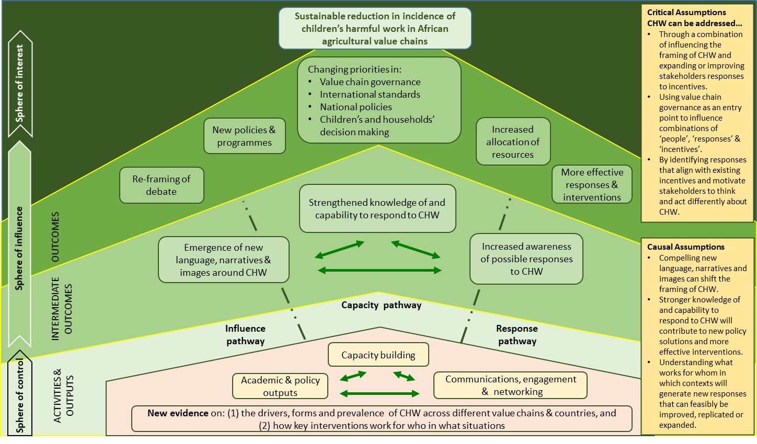
The programme’s Theory of Change and results framework were developed as part of the Inception Phase, but not finalised as the programme did not move to Implementation. The draft Theory of Change is shown below.

C: Detailed Output Assessment [aim for max. 1 page per output. Repeat for each output]

Output Number and Title | 1 ACHA Inception Phase successfully completed.
Output Score | A
Impact weighting (%) | 100 | Impact weighting revised since last AR? | No

Indicator(s) | Target | Achievement
- Successful completion of Inception Phase and production of Inception Report | Inception Completed by July 2020 | Met: IDS submitted the Inception Report on time in early July
- Framing and Background papers. | 7 Framing papers  3 Background papers | Exceeded: a total of 13 papers were produced.

Briefly describe the output’s activities and achievements during its lifetime, and provide supporting narrative for the score. [1/2 page]
The Action on Children’s Harmful Work in African Agriculture (ACHA) programme was conceived as a seven-year programme running from January 2020 – January 2027. However, due to the reprioritisation of the UK Government’s international development programmes as a result of COVID-19, the programme did not proceed into the Implementation Phase. The reason for this decision was that the programme was not closely aligned with a shift in the focus of the portfolio towards research on climate resilient food systems.
Whilst the project was closed early, the Inception Phase was completed successfully, with a number of quality papers delivered in addition to other materials, justifying a score of “A: Output met expectations”, delivering against the workplan for Inception agreed by IDS and FCDO. As previously reported, the agreed contract start date was the 6th January 2020, kicking off a 6-month inception phase, which completed on 5th July 2020.
During the Inception Phase, much of the programmatic activity was evidence gathering and synthesis including
- Seven framing papers (covering the programme, harm, methods, education, politics and policy, disabilities, and value chains)
- Three background papers (covering the cocoa, fisheries and shallot cases)
- Three other papers (a Rapid Review paper covering living income, living wage and ‘child labour-free zones’; a paper reflecting on ethical dilemmas; and a paper that explores the potential for further analysis of existing data sets).
The Team also held a virtual Inception Workshop and bi-weekly webinar series, published a number of blogs and put in place the various systems and processes needed for ongoing management of the programme, including risk register and safeguarding policy and training.
A full list of papers produced by the ACHA Team during the Inception Phase is provided at Annex 1 and were intended to provide the foundation for the programme, define key concepts and developing research methods for the programme. Annex 1 also includes the status of the papers at the time of this review, including weblinks where they are available online. All papers are open access and DOI links are provided.
The paper ‘Understanding children’s harmful work: a review of the methodological landscape’ reviewed a variety of previous studies on child labour and children’s work with a special focus on the methods used. It proposed a methodological landscape for the programme (Figure 1). While it will not be taken forward under ACHA, this analysis will be available for future research on harmful children’s work.
Figure 1: Proposed methodological landscape for ACHA.
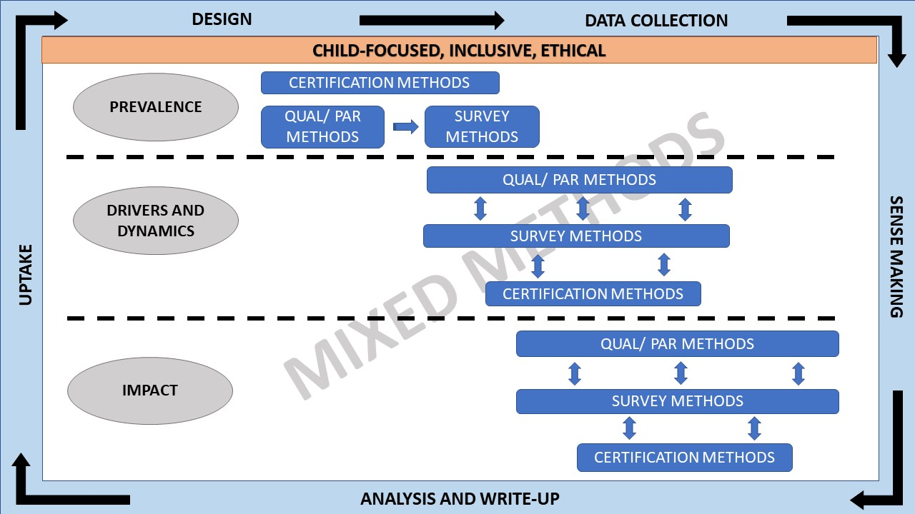
The paper entitled ‘Policies and Politics Around Children’s Work in Ghana’ reviewed the policy context in Ghana, the first country where research would have been conducted under the ACHA programme. A key argument in the paper is that much of Ghana’s legislation relating to children and children’s work draws heavily from international conventions and texts. As a result, little if any account is taken of local conceptions and norms around childhood and associated institutions or traditions (like fostering, and the belief that children must learn to work). This results in a disjuncture that makes much of the existing law and regulation impossible to implement, if not actually harmful.

D: Risk [½ - 2 pages]
Overview of programme risk during the past year and over the life of the programme, drawing on FCDO’s Risk Management Policy and Risk Appetite Statement and wider risk guidance. [1/2 page]
The overall Risk is Minor. The Business Case gave a Moderate risk to the programme given that the programme would conduct research with vulnerable groups and address the sensitive issue of harmful children’s work. However, the majority of the Inception Phase was desk-based work result in actual risk for the past year being Minor.
Following the decision to not continue the programme past Inception, the programme team worked closely with IDS to manage any issues arising from the early closure. As the full programme had not started there were no major risks.

E: Programme Management: Commercial and Financial Performance, Monitoring and Evaluation [1 - 1 ½ pages]
Summarise the performance of partners and FCDO, notably on commercial and financial issues, and including VfM measures of economy and efficiency. [1 page]
The Overall assessment is that this programme delivered good value for money. IDS performed well, delivering quality outputs on time and engaging constructively with FCDO staff in the UK and Ghana. The contract was awarded to IDS under competitive tender using the International Multi-Disciplinary Programme Framework Agreement Framework. Value for Money was a key criterion used in the selection process and cost savings were identified during Inception.
The Inception phase began in January 2020 and was completed on time by the agreed date of 6th July 2020. Milestones payments were on the basis of satisfactory submission of an Interim and final Inception report and both were completed satisfactorily.
From the outset the ACHA team were proactive arranging dialogue with FCDO on key management issues. IDS produced a detailed workplan that set out delivery mechanisms, milestones, and indicative outputs for the next phase in both the Interim and final Inception Report to ensure Efficiency and Effectiveness. Discussions were held with the ACHA Project Management Team outlining the quality of financial management expected, i.e. accuracy of forecasting, monitoring and invoicing processes.
The total Value of the Contract was £8,332,757 (excluding VAT) covering both Inception and Implementation. The Total Cost of the Inception phase was originally £435,566 and reduced slightly because of the cancellation of the launch event. The final total was £406,412.72.
The Inception Budget is as outlined in the table below :
Description | Budget | Expenditure | Commitments | Total | Difference
Fees | 297,332.73 | 246,556.42 | 46,709.45 | 293,265.87 | 4,066.86
Other | 21,840.90 | 14,749.65 | 6,156.04 | 20,905.69 | 935.21
NPAC* | 61,861.59 | 55,777.44 | 8,860.66 | 64,638.10 | -2,776.51
Total | 381,035.22 | 317,083.51 | 61,726.15 | 378,809.66 | 2,225.56
Savings |  |  |  |  | 2,225.56
*NPAC – Non Project Attributable Costs and are the overhead costs that relate to the overall operations, management and identity of the delivery partner rather than to programme services.

IDS reported a modest saving of £2,225.56 for the inception phase of ACHA and the final Milestone payment was reduced accordingly. The bulk of the costs were Salary, and the competitive rates were secured under the agreed IMDP Framework rates. COVID19 related issues meant that the proposed launch meeting scheduled for March 2020 was cancelled. Although these were Milestone payments IDS ensured they adhered to the Value for Money principles and the final saving was off set against the costs required for winding up the Contract
VfM measures of economy and efficiency
Despite the early closure, the programme has delivered value for money through the range of valuable research outputs produced during the Inception Period, including reviews of research methods and the policy landscape in Ghana (Annex 1). Although the research will not be taken forward through this programme, it has contributed to the wider research agenda in this area and has the potential to influence debates around harmful children’s work, particularly in Ghana where the work was focussed.
FCDO agreed to meet the IDS costs for closing down the programme from the end of the Inception report to 31st August 2020 as the reprioritisation of the UK Government’s international development programmes was on-going at the end of the Inception Phase. This totalled £27,603 and covered in the main the salary costs of the Programme Management team in finalising activities, including publication of papers to ensure Value for Money.
Programme-level approach to monitoring and evaluation [1/2 page]
A formal monitoring and evaluation framework was drafted as part of the Inception Phase, but this was not finalised. During the Inception Phase the FCDO Programme Team held regular calls with the ACHA team after the formal kick-off meeting on 13th January 2020. Technical input was also garnered from key teams within FCDO.
Date of last narrative financial report | July 2020 | Date of last audited annual statement | 31st March 2020.

Annex 1: Full list of ACHA publications (January – October 2020)
Paper | Date | Type | Status and weblink
Understanding Children’s Harmful Work in African Agriculture: Points of Departure | April 2020 | Working Paper | Published
Children’s work in African agriculture: Time for a rethink | June 2020 | Journal Article | Published in Outlook on Agriculture
Breaking out of the policy enclave approach to child labour in Sub-Saharan African agriculture | Oct 2020 | Journal article | Revise and Resubmit for Global Social Policy
Forms, Prevalence and Drivers of Children’s Work and Children’s Harmful Work in Shallot Production on the Keta Peninsula, South-eastern Ghana | October 2020 | Working Paper | Submitted for publishing on IDS website
Understanding children’s harmful work: a review of the methodological landscape | October 2020 | Working Paper | Submitted for publishing on IDS website
Children’s harmful work in Ghana’s Lake Volta Fisheries: research needed to move beyond discourses of child trafficking | October 2020 | Working Paper | Submitted for publishing on IDS website
Theorising ‘Harm’ in Relation to Children’s Work | October 2020 | Working Paper | Submitted for publishing on IDS website
Value Chain Governance: Entrance points for interventions to address children's harmful work in agriculture |  | Working paper | Submitted for publishing on IDS website, due to be online November 2020
Policies and Politics Around Children’s Work in Ghana |  | Working paper | Revisions from peer review being made, due to be submitted for publishing November 2020
Education and Children’s Work |  | Working paper | Revisions from peer review being made, due to be submitted for publishing November 2020
Disabled children and work: an overview of a neglected topic |  | Working paper | Revisions from peer review being made, due to be submitted for publishing November 2020
Children’s work in West African cocoa production: Drivers, contestations and critical reflections |  | Working paper | Revisions from peer review being made, due to be submitted for publishing November 2020
Living Wage, Living Income, and Child Labour-Free Zones: Arguments and Implications for Children’s Work | May 2020 | Rapid Review | Published
Ethics guidance document | June 2020 | Programme Document | Submitted with Inception Report
ACHA safeguarding document | June 2020 | Programme Document | Submitted with Inception Report
Tackling harmful types of children’s work: why social assistance is not currently fit for purpose |  | Journal Article | Draft: writing ongoing
Kneejerk reactions to ending child labour don’t benefit children | April 2020 | Blog | Published
Child labour in cocoa from a European ‘doughnut’ perspective | April 2020 | Blog | Published
Could increasing incomes help reduce harmful children’s work? | June 2020 | Blog | Published
Is all work harmful to children? | June 2020 | Blog | Published
Child workers need rights, not policing, to weather the pandemic | June 2020 | Blog | Published
Child work bans and adult’s high incomes: in children’s best interest? | June 2020 | Blog | Published
Mid Inception Report | April 2020 | Report | Submitted to FCDO
Inception Report | July 2020 | Report | Submitted to FCDO

Child labour is defined by the International Labour Organisation as ‘work that deprives children of their childhood, potential and dignity, and that is harmful to physical and mental development’. This programme intends to focus specifically on the forms of harmful work that children do in African agriculture (arable, pastoralist, and fishing), and how that harm can be prevented. ILO (2017) Ending Child Labour by 2025: A review of programmes and policies. Geneva; ILO
A ‘child’ is defined as someone under 18 years of age. ILO (2017) Global Estimates on Child Labour and Modern Slavery. Geneva: ILO
ILO (2017) Global Estimates of Modern Slavery and Child Labour: Regional Brief for Africa. Geneva: ILO.
On 2nd September 2020, the Department for International Develpoment (DFID) merged with the Foreign and Commonwealth Office (FCO) creating the Foreign, Commonwealth and Development Office (FCDO)
‘Agriculture’ includes high value and staple crops, pastoralist and livestock, and fishing sectors, and across the value chain including production, processing, and distribution.

