Umoja House, P.O BOX 9200, Dar-es-salaam, Tanzania | www.gov.uk/dfid | +255 22 2110141
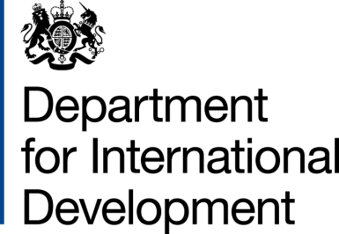 | 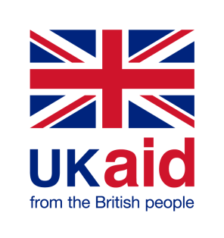
EMERGENCY HUMANITARIAN RELIEF PROJECTS
MEMORANDUM OF UNDERSTANDING
Between
The Government of the United Kingdom of Great Britain and Northern Ireland acting through the Department for International Development (“DFID”)
and
The Office of the United Nations High Commissioner for Refugees (the “Partner” or UNHCR)
Sustaining lives and securing a sustainable future for refugees and migrants in Western Tanzania Programme

ARIES Code 204805-101
Amendment No. 03-2018

- I refer to the Memorandum of Understanding (MoU) for the above project signed by DFID and United Nations High Commission for Refugees (UNHCR) on 27 October 2017 including its subsequent amendments no. 1 of 2017 and no. 2 of 2018. Following recent “discussions/correspondence”, DFID proposes to change the end date of the Memorandum and to “increase” the amount made available to UNHCR by £5,000,000 (Five million pounds sterling)
  - I propose that the end date of “31/12/2018” in paragraph 2 of the original MOU be deleted and replaced with “31/12/2019”.
  - that the contribution figures and words “£8,700,000 (Eight million seven hundred thousand pounds sterling)” in paragraph 1 of the original MoU be replaced by the figures and words “£13,700,000 (Thirteen million seven hundred thousand pounds sterling)”.
  - to add to the disbursement schedule in paragraph 5 of the original MoU, a disbursement of this cost increase of £5,000,000 to be made in April 2019 after the signing of this amendment letter.

- This letter of amendment will place on record our common understanding of the above change and will come into operation on the date you sign your confirmation below. This note will be known as Amendment No. 3 of 2018
- Please sign both copies of this letter; return one to me and retain the other for your own records.

Signed for DFID: | Confirmed by UNHCR
Name: | Name:
Position: DFIDT Deputy Head of Office | Position: Representative
Date: | Date:

