Annual Review - Summary Sheet

Title: ACCELERATING THE RISE IN CONTRACEPTIVE PREVALENCE IN UGANDA (ARC) PROGRAMME

Programme Value: £31.8m |  | Review Date: October 2015
Programme Code: 202420 | Start Date: Oct 2011 | End Date: September 2016

Summary of Programme Performance
Year | 2012 | 2013 | 2014 | 2015 | 2016
Programme Score | A | A | A | B
Risk Rating | Low | Low | Medium | Medium

Summary of progress and lessons learnt since last review
In March 2015, following a suspension of the project in August 2014, a decision was taken to resume funding to the programme over an 18 months period (April 2015 to September 2016). This followed an extensive re-structuring of the programme including cancellation of the agreement with Marie Stopes Uganda (MSU) and putting in place an agreement with Marie Stopes International Uganda (MSIU). Since then MSIU has worked to: fundamentally alter the management structure; introduce improved voucher management systems; and introduce improved stock management systems. Activities in the first quarter of implementation mainly constituted recruitment of personnel in addition to intensive induction and training of all staff on key aspects of programme delivery including; fraud and compliance; coercion and informed choice; and quality of service delivery. Several policies and guidelines such as on compliance were developed and put in place.

In mid-May 2015 following the induction and training of new outreach teams, the project began delivering outreach services, six weeks after start-up. The outreach teams served 12,533 clients with high quality, voluntary modern contraceptive services among whom 69% (8,592) were provided with long-acting or permanent methods attributable to DFID. Using past quality and performance data, agreements were signed with 220 Blue Star providers reconfirming their commitment to comply with the requirements of the network, including clinical standards, informed choice and voluntarism. To complement service delivery and increase awareness, the project developed a demand generation strategy, recruited and trained 1,209 Village Health Team (VHT) members/Community Based Distributor’s (CBDs) and contracted 45 radio stations in all regions of the country to provide mass media services. Through support to FHI 360, the Communication for Health Communities (CHC) project reached 3,000 Adolescent Girls and Young Women (AGYW) in Kamuli and Iganga districts through one on one and small group sessions.

The signing of a new Joint Management Framework has improved DFIDs oversight over the programme. Nonetheless, contractual obligations between USAID and its partners limit, to an extent DFID’s direct engagement with the partners.

A review of the achievements against the milestones shows that the programme moderately did not meet expectations. This was mainly due to the fact that more time than had been anticipated was required to put in place the systems needed to deliver results under the new bridging programme with MSIU; and negative misconceptions in the community created by the suspension of the previous programme had an impact on uptake of services. It is expected that with intensified demand generation activities in the community and the required systems in place, the programme will deliver anticipated results although a no cost time extension may be required to achieve this.

Summary of recommendations for the next year
MSIU:
- Due consideration must be given on how to further strengthen the information systems (CLIC and Maritex) to mitigate over reporting and fraudulent reimbursements on the voucher system.
- Put in place a system to better track the outcome of the CHC activities including at public health facilities.
- Improve Stock Management System to further strengthen management of contraceptives supplied to the Blue Star clinics and the outreach teams.
- DFID and USAID to continue open and regular dialogue with MoH and other partners to ensure ongoing coordination of the project. Maintain quarterly monitoring and evaluation meetings following production of quarterly reports (with actions from those meetings listed and tracked) and follow up recommendations from this annual review at quarterly meetings

A. Introduction and Context (1 page)

DevTracker Link to Business Case: | http://iati.dfid.gov.uk/iati_documents/3719238.odt
DevTracker Link to Log frame: | http://iati.dfid.gov.uk/iati_documents/5191622.xls

Uganda’s fertility and population growth rates are among the highest in the world. 41% of women have an unmet need for family planning (nearly 40% of the unmet need for family planning is for long term and permanent methods of family planning); only 31.9% of women are using modern contraception. Over half of all pregnancies are unintended, and these account for the deaths of about 3,800 women every year. The burden of unwanted pregnancy and its consequences disproportionately falls on poor women and adolescents. High fertility is undermining the potential for per capita income growth, and creating additional costs for public service provision. Half of contraceptive users in Uganda get their contraceptive supplies from the non-state sector; condoms and pills from shops and pharmacies, and injections and intra-uterine devices (IUDs) from NGOs/ for-profit providers. A large percentage of sterilisations and implants are administered in public health facilities. Therefore, partnerships between the state and non-state actors are important for increasing uptake of family planning (FP) services in Uganda. The Government of Uganda recognises the importance of family planning and the need to collaborate with non-state actors to provide family planning services. It has established an alternative mechanism / distribution channel through the Uganda Health Marketing Group (UHMG) to make available family planning commodities to the private sector and non-governmental organisations (NGOs).

DFID has committed to provide £31,841,723 for implementation of the Accelerating the Rise in Contraceptive Prevalence programme (ARC) between 2011 and 2016. The ARC programme aims to increase the availability and use of cost-effective modern family planning services through partnership between state and non-state actors. This programme will make possible a major uplift in the provision of family planning services. The programme focuses on improving the range of available choices, particularly so that more women that would like to can access long-term and permanent contraceptive methods; and ensures that the poorest groups benefit most from the programme.

Funded jointly by USAID and DFID (DFID as majority funder), the programme is providing funding to increase coverage of high quality family planning services including long term and permanent methods through proven private sector service delivery channels such as outreach and social franchising with vouchers. Between 2011 and 2014, the programme was implemented by Marie Stopes Uganda. However following allegations of fraud and an extensive investigation by the US Office of the Inspector General, the contract with Marie Stopes Uganda was cancelled in 2014. DFID worked closely with USAID to put in place measures to mitigate future risks of fraud which resulted in the resumption of funding in April 2015 through a new implementing partner Marie Stopes International Uganda (MSIU) over an 18 month bridging activity.

ARC aims to prevent an estimated 650,000 unwanted pregnancies between 2011 and 2016 in Uganda. DFID support will enable at least 300,000 additional women to voluntarily use modern family planning methods of their choice. DFID-attributable planned outputs as stated at the start of the programme were:
i. Better information about family planning choices.
ii. Fewer barriers to accessing family planning services.
iii. A better supply of quality family planning services.
iv. More choice of family planning methods. DFID-funded services to provide over:

B: PERFORMANCE AND CONCLUSIONS

Annual outcome assessment
The three main outcomes of the programme are: i) Contraceptive prevalence rate (to which the programme contributes) ii) Couple Years of Protection delivered through ARC (attributable to DFID) iii) Cost per Couple Years of Protection per delivery channel (attributable to DFID). During the period under review (October 2014 to September 2015) the following progress has been made at the outcome level.

Outcome indicator 1 | Baseline  (October 2011) | Milestone (Sept 2015) | Achieved  (Sept 2015)
Contraceptive prevalence rate (modern methods: women of reproductive age) | 25.6% | 35.6% | 31.8%
Couple Years of Protection delivered through ARC (attributable to DFID) | 0 | 174,195 | 79,486
Cost per CYP per delivery channel (attributable to DFID) | Outreach | £5 | £8.57
Cost per CYP per delivery channel (attributable to DFID) | Social franchise | £7 | £24.91

There has been notable improvement in the contraceptive prevalence rate (CPR) in Uganda since the inception of the programme. Estimates at the inception of the programme where that DFID contributes 41% of the financing for family planning in Uganda and thus 41% of the results including CPR could be attributed to DFID. Given that the first three months of the 18 month bridging programme largely focused on recruitment, procurement, and putting in place systems to deliver the programme effectively, there was less than optimal achievement on two outcome milestones. In addition significant startup costs had an impact on the cost per CYP particularly for the Blue Star social franchise clinics. However, it is anticipated that over the next 12 months, there will be significant improvements including a reduction in the cost per CYP.

Overall output score and description B
Based on progress over the review period, the programme moderately did not meet expectation. This was mainly due to the fact that more time than had been anticipated was required to put in place the systems needed to deliver results for modern contraceptive services under the new agreement with MSIU; and negative misconceptions in the community created by the suspension of the previous programme had an impact on uptake of services.

However, significant progress has been made by MSIU to put together a new team, alter the management culture to remove any incentive that outreach teams may have to falsify results, and strengthen compliance. Initial hurdles in procurement have been overcome. In addition MSIU has put in place an accelerated implementation plan that outlines key strategies to support attainment of results including an intense demand generation and awareness campaign; unlocking bottlenecks in supply chain management; and strengthening cohesion between the Community Based Distributors and Blue Star providers to improve voucher redemption rates. It is expected that with intensified demand generation activities in the community and the required systems in place, the programme will deliver anticipated results. While it is not expected that additional funding will be required to deliver the anticipated results, a three months no cost extension of the programme may be essential given initial delays in delivering at pace.

Key lessons
- The assumption made during the proposal writing was that the 18 month bridging activity would be a seamless continuation of the suspended ARC program. However the time required for the overhaul of the old management and staff structure and the unanticipated negative misconceptions in the community about the programme have meant that additional time was required before the programme could begin to deliver at the expected pace.
- Given that the DFID/USAID support was the largest funding for FP services in Uganda, the suspension of the programme would have benefitted from a better managed communication strategy to GoU on the suspension. Any major changes to a health service delivery programme must be communicated effectively to all stakeholders including at the national and sub-national level and to the extent possible, to the beneficiaries.
- Radio talk shows and community dialogues are a good medium to engage men in FP matters as observed by the MSIU Interpersonal Communication (IPC) Campaign.

Key actions
- The CYP targets reflected in the Logframe should continue to be viewed as benchmarks and not targets.
- MSIU should review modalities to increase community mobilization and demand generation.
- The Maritex system should be strengthened to track voucher movement using specific phone numbers attached to specific IPC coordinators, CBDs and Providers.
- Further strengthen the stock management system.
- The Client Information Centre (CLIC) data isn’t always being input in real time and this exposes the programme to over reporting. There is a need to further strengthen the CLIC data input process.

Has the logframe been updated since the last review?
Yes, the logframe has been revised:
- Period under review for 2015 is only 6 months given the suspension last year. The milestones therefore reflect a 6 months implementation period.
- Outputs have been streamlined down from 4 to 3 to take into consideration the closure of the UHMG component of the project.
- The log frame has been revised to reflect the no cost extension from 2015 to September 2016.

C: DETAILED OUTPUT SCORING

Output 1 Title | Women and men have better information to make healthy reproductive choices
Output number per LF |  | 1 | Output Score | A+
Risk: |  | Low | Impact weighting (%): | 20%
Risk revised since last AR? |  | N | Impact weighting % revised since last AR? | N

Indicator(s) | Milestones | Progress
Output Indicator 1.1:  Number of people reached with FP messages through DFID supported IPC and community mobilisation activities of MSIU disaggregated by age | All age groups: 25,706 | 25,911
 | 12,081 (15-24 yrs) | 8,926
 | 13,625 (25 yrs and above) | 16,985
Output Indicator 1.2:  Number of IPC touch points through CHC disaggregated by age (attributable to DFID) | All age groups: 2,840 | 5,000
 | 1,704 (15-19 yrs) | 3,000
 | 1,136 (20-25 yrs) | 2,000
Output Indicator 1.3:  Number of Family Planning radio mentions on local radio through CHC in the 5 districts  (attributable to DFID) | 1,350 | 1,350
Key Points

MSIU: A demand generation strategy was developed to guide implementation of IPC activities using a combination of interpersonal communication (IPC) and mass media channels. The strategy is meant to address myths and misconceptions, as well as social and gender barriers that limit voluntary FP uptake. At least 10 IPC Coordinators and 2,203 VHTs attached to outreach teams and 504 CBDs attached to the Blue Star clinics received training in demand generation including for the voucher programme. In addition the project identified and trained six drama groups to conduct community theatres in the Karamoja region and utilised 346 satisfied users as champions of family planning.

The CHC communication campaign targeted out of school adolescents and young women 15-24 years in the selected districts with high teenage pregnancy rates- Luuka, Mayuge, Namutamba, Iganga and Kamuli. Working with District Health Teams (DHTs) and other implementing partners, 250 champions reached 3,000 AGYW in Kamuli and Iganga with messaging on FP through one-on-one and small group dialogue sessions. In addition, 546 AGYW received information on Adolescent Sexual Health and Reproductive (ASHR) services through creative edutainment sessions. The main challenge faced by CHC is a lack of harmonisation between their demand generation activities and clinicians to provide FP during community events. In addition, some public health facilities do not provide youth friendly services, a situation that impact negatively on health seeking behaviour by the AGYW.

Key lessons
- Traditional female sex educators (Sengas) are a key and credible source of information for AGYW.
- The peer to peer approach has a strong impact on mobilising young people.
- MSIU introduction of the district VHT peer coordinator has contributed to motivating and building the capacity for VHTs.
Summary of responses to issues raised in previous annual reviews (where relevant)

- The indicator on disaggregation of data needs to be further developed to understand better who is being reached. Consider disaggregation by gender and by income quintile. Disaggregation of data by gender is being done.
- Consider ways of collecting beneficiary feedback to assess understanding of information provided. This could either be done by the partners or independently as part of the project evaluation. Not yet implemented.
- DFID and USAID to meet quarterly to discuss the programme. Following the signing of the Joint Management Framework in the July 2015, DFID and USAID have been meeting at least one a month to discuss implementation of the programme.

Recommendations

- CHC to synchronise their community events with availability of FP service providers including MSIU to increase uptake of FP services during community events.
- The programme could further strengthen male engagement in uptake of FP services through exploring opportunities to scale up interventions such as the MSIU radio community dialogues and other community initiatives.
- Given the role of young people in driving Uganda’s high fertility rate, it will be important to have a strong focus on reaching young people with the right information and through channels that promote uptake of services.

Output 2 Title | Women and men face fewer barriers to accessing Family Planning services
Output number per LF |  | 2 | Output Score | C
Risk: |  | Medium | Impact weighting (%): | 40%
Risk revised since last AR? |  | N | Impact weighting % revised since last AR? | N

Indicator(s) | Milestones | Progress
Output Indicator 2.1: Number of LAPM vouchers redeemed through accredited service delivery points ( attributable to DFID) | 13,531 | 3,312
Output Indicator 2.2: Number of LAPM services provided by outreach at public health sector facilities (attributable to DFID) | 27,930 | 14,932
Output Indicator 2.3:Percentage of HCWs that score above 85% on the QTA score after the training and mentoring process | 70% | Not done yet
Key Points
A total of 36,452 vouchers were channelled through IPC coordinators and 72% of them sold by Community Based Distributors (CBDs). Of the vouchers sold, 3,312 vouchers were redeemed at Blue Star Clinics, a 24.5% redemption rate compared to 22% (end of July 2012) and 63% (July-August 2013). It is interesting to note the current redemption rates are similar to those experienced at the start of the previous programme suggesting similar challenges to redemption rates.

Twenty seven outreach teams were operational and providing services primarily at HC II and HC III public facilities where there is limited access to public sector providers trained in Long Term and Permanent Methods (LTPM) service delivery. MSIU employs a cluster model of management for quality improvement to create a culture of peer support and mutual accountability. Currently, at 61% the biggest demand at outreaches is for the implants. Several systems have been put in place to mitigate against fraud including; the use of an automated data collection system (CLIC); use of dash boards at the centre to monitor each team’s performance on indicators on quality and efficiency and; the separation of the demand generation team from the outreach team. Whilst recruitment of 65 Dedicated Providers (DPs) was undertaken during the first quarter start up kits were only given in September 2015.

Challenges
- Whilst the separation of the demand creation team from the service delivery team has serviced to reduce incentives for collusion it has negatively impacted on numbers of clients seeking FP services.
- Some outreach teams first serve the client and later input data into the CLIC system, a practice that undermines the whole essence of the system design as a means to mitigate mis-reporting.
- Resistance from a small number of districts of operation and health centers was experienced by MSIU during project inception. This appears to be due to the change in policy on provision of allowances for public health workers at outreach sites resulting in some districts discontinuing provision of services by MSIU at public facilities.
- Difficulties in recruiting and retaining medical officers to lead the outreach teams. In addition, high turnover in the private sector mean that retention of trained staff at the blue star facilities remains a challenge.
- Data on reasons for removal/discontinuation of contraceptives is currently not captured in the CLIC.
The project has developed an Accelerated Implementation Plan (AIP) for addressing the multiple challenges that have been identified during the first six months of implementation.

Summary of responses to issues raised in previous annual reviews (where relevant)

- MSU to consider additional ways of improving financial sustainability of the Blue Star Clinics: Several initiatives including transitioning of the demand creation function to the clinics are being implementing as part of a broader transition plan.

Recommendations

- Regular discussions possibly bi-monthly updates on the progress made against implementation of the AIP will be important to ensure attainment of desired results including on increasing the voucher redemption rates.
- To enable achievement of the overall anticipated results, the option for a no cost extension for the MSIU component of the project should be considered.
- Due consideration must be given on how to further strengthen the information systems (CLIC and Maritex) to mitigate over reporting and fraudulent reimbursements on the voucher system.
- Improve the Stock Management System to further strengthen management of contraceptives supplied to the Blue Star Clinics.

Output 3 Title | A better choice of family planning methods is available and being used
Output number per LF |  | 3 | Output Score | C
Risk: |  | Medium | Impact weighting (%): | 40%
Risk revised since last AR? |  | N | Impact weighting % revised since last AR? | N

Indicator(s) | Milestones | Progress
Output Indicator 3.1: Number of implants and IUDS provided by MSIU programmes (attributable to DFID) | 9,132 (IUDs) | 1,689
 | 25,542 (Implants) | 15,237
Output Indicator 3.2: Number of tubal ligations/vasectomies performed by MSIU programmes (attributable to DFID) | 155 (Vasectomies) | 84
 | 6,632(Tubal ligations) | 1,235
Key Points
The uptake of long term and permanent methods (LTPM) was below the anticipated results. This was mainly because of delays in putting in place the systems and mechanisms required to deliver results, including hiring the outreach teams. Over 60% of the staff in the outreach team had to be hired afresh following the cancellation of the contract with MSU. In addition negative misconceptions in the community created by the suspension of the previous programme had an impact on uptake of services particularly the LTPM.

The majority of clients at outreaches and Blue Star clinics choose implants (61%) followed by IUDs (22%) and tubal ligation (16%). All the Implants and IUDs are requisitioned from the UHMG warehouse. It was noted that there was a high implant removal and discontinuation rate. There were a total of 10,043 implant removals with only 44% of clients that removed implants switching to another FP method resulting in a discontinuation rate of 56%. During discussions with beneficiaries, it emerged that many women are having implants removed because of uncertainties created by the abrupt suspension of project activities. Similarly, the IUD removals and discontinuation are higher than would be expected. However MSIU has embarked on implementation of a communication strategy to allay these fears but more importantly work with public health workers through the dedicated provider model to build capacity at public facilities for service provision. This is expected to decrease reliance by beneficiaries on outreach camps by NGOs for service provision.

Since the start of the programme in 2011, UHMG had received a total of 285,823 pieces of Jadelle, 230,403 pieces of Implanon and 164, 874 IUDs including 88,000 pieces of Jadelle received in March 2015. At the time of the review, UHMG had distributed 220,223 pieces of Jadelle, 145,797 IUDs and all the implanon. All procurements of implants and IUDs were carried out by the International Procurement Agency (IPA) and delivered to UHMG for warehousing and distribution. Joint Medical Stores (JMS) was contracted for the procurement and supply of medical supplies and equipment including for infection control, pain relief and local anaesthesia. The programme spent approximately $68,686 on medical supplies at JMS during the period under review. The main concern at the moment is that the contract between USAID and JMS has come to an end and the possibility of a future contract is still under review. Unless an immediate solution is sought, this may affect timely procurement of medicines and supplies for the programme.

Summary of responses to issues raised in previous annual reviews (where relevant)

- Consider independent quality checks of clinics or review quality tools used as part of the evaluation. Ongoing- MSIU carries out weekly outlier analysis of data received in the central server of Maritex and conducts; independent tracing of an average of 12 Blue Star facilities every two months by physically visiting clients per facility per month is being implemented.
- Continue to look for ways to improve measurement of willingness to pay data and information on socioeconomic profile of clients. Not yet implemented due to disconnect after suspension.
- Consider sustainability of the dedicated provider model of training. Discuss other methods of mentoring and capacity building with USAID and partners. Ongoing- 65 DP completed training and posted in September 2015.
- Consider ways of working with men to increase uptake of permanent methods of contraception. Radio community dialogues and play games have been conducted to engage men at work place in trading centre’s and markets

Recommendations
- An assessment of the reasons for increase in implant removal should be carried out
- The CLIC system should be customised to capture reasons for removal/discontinuation of FP
- The JMS contract for supply of essential equipment and supplies is subject to USAID regulation and has come to an end. There is need to explore options for continued supply of the essential equipment and supplies.
- MSIU to continue to work with communities through VHTs to tackle myths and misconceptions affecting uptake of services but more importantly through the DP model, build local capacity at public facilities for service provision.

D: VALUE FOR MONEY & FINANCIAL PERFORMANCE

Key cost drivers and performance
- Overall performance
A total of $20,000,000 (approx. $11,000,000-DFID and $9,000,000-USAID) was awarded to MSIU for implementation of the programme through the Outreach, Blue Star and Dedicated Provider channels over an 18 months bridge period. During the period covered by this review, a total of $8,143,800 was obligated to MSIU with DFID contributing $5,143,800 towards project implementation. Of the DFID allocated funds, $2,796,427 was expended ($1,435,605 in the 1st Quarter and $1,360,822 in the 2nd quarter) representing a 54% burn rate. It is expected that by December 2015, all DFID funds would have been spent. It is important to note that the costs for procurement of contraceptives are not included in the MSIU budget as DFID procured commodities directly through International Procurement Agency (IPA). FHI 360 received $1,700,000 and expended $57,264 during the review period representing a 4% burn rate.

- Cost drivers
MSIU: Based on the SUN 6.1 financial software being used by MSIU, Labour (salaries) and travel are the largest cost centres representing 43% and 13% respectively of the total funds expended. When classified by channels, outreach services and support functions represent 31% and 30% respectively of total funds expended. MSIU has expended $2.8 million out of the obligated $5.1 million representing a 54 percent burn rate.

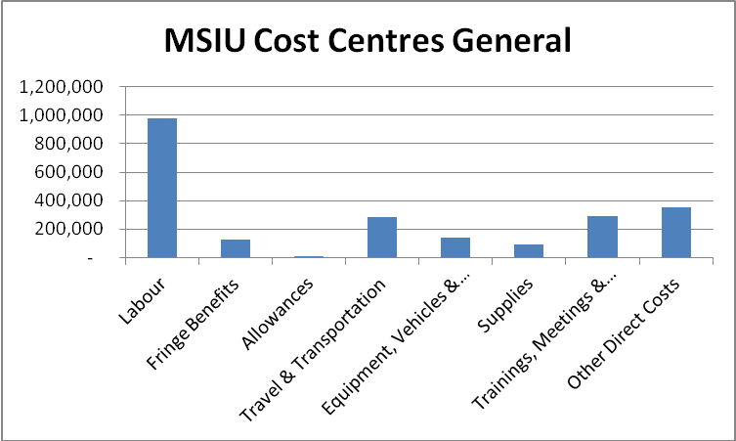
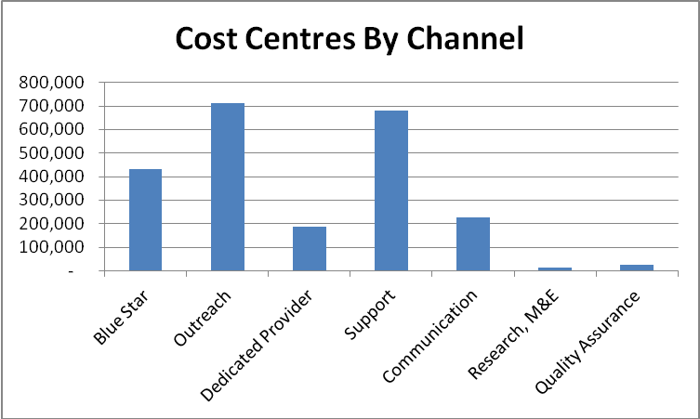

CHC: The cost centres are categorised into personnel and consultants, fringe benefits, equipment, other direct costs and indirect costs. The largest cost centres are personnel and consultants taking up 32% of the total expenditure during the review period. The total expenditure against funds released was 4% mainly due to the lead time required for the start-up of communication programming, usually 3-6 months to plan and design a good intervention. The main cost drivers include costs for mass media (Radio and TV), experiential activations and outdoor placements (billboards, road stars). This was attributed to ongoing political campaigns that increased outdoor advertising costs due to the heightened demand for billboards and road stars.

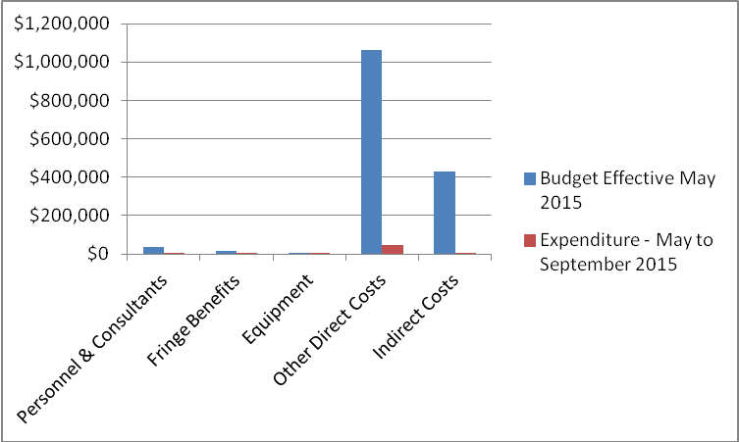

VfM performance compared to the original VfM proposition in the business case

Economy: IPA procured and delivered 41,000 pieces of Jadelle (November, 2014) and 88,000 pieces of Jadelle (March 10th, 2015) to UHMG at an internationally negotiated rate of 50% price reduction compared to costs at the beginning of the programme. Following discussions in the national FP commodities security technical working group, there were no IUDs or implanon procured during the review period. This has improved and harmonized the procurement of FP commodities amongst different stake holders representing value for money from reduced duplication that increases expiries and additional costs in warehousing.

Efficiency: The key efficiency measures are costs of delivering services through the different channels. The Cost per CYP and Cost per DALY are very high because of the initial investment in the start-up activities that do not directly translate into outputs e.g. procurement of vehicles, development of compliance materials, staff hiring costs etc. However, with the infrastructure in place to deliver services, it is hoped that the Cost per DALY and Cost per CYP will go down. The long term benefit of the programme will be an increased number of women and men reached with the same resource envelope due to decreased cost per CYP and Cost per DALY.

Effectiveness: This concerns whether the interventions chosen are the right ones to maximise the impact on the desired outcome. Based on the business case, effectiveness of this project is measured by the rise in CPR and total cost saving. Overall the national Contraceptive Prevalence Rate for married women (mCPR) has increased by 5 percentage points over a 4 year period representing a 1 percentage point increase per year. Given that DFID is one of the biggest funders of family planning in Uganda (estimates at the start of the programme - 41% of total funding in Uganda), it can be derived that DFID has contributed substantially to this rise in CPR. Over the past 6 months, the programme has been able to make a total cost saving in terms of lives saved of £4,615,375 (total cost saving for Uganda according to the MSI impact calculator is £58.09 per CYP). Of this total saving, £2,538,456 is attributed to DFID.

Measure | Indicator | Standard based on the Business case | VFM
Economy | Contraceptive input costs | $18 per unit | Jadelle: $ 8.7 per unit
Efficiency | Cost per CYP | £11 | £18.8
Efficiency | Outreach | £ 5 | £8.57
Efficiency | Social franchise | £ 8 | £ 24.91
Efficiency | Cost per DALY | £45 | £76.3
Effectiveness | Total Cost Saving (Lives saved) |  | £4,615,375
Effectiveness | Contraceptive prevalence rate | mCPR: 26% (UDHS 2011)-Married | mCPR: 31.8% (PMA2015-R2)- Married

Assessment of whether the programme continues to represent value for money
At the start of the programme, it was projected that 2,139 maternal deaths and 1,242,872 unintended pregnancies would be averted. During the period under review, the programme delivered 79,456 CYPs translating into 45,403 unintended pregnancies prevented and 170 maternal deaths averted. An assessment of the VFM shows that the cost per CYP is higher than the benchmark in the business case but this is to be expected at this point in the cycle given the costs of start-up. Though it is expected that this cost per CYP will come down significantly, it is unlikely to reach the original benchmark in the business case. This is because of the cost of additional systems that have been put in place under the new programme with MSIU to strengthen compliance, monitor performance and increase demand.

Despite the slightly higher expected cost per CYP in the programme, we judge that the programme continues to deliver value for money. The decision to continue to provide support through a new arrangement with MSIU following the closure of the previous programme means that DFID support is responding to the high unmet need for family planning in Uganda. In addition to the direct benefits it will deliver, this bridging programme also provides an opportunity for learning that will inform implementation of DFIDs future support to family planning which remains a big priority for the UK government. Several of the lessons emerging from the programme are expected to influence not only DFIDs support but the support of other donors and also drive GoU policy such as on the role of dedicated providers in building capacity in public facilities for FP provision. Lastly, it is important to note that DFID is currently one of the largest funders of family planning services in Uganda. Based on this analysis the programme continues to deliver Value for Money.

Quality of financial management
MSIU has robust financial management policies and regulations in place that guide financial management of the programme. The Chief of Party and the Director of Finance, with technical support from MSI’s USAID and financial management team, are responsible for budget monitoring and cost containment. MSI’s Regional Finance Director provides support and oversight of the Director of Finance to ensure timely and accurate financial management and reporting. MSIU implements the MSI’s global Sun Systems 6.1 (Sun 6.1) to monitor and closely track project expenditures, and manage all financial transactions.

Sun 6.1 enables centralized maintenance of the system and allows for systemic control and validation of data. The system can be accessed from anywhere in the world enabling MSI’s global finance team in London to have real-time up-to-date financial data on the programme, providing additional oversight to in-country supervision from the Chief of Party, Director of Finance and Country Director. A SUN financial system training for all finance staff was conducted to ensure proper financial controls and anti-fraud policies and procedures are in place.

Some of the systems/procedures that have been put in place to further strengthen compliance to financial guidelines include: payment of VHTs through mobile money transfers; tracking vehicle fuel consumption using GPS system and linking it to CLIC; having a fulltime internal auditor; having quarterly meetings between field teams and management teams including with the finance department; tracking of vouchers through Maritex system; separation of demand generation teams from the outreach teams; supplier accreditation; use of framework contracts; and ensuring competitive bidding.

Date of last narrative and financial report | 25 November 2015
Date of last audited annual statement | N/A. USAID does not provide audited statements as audits are conducted for the whole USAID portfolio and are not specific to Uganda. Only financial reports are shared. However in the event that the audit picked up an issue relevant to the DFID programme, this would be shared with DFID.
E: RISK

Overall risk rating: Medium

Overview of programme risk
- Fiduciary risk
- In order to reduce fraud related to the voucher system, a Maritex SMS system was introduced for management and tracking of vouchers. The system is functioning well though there still remains the need to tag each SMS message to a specific phone number of a known IPC coordinator, CBD or provider.
- In order to reduce the risk of over reporting and forging results, the CLIC system was introduced for use by all outreach teams. The CLIC system is not being used consistently as it should be. The original idea behind CLIC was that data is input in near real time so that client data is not manufactured by the field teams. However field visits showed that CLIC data input is not in real time and outreach team members gather about 10 fully filled client forms before inputting the data.
- The stock management system for the Blue Star clinics means that some commodities can be supplied at full profit. This is an area that needs close monitoring. The system for stock management is currently being reviewed and will be strengthened.

- Delivery risks
- The design of the programme to last 18 months is not sufficient to efficiently utilise the resources allocated ($20 million) and achieve the desired outcomes/outputs. The risk could be mitigated through a no cost extension of the bridge activity.

- Reputational risks
- The suspension of the programme and the manner in which it was executed negatively impacted on the reputation of the programme including at community level. DFID reputation was not affected mainly because the programme is implemented through USAID.

Outstanding actions from risk assessment
- The Maritex and CLIC systems need to be assessed and strengthened for compliance.
- The innovation of separating the outreach teams and demand generation should be reviewed in terms of it practicability.

F: COMMERCIAL CONSIDERATIONS

Delivery against planned timeframe: No
DFID committed $5,143,800 towards implementation of MSIU activities in the review period and $2,796,427 as expended posting 54% burn rate while FHI360 CHC component of the project received $1.7 million and expended 4% of the DFID funds allocated. Delays in the initial start-up of the programme meant that actual service delivery began approximately 3 months into the programme. A review of achievements of the programme at the quarterly meetings over the next year will be important for assessing whether the programme will deliver the anticipated results. A very good foundation and infrastructure has been put in place including compliance systems, recruitment of personnel, procurement of equipment and vehicles. These key ingredients position the programme for accelerated service delivery.

Asset monitoring and control
MSIU has an inventory of all the assets procured for the programme including assets inherited from the previous programme. These assets are tracked in the partner’s inventory list. USAID disposes off assets using their procedures.
G: CONDITIONALITY

Not relevant for this programme.

H: MONITORING & EVALUATION

Evidence and evaluation
Given that the joint DFID/USAID programme was the biggest driver for increasing access to FP, the abrupt suspension of the program in April 2014 had an immense negative impact on the family planning landscape in Uganda resulting in reduced FP uptake, anxiety and speculation. This was mainly driven by less than optimal communication at the national and community level on the reasons for the closer of the programme.
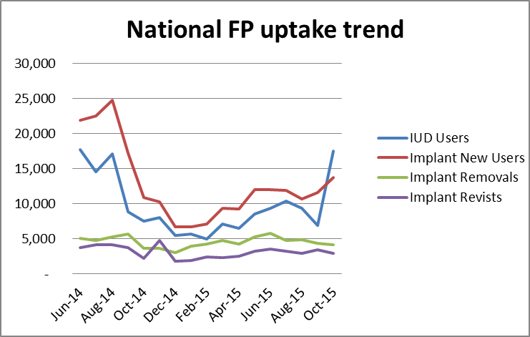

This provides an important lesson on the way programmes particularly those of a sensitive nature such as this one, should be discontinued. Furthermore, it will be important that lessons emerging from the implementation of the dedicated provider model are documented for future programming and to feed into policy dialogue.

Monitoring progress throughout the review period
The Joint Management Framework stipulates quarterly meetings between DFID, USAID and representatives from GoU, quarterly meetings with the recipients (MSIU and FHI) and monthly meetings between DFID and USAID. In addition, field visits by both USAID and DFID are specified in the framework to ensure oversight of programme implementation. Following the signing of the framework in July 2015, two field visits have been conducted by DFID to review progress on implementation. In line with the Joint Management Framework, six meetings were held between USAID and DFID. In addition one quarterly meeting was held in the second quarter with GoU to discuss broader policy issues relevant to the programme. To provide feedback to MSIU, a joint meeting was held in November 2015 to discuss the second quarter report. DFID continues to receive bi-weekly technical updates on the programme and quarterly reports on progress of implementation.

(PMA2015-R6)-National outcome

