Business Case

Summary Sheet

Title: DFID support for the eradication of Guinea Worm Disease, 2015–2017.
Project Purpose: Control and eradicate Guinea Worm disease by 2020.

Programme Value: £4.5m |  | Country/Region: Global programme
Project Code: 204938 | Start Date: November 2015 | End Date: 31st December 2016
Overall programme risk rating: | Medium
Quest Number: 5226111

Intervention Summary

What support will the UK provide?
The UK will provide £4.5m from November 2015 to the Guinea Worm Eradication Programme (GWEP), to coordinate efforts to control and eradicate Guinea worm disease (GWD), with a DFID programme end date of 31 December 2016. The Carter Centre (TCC), in conjunction with the World Health Organization (WHO), have led the GWEP since 1986, bringing the programme closer to the goal of eradication each year.

GWD is a parasitic disease, transmitted by drinking contaminated water, which affects people in rural, deprived and isolated communities without safe drinking water sources. The disease has considerable socio-economic consequences for poor people. It causes agonising pain and incapacitates people for an average of 8.5 weeks, preventing them from working or attending school, leading to economic losses, increased poverty and malnutrition. Women are equally affected by the disease as men. Consequences of the disease include girls missing weeks of school and women being unable to work. All programmes now have a minimum of one male and one female village volunteer to ensure access to all female patients. GWD is one of only two diseases currently agreed for global eradication, as mandated by the World Health Assembly (WHA). GWD cases have fallen from 3.5 million cases in 1986 to just 126 cases in 2014, and has been reduced to being endemic in just four countries in Africa (South Sudan, Mali, Ethiopia and Chad).

GWD is part of a group of diseases referred to as Neglected Tropical Diseases. In 2012, the UK, the World Bank, BMGF, USAID and number of leading pharmaceutical companies and NGOs, committed to ‘a new coordinated push to accelerate progress toward eliminating or controlling ten neglected tropical diseases by 2020’ (The London Declaration on Neglected Tropical Diseases). This included a commitment to sustain programmes that help eradicate GWD. The UK has been a consistent advocate of GWD eradication, having provided £30m from 2009 to 2014. Eradicating GWD aligns well with the Government’s objective to end extreme poverty, through putting the poorest, weakest and most marginalised first, and leaving no-one behind. It will also be a key contributor to achieving sustainable development goal 3.3, ‘to end the epidemics of AIDs, tuberculosis, malaria and neglected tropical diseases and combat hepatitis, water-bourne diseases and other communicable diseases’.

What are the main programme activities?
People get infected with GWD by drinking contaminated water. GWD can be prevented through breaking the transmission cycle and increasing access to uncontaminated water.

DFID’s funds will contribute towards the following activities:
- Assisting the national eradication programmes in the remaining four endemic countries with:
- Extensive surveillance, to quickly identify cases of GWD.
- Implementation of interventions to interrupt transmission, including containment of cases.
- Dissemination of information about GWD. Once transmission is stopped, assisting countries to develop and maintain capacity for surveillance and rapid response.
- Advocating with endemic countries and the international community to maintain adequate resources until eradication is achieved.
- Conducting certification of countries as being guinea worm free.
- Strengthening surveillance and health delivery systems.

Why is UK support required?
Historically, the GWEP has had a large donor base but there is now a funding gap which puts the goal of eradication, and the past achievements, at risk. DFID’s support would fill the immediate funding gap and ensure the success of the programme to date is not put at risk.

DFID has provided support over the last six years to the global GWEP, with the last tranche of funding ending in September 2014 and the Project Completion Report giving the programme an A rating. As with other eradication programmes, since the disease now affects so few people, the cost per case prevented inevitably increases as the goal of eradication becomes closer. This is making it increasingly difficult to mobilise support for the final years of the programme. To meet the funding gap, TCC and WHO are putting considerable effort into reaching out to previous donors and soliciting new ones. Both the Bill and Melinda Gates Foundation (BMGF) and the Children’s Investment Fund Foundation (CIFF) have committed considerable funds 2016 and more donors are expected to follow.

What are the expected results?
The expected impact of the eradication programme over the next 5 years programme will be the eradication of GWD. This means that the disease will no longer occur anywhere in the world and that future generations will be protected from ever suffering from the disease.

Our support over the period November 2015 to December 2016 will contribute to this impact. Although this project is not expected to achieve eradication in the timeframe, the funding will move the GWEP closer to this goal. By contributing to closing the immediate funding gap, the expected outcome of this programme is the prevention of GWD transmission through the implementation of effective prevention strategies, and strengthened case surveillance and containment measures. DFID’s financial support will also help to influence additional donors to contribute to closing the funding gap, placing the programme on a sound footing to achieving eradication.

Specifically, by the end of the programme:
-Guinea worm cases are expected to have fallen from 126 in 2014 to 8 in 2016.
-Endemic villages are expected to have reduced from 69 in 2014 to 15 by December 2016.
-The remaining 15 endemic villages are expected to have all received health education; have trained and supervised village volunteers undertaking surveillance; and be protected with larvicide. All households in these villages are also expected to have receiving cloth filters.
-Democratic Republic of Congo and Kenya are expected to have submitted documentation demonstrating absence of GWD; with reports verified by international certification teams.
-The surveillance system will cover approximately 6000 villages in the four endemic countries.

How does the project fit with the country programme or department’s strategic objectives set out in the Operational Plan?
This programme will make a contribution to the ‘no-one left behind’ agenda and the department’s strategic objectiove to improve access to basic services for the world’s poorest people. This programme will prevent poor people, often living in remote and conflict areas affected, from suffering from the disease, which impacts on their ability to work and go to school. The programme will also advocate and provide safe water for underserved communities.

What are the key risks to the success of the programme?
The risk for this project is medium, largely reflecting the security situation in all four endemic countries and an unexpected GWD outbreak in Chad. The Carter Center (TCC) works closely with the national GWEPs towards managing the many challenges and further research to understand and stop transmission in humans and dogs in Chad are being intensified. TCC and WHO have a good track record of success, with DFID’s previous support to the progamme scoring an A in the recent
project completion report.

There remains a considerable funding gap for the eradication programme which is a major risk to achieving success. However, TCC and WHO are putting considerable effort into closing the gap. In addition to this, President Carter has personally met national leaders to increase commitment. The BMGF have historically been the largest donor and remain closely engaged.

Strategic Case

1. Background
Guinea worm disease
GWD is one of 17 neglected tropical diseases (NTDs) prioritised by the WHO, defined as ‘a diverse group of diseases with distinct characteristics that thrive mainly among the poorest populations’. GWD is caused by the parasitic worm dracunculus medinensis, which infects people who drink water containing microscopic infective larvae harboured by tiny copepods (water fleas), usually present in stagnant water sources. Approximately one year after drinking the water, an adult worm, measuring up to three feet long, emerges painfully through a person’s skin, usually through a limb. This painful blister has led to the disease being called ‘the fiery serpent’ or ‘the dragon’.

There is no drug to cure GWD, or vaccine to prevent it, and humans do not develop immunity to the disease. The same treatment has been used for thousands of years and consists of winding the worm around a piece of gauze/small stick and manually extracting it. This is a slow and painful process that usually takes weeks. The parasitic infection causes severe pain and incapacity. Secondary bacterial infections are common, prolonging recovery time, and sometimes lead to permanent disability. The average length of disability associated with GWD is reported to be 8.5 weeks (ranging from 2 to 16 weeks). This does not include the more severe and protracted disability associated with a small proportion of people who are repeatedly infected and suffer from the emergence of multiple guinea worms, often leading to them being incapacitated for most of a year.

GWD is transmitted when a patient enters water: at this point the worm releases hundreds of thousands of larvae, contaminating the water source and continuing the cycle of disease when the contaminated water is consumed by others (see Figure 1).

Figure 1. The life cycle of guinea worm

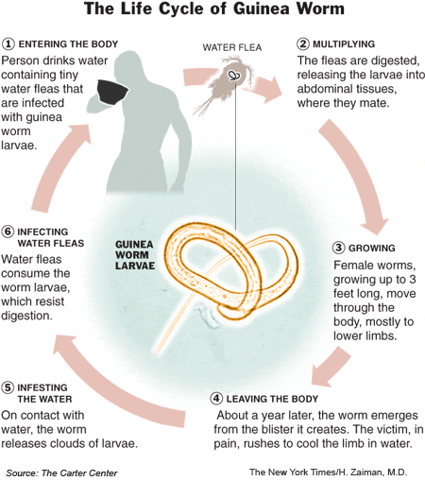

GWD disproportionately affects the poor, often in remote areas, affecting men and women equally. In remote communities with no access to safe drinking water, people depend on stagnant sources such as lakes and ponds. Health services are often absent or far away, making them difficult to access. The absence of an easy treatment is often an additional disincentive to seek medical attention. Given the time consuming extraction process, the economic burden of the disease is significant as individuals are unable to work or go to school.

GWD is seasonal: in the Sahel, the peak generally occurs in the rainy season (May to August), whereas in the humid savannah and forest area, the transmission takes place in the dry season (September to January). The seasonality of the disease means that it tends to disable farmers at the critical harvesting time, leading to lost productivity for the household and community. GWD is also associated with a higher risk of malnutrition among children. In South Kordofan, Sudan, children under 6 years old were nearly three times as likely to be malnourished (wasted) if their parents had suffered from GWD in the last year. Infected children are unable to walk to school when the worms break through, and often have to substitute for their parent’s labour when they themselves are temporarily disabled by the emerging worm. School absenteeism has been shown to peak during the GWD season in endemic areas, with schools having to close for a month each year as a result.

The long incubation period and movement of nomadic groups pose a threat to both surveillance and case containment of GWD in the remaining endemic countries. For example, in Ethiopia, some communities move to and from South Sudan; and in Mali, nomadic groups band together one year but often form different groups in subsequent years, making tracking specific groups challenging. Herders often move over long distances, making it difficult to accurately recall where they have been.

2. Opportunity for eradication
Eradicating a major infectious disease is a remarkable gift from one generation to all subsequent generations, with the benefits of GWD eradication lasting in perpetuity.

GWD is set to become the second human disease in history, after smallpox, to be eradicated. Once achieved, it will be the first parasitic disease to be eradicated and the first disease to be eradicated without the use of a vaccine or medicine. Such an accomplishment is unprecedented and will mark a major global step towards achieving the sustainable development goal, ‘ensure healthy lives and promote well-being for all at all ages’, specifically target 3.3: ‘By 2030, end the epidemics of AIDS, tuberculosis, malaria and neglected tropical diseases and combat hepatitis, water-borne diseases and other communicable diseases’.

Specifically, the benefits include:
• Improving the health status, agricultural productivity and school attendance of poor and underserved populations in Africa.
• Improving access to safe drinking water for neglected populations.
•Establishing a robust platform for delivering integrated public health interventions and village-based surveillance among underserved populations, including those living in remote and conflict affected areas.
•Freeing up resources for other health/development work.

To achieve eradication, finding and containing each remaining case is critical.

3. The global effort to eradicate guinea worm
GWD can be prevented through low cost, simple strategies, and can be eliminated by breaking the transmission cycle. The fundamental strategy for eradication has remained effective since the campaign began in the 1980s, with some modification and refinement based on local circumstances and the changing pattern of the disease. Transmission can be prevented by the following strategies:

1) Health education: Village-based health workers (at least one male and one female) are trained to educate people about the origin of the disease and what they can do to prevent it.

2) Filters: Village volunteers distribute filters and teach people how to strain the water fleas from untreated water, as well as how to maintain the filters.

3) Treatment of sources of drinking water: The chemical temephos, which kills the water fleas, is used monthly to treat stagnant sources of drinking water.

4) Advocacy for and provision of clean water: TCC staff, and the national eradication campaign staff based in the ministries of health, advocate with district, regional, and national authorities, and with external water sector organizations, for the provision of safe water sources in endemic villages.

5) Case surveillance and containment: Health workers aim to detect and contain cases within 24 hours of the emergence of the worm, through reporting, isolation and medical care for patients. An extensive and intensive surveillance system must be maintained for at least one year beyond the report of the last indigenous case. Certification of eradication requires maintaining countrywide surveillance during three consecutive years beyond the report of the last case.

4. Success to date
The eradication campaign has had outstanding success to date. GWD cases have fallen by more than 99.99%, from 3.5 million cases in 1986 to just 126 cases in 2014 (see Figure 2).

If the GWD eradication campaign not been initiated in 1986, it is estimated that 3.5 million GWD cases would have occurred annually making a cumulative total of 101.5 million cases from 1986-2014. In 1986, the disease was endemic across much of South Asia and Africa, but has now been reduced to just four endemic countries: South Sudan, Mali, Chad, and Ethiopia (see Annex 1).

Of the 126 GWD cases reported in 2014, 92 (73%) were contained (cases reported and isolated within 24 hours of the emergence of the worm), reflecting the speed with which cases were identified. This is one of the most important components in reducing cases year to year, given that it takes only one person to potentially re-infect a whole village via a common water source. The importance of strong surveillance and the need for eradication has been demonstrated in Mali, where one missed case in 2006 led to 80 cases one year later and another 120 cases the following year.

Figure 2. Number of reported cases of GWD by year, 1986-2014.
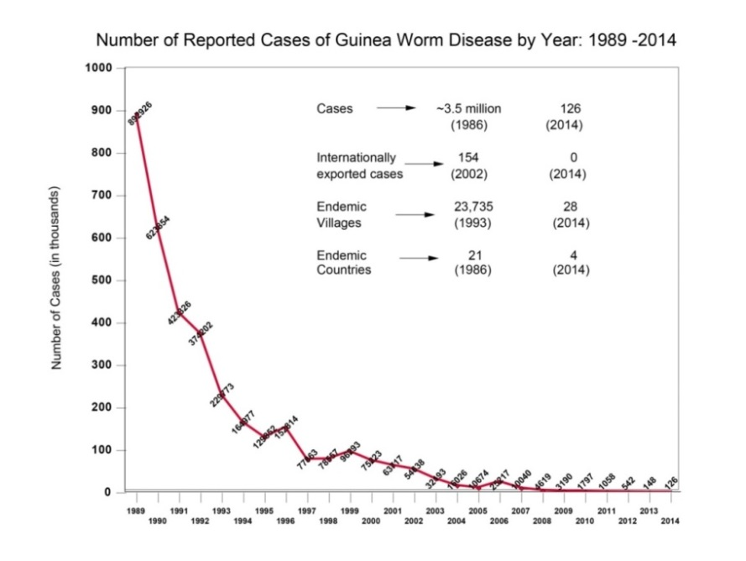
Table 1. Total reported GWD cases by month, 2014-15

Year | Jan | Feb | March | April | May | June | July | Aug | Sept | Oct | Nov | Dec | Total
2015 | 0 | 1 | 2 | 1 | 1 | 3 | 4
2014 | 1 | 1 | 4 | 5 | 5 | 11 | 25 | 23 | 24 | 16 | 9 | 2 | 126

5. Challenges
There are a number of challenges which put the current achievements, and future ambition for eradication, at risk:

Insecurity
Insecurity continues to pose a challenge in accessing areas for continued surveillance. The GWEP has had long standing experience of working in conflict-affected areas and has made considerable progress, despite the challenging environment.

National GWEP coordinators in Uganda, Niger and Mali have reported that GWD staff have not been targeted by insurgents because the programme is recognised as one of the few, if any, health programmes serving remote communities. The trust that develops, due to the GWEP staff’s almost daily interactions with community members, is an important asset to GWEP staff safety.

Access
Harsh terrain and poor infrastructure also makes implementation of the GWDP difficult. During the rainy season in South Sudan, some teams have been stranded for up to three weeks and the plateau near the border with Ethiopia is only accessible via heavy duty trucks. In Chad, most vehicles wear out within two years, due to the damage to the undercarriage by driving in mud for long hours and over many days. In Mali, the rocky terrain means that tyres often need to be replaced within a few months.

Atypical epidemiology
The atypical epidemiology of GWD in Chad has required implementation of enhanced interventions to address the spread of infections in dogs (thought to be through eating raw fish entrails) and humans (thought to be from eating raw or poorly cooked/cured fish). Given the sudden and unexpected emergence of cases in areas that had previously not had GWD, volunteers have had to be trained quickly to educate communities on the disease. Further research and control measures to understand and stop the unusual pattern of transmission in Chad are being intensified. To ensure prompt response to rumours and improved surveillance data, the GWEP has also established links with polio response teams based in ministry of health surveillance hubs located in the outlying areas with a strong immediate response capacity.

Potential for discovery of a new endemic area
Concern has also been raised over the potential for endemic transmission of GWD in Democratic Republic of Congo (DRC) . The WHO is providing financial and technical support to DRC’s Ministry of Health to undertake additional work to clarify the epidemiological situation, which involves conducting a nationwide case search and tight follow-up for 10-14 months (GWD incubation period), specifically focussed on provinces that reported historical cases and any additional suspected areas identified by the case search. This work will remain challenging and costly, due to the country’s weak health infrastructure; insufficient manpower; and security concerns.

Maintaining high political commitment and engagement at the national level, as well as commitment at district levels, is critical but is challenging as fewer cases are reported within each country.

Securing funding
The global programme currently has a funding gap which puts the global gains to date at risk (see Table 2). The full GWEP budget is $212.92 million between 2015 and 2020. As of end August 2015, $31 million has been secured, with a remaining funding gap of $12.26 million for 2015 and of $181.92 million through CY 2020.

Absence of funding would lead to delays in efforts to interrupt transmission in the remaining four endemic countries, putting the timeframe for eradication at risk and increasing the total cost of the campaign as the number of cases begin to increase.
Historically, the GWEP has had a large donor base, with support from a number of governments and development agencies. From 2009-2014 the budget for eradication was $150 million. DFID provided 32%, BMGF provided 42%, the United Arab Emirates and CIFF provided around 10% each with other smaller donors providing the balance. Due to the fact that the disease now affects so few people, and the cost per case prevented inevitably increases as the goal of eradication becomes closer, it is becoming increasingly difficult to mobilise funding support for the final years of the programme. To meet the funding gap, TCC and WHO are redoubling efforts to reach the previous donors that have provided support to the GWEP since 1986 and are also soliciting new foundation, government, corporate, and individual partners for GWEP. BMGF report that they remain a committed partner and are currently considering their longer term support beyond what they have already committed. Given the low-resource settings where GWD still persists, there is little evidence that countries would be able to stop transmission of GWD or support the costs of surveillance and WHO certification without international support.

Table 2. Funding need and current gap for the GWEP, 2015-2020

 | CY 2015 | CY 2016 |  | CY 2017 | CY 2018 | CY 2019 | CY 2020 | TOTAL
Need | $38.26m |  | $52.85m | $49.84m | $38.78m | $25.42m | $7.77m |  | $212.92m
Secured | $26.00m* |  | $0 | $1.25m** | $1.25m** | $1.25m** | $1.25m** |  | $31.00m***
Gap | $12.26m |  | $52.85m | $48.59m | $37.53m | $24.17m | $6.52m |  | $181.92m
* $11m from BMGF; $15m from CIFF
** From CIFF
*** $11m from BMGF, $20m from CIFF

6. UK support for GWD eradication
The UK has been a consistent advocate of GWD eradication, acknowledging that the work will contribute towards ending extreme poverty and leaving no-one behind, a key government priority. In 2008, DFID committed £50 million over five years to tackle NTDs, allocating £10 million of this to the eradication of GWD. In January 2012, DFID joined the World Bank, WHO, USAID, BMGF, pharmaceutical companies and NGOs in committing to “a new, coordinated push to accelerate progress toward eliminating or controlling 10 NTDs by 2020” (London Declaration on Neglected Tropical Diseases). At the London Declaration, DFID announced an increase of its commitment to the control and elimination of NTDs, from £50 million to £245 million, noting that it “is a tragedy that the lives of millions of the world’s poorest people are still being destroyed by these ancient and avoidable tropical diseases when we have the means to tackle them.” Ministers decided that this increased funding for NTDs would include a further £20m for GWD eradication.

DFID’s last tranche of funding was in September 2014, with the Programme Completion Report (PCR) giving the programme an A rating and highlighting the substantial progress that had been made. Successes highlighted in the report included Ghana being certified by the WHO as GWD free in 2015 and Sudan reporting zero cases in 2014. The PCR noted that the original milestone for GWD eradication was not met and emphasised the importance of ensuring that a revised target was realistic, reflecting the reality of the final stages of an eradication campaign, focussed largely in unstable environments. The PCR highlighted a number of key lessons and recommendations which included:
- Much of the success of the programme has stemmed from the community based nature of the interventions. This has facilitated programme adaption, such as the development of a portable pipe filter for nomadic groups to purify drinking water.
- The elimination of GWD has been one of the driving forces behind the provision of safe water in many villages.
- The GWEP reward system has been well used and it would be useful to evaluate this against the different methods available to incentivise reporting.
- As the cost per case in the final years increases, fundraising becomes more challenging. There is a risk that the funding gap remains unfilled up to 2019 which could back track on the success to date.
- The changing epidemiology of GWD in Chad, as well as access issues in South Sudan and Mali, have meant that reaching the final case is proving extremely difficult. In addition to this, the overall distribution of NTDs means that it is the most remote and marginalised groups in society which need to be accessed, making reaching the last cases challenging.
- As the GWEP is now in the final stages of the campaign, there is a welcomed focus on horizontal efficiencies through health system strengthening and legacy planning. It is important for the programme to look towards more of these efficiencies, to provide value for money and sustainability.

A further DFID contribution of £4.5m, covering 10.9% of the total GWEP cost during the 14-month time period (Nov 2015-Dec 2016), will therefore help fill the immediate funding gap, keep activities on track, and maintain the pace of eradication.

7. Compliance with the Gender Equality Act
Guinea worm infects men and women in similar numbers. Data on guinea worm disease cases will be disaggregated by gender in the logframe and analysed to ensure any gender disparitiers are detected and addressed. Those affected by the disease are however, by its nature, those in hard to reach and insecure environments. Consequences of the disease for both men and women include children missing weeks of school and adults being unable to work.

To combat these effects, national GWEPs deliver health services at the village or household level, extending beyond facility based delivery. As a result, access to health services has been increased for people usually underserved by the health infrastructure. Similarly, in the early 1990s the use of village volunteers was introduced. Soon after the introduction, the programmes realised that male village volunteers often were not allowed, or were unable to gain access to women. All programmes now have a minimum of one male and one female village volunteer to ensure access to all patients. In addition, if a patient is being treated in a case containment center, food and sleeping arrangements for mothers with children are provided in order to increase compliance and reduce stress.

8. Expected impact and outcome
The expected impact of this programme (GWEP) over 5 years will be the eradication of GWD. This means that the disease will no longer occur anywhere in the world and that future generations will be protected from ever suffering from this disease. Our support over the period November 2015 to December 2016 will contribute to this impact, with 200 GWD free countries certified by WHO expected by the end of the project.

The three main criteria for certification of GWD elimination, established by the International Commission for the Certification of Dracunculiasis Eradication (ICCDE), are:
1. Evidence of absence of transmission of the disease.
2. Evidence of a functional country-wide surveillance system and high levels of awareness about the cash reward for reporting cases of GWD.
3. No risk of re-establishment of local transmission from any imported case.
An independent evaluation must verify whether the country meets these criteria, involving a visit of an International Certification Team (ICT), and an ICCDE review of documents submitted by the ministry of health, the evaluation team, and the ICT.

The expected outcome of this programme is the prevention of GWD transmission through the implementation of effective prevention strategies, and strengthened case surveillance and containment measures. Over the period of our support we expect cases of GWD to decrease from 126 cases in 2104 to 8 cases in 2016.

The target date for interruption of transmission of GWD in the remaining endemic countries is the end of 2016/17. If this is achieved, a global eradication date of 2020 is feasible. The date of the last case will not be known until at least one year after it occurs , given the average 12 month incubation period. Transmission is likely to be halted in South Sudan, Mali and Ethiopia by 2016, considering the small number of cases remaining and the sharp decrease in infections between 2014 and 2015. The final case in Chad will be affected by dog infections. While less certain, TCC anticipates the final case in Chad could be in 2016 or 2017. This rationale is based on past experience and awareness of the current situation, including intensified, enhanced interventions, robust surveillance and ongoing research.

To achieve this in the time of this project, it is expected that 100% of endemic villages will be receiving education, with all of these villages protected with larvicide and allocated village volunteers. 100% of households in these villages are expected to have cloth filters and all rumours of GWD are predicted to be investigated within 24 hours of receipt of the notification A meeting will be held during the WHA with endemic countries and two articles are expected to be published in media/journals to ensure strong commitment in the endemic countries and adequate resources for GWD eradication.

After transmission is halted, each of the formerly endemic, and not yet certified, countries need to successfully complete the three year pre-certification period with no new cases. Global eradication will be declared after the eight countries still remaining to be certified as free of GWD complete this process. The evidence that the impact and outcomes are achievable is provided by the success of the programme to date, with the number of cases declining each year.

Figure 3. Theory of change
Assisting the national eradication programmes in the remaining four endemic countries with the implementation of all interventions.
Effective GWD prevention strategies in place in all endemic countries.
Once transmission is stopped, assisting countries to develop and maintain capacity for surveillance and rapid response.

Active surveillance and containment incentives in place in remaining endemic countries until transmission is interrupted.
Advocacy with endemic countries and the international community.

Strong commitment in the endemic countries and adequate resources for GWD eradication.

Pre-certification and certification activities conducted by WHO in countries that have yet to achieve certification.

Submission of documentation demonstrating absence of GWD in countries yet to achieve this, with reports verified by international certification teams.

Eradication of GWD.
Inputs
Activities
Outcomes
Impact
Outputs

DFID funding

BMGF funding

CIFF funding

Other donor funding

Government funding and policy

CC and WHO technical support and coordination

Prevention of GWD transmission.

Appraisal Case
In order to move the global campaign for GWD eradication closer to the end goal, DFID have two different options:

Option 1 is to do nothing more than is already being done (counterfactual).

Option 2 is to continue to support the global eradication programme.

These options are outlined in more details below.

Option 1. Do nothing
There is an immediate funding gap for 2015 and early 2016 which puts the achievements of the global eradication programme at risk. No new donors are expected to be found to fill this funding gap in time.
Should the gap remain, activities would need to be scaled back, leading to increasing numbers of cases and re-emergence of the disease in areas which have previously eliminated guinea worm. The funding gap not only puts the goal of eradication at risk but also a reversal of the public health gains, therefore reducing the impact of previous DFID and other donor support.

Option 2: Support the global eradication programme
The Guinea Worm Eradication Programme (GWEP) is an international coalition of communities, health workers, volunteers, governments, international agencies, non-governmental organisations and others, that have worked together towards achieving the goal of GWD eradication. TCC, in conjunction with the WHO, has led the global effort of the eradication of GWD for over 20 years, with countries seen as the owners and implementers of the eradication programme. They have provided a clear vision since 1986 and have fostered global cooperation of all the necessary actors required for the programme’s success. Through their efforts, a unique platform has been developed, without which the current programme would not be possible. An extremely effective eradication strategy now exists that has been proven to work, acknowledged by the 2011 WHA resolution (64.16) on the eradication of dracunculiasis.

TCC works in collaboration with the WHO, UNICEF and the US Centers for Disease Control and Prevention to support countries with technical assistance, monitoring and oversight, until they have reported zero cases for one year. WHO is mandated by the WHA to coordinate, build capacity, and provide technical assistance and guidelines to programmes in both endemic and formerly endemic countries. After transmission is interrupted in individual countries, surveillance continues for at least three years to ensure the detection and containment of any new indigenous or imported cases. During this time, WHO sends certification teams to assess coverage and quality of surveillance. The team submits a report to the independent International Commission for Certification of Dracunculiasis Eradication (ICCDE) and, once reviewed and evaluated, WHO issues an official certification that the country is free of GWD.

TCC’s strong leadership, expertise, governance and transparency puts them in an excellent position to lead on the programme’s implementation. The WHO is the only agency mandated to certify that countries are free of GWD. These strengths complement those of TCC’s in advocacy and programme management/implementation.

The GWEP has considerable experience and success in working in conflict and fragile states. President Carter’s personal involvement in the programme has been extremely important in achieving political support for the campaign both from the countries themselves and from international donors. The Programme continues to reach women, who are as equally affected by the disease as men, and reach people living in remote and underserved populations.

The GWEP are also working to ensure the sustainability of the health delivery system and strong surveillance system they have established in thousands of communities, which have the potential to be used to provide health education and interventions to prevent other diseases. Work is taking place to ensure that integration with existing health systems takes place wherever possible: for example, in Nigeria, around 200 supervisors have been absorbed into the Ministry of Health.

DFID’s funds would contribute towards:
-Assisting the national eradication programmes in the remaining four endemic countries with the implementation of all interventions, including:
-Surveillance, to stop transmission of the disease.
-Implementation of interventions to interrupt transmission, including containment of cases.
-Dissemination of information about the cash reward for reporting about GWD cases.
- Once transmission is stopped, assisting countries to develop and maintain capacity for surveillance and rapid response.
-Advocating with endemic countries and the international community to maintain adequate resources until eradication is achieved and certified.
-Conducting pre-certification and certification activities.
-Strengthening surveillance and health delivery systems.

Specifically, DFID’s funds are expected to contribute towards:
-Guinea worm cases falling from 126 in 2014 to 8 in 2016, of which over 80% will be contained within 24 hours of the worm emerging.
-Endemic villages reducing from 69 in 2014 to 15 by December 2016.
-Health education, filters in all households, supervision and larvicide protection in the remaining 15 endemic villages.
-Surveillance across approximately 6,000 villages in the four endemic countries. Currently, 757 villages in Chad, 173 in Ethiopia, 375 in Mali, and 4,700 in South Sudan are under active surveillance. DFID’s support will be essential in maintaining these strong surveillance networks.
-Democratic Republic of Congo and Kenya submitting documentation demonstrating absence of GWD; with reports verified by international certification teams.
-Meetings held during the World Health Assembly with active participation by ministers of health from endemic countries.
-Two articles in national and international media and medical journals.
-$40m new funding for eradication of GWD agreed from other donors.

DFID’s funding will cover 10.9% of the total GWEP costs during the 14-month time period of the programme: consequently, 10.9% of the achievements can be attributed towards DFID’s funding. We considered other funding amounts and durations. The £4.5m we will be providing meets a funding gap at a critical period (refer to table 2). Regarding duration there is much research ongoing at present due to the atypical transmission in dogs. This research may have implication on how the end game is managed. In a years’ time we should have more knowledge on this including how best to prevent transmission in dogs. This knowledge will help TCC and WHO to fine tune the plans for the end game. We will then be in a stronger position to decide on our support for the duration to 2020.

Costs and benefits for each option

Option 1. Do nothing
If DFID do not provide further support to the GWEP, there will be no costs, nor further benefits. If the immediate funding gap for the GWEP is not filled, there could be a reversal of the benefits achieved to date, as the number of GWD cases increase and surveillance in countries weakens.

Option 2. Support the global eradication programme

Benefits
Overall, the economic impact of the GWD eradication programme remains strong, as once eradication is achieved no further investment will be required. Although, in the timescale of this project, eradication will not be achieved, DFID’s funds will help to close the funding gap; ensure the success of the programme to date is not at risk; and move the programme closer towards the goal of eradication. More specifically, the funding will contribute to the following benefits:
-Averting lost working days: The average length of disability associated with GWD is 8.5 weeks, preventing farmers from working at the critical harvesting time. This can have a considerable impact on agricultural output.
-Preventing treatment costs: TCC has estimated that it costs between $100 and $200 per patient for first aid treatment costs associated with GWD. Where possible TCC will, over the next 15 months, monitor the cost per patient treated and report it DFID on these costs. However, in most of the endemic countries, public health clinics (not TCC) bear the direct treatment costs for GWD cases. TCC has built case containment centers in South Sudan, since the country lacks the public health infrastructure that other countries have.
-Equity: The GWEP reaches the most marginalised groups who live in isolated communities, usually without safe drinking-water. Both sexes benefitting equally from the programme: to ensure measurement of this, data on the number of cases of GWD will be disaggregated by gender.
-Empowering women: The GWEP trains women in community education to report cases and encourage GWD patients not to enter water sources. In 2008, 47% of GWEP community-based volunteers were women.
-School attendance: The GWEP helps to keep children in school by stopping children getting the disease and preventing their parents’ becoming unwell, requiring their children to work in their place.
- Better childhood nutrition: A study in Sudan found that children were three times more likely to be malnourished if more than half the adult members had suffered from the GWD in the previous year.
-Infrastructure for other health improvement programmes: The infrastructure provided by village volunteers undertaking health promotion and surveillance is now being used for other health activities.

Costs
DFID would contribute £4.5m towards the programme. The largest proportion of this funding would be spent on field interventions (£1,255,273). Of this, £589,978 would be spent on surveillance and associated supervision. Currently, TCC assists the ministries of health of South Sudan, Ethiopia, Mali, and Chad to manage surveillance and interventions in over 6,000 villages that aim to interrupt endemic transmission of GWD. £326,371 would be spent on implementation and distribution of filters and Abate® treatment of water sources where contamination is suspected. £276,160 would be spent on training and educating communities about GWD, mobilizing residents to take action to prevent disease transmission, and report anyone with GWD immediately. A reward of $100 is given for information leading to confirmation of GWD cases, which DFID’s funds would proportionately contribute towards. This is paid by national GWEP secretariat staff directly to the patient or informer during a special ceremony at the village level. Reward funds are not channeled through a third party. The cash reward provides an incentive for reporting cases, particularly in communities that may wish to hide cases due to distrust of authority, etc. Cash rewards were used in the highly successful smallpox eradication campaign. The remaining funds spent on field interventions will go towards surveys and assessments (£62,764).

After field interventions, the largest proportion of DFID’s resources would be spent on salaries of headquarter and field staff (£777,756) and consultants (£462,965), incuding technical adviser, security firms and public relation organsiations. £58,564 would be spent on cash reward promotion, which includes contracts with prospective public relations firms who will be engaged to conduct joint public information campaigns on cash rewards and broadcast information on GWD.

Key cost drivers
The number and location of villages under surveillance, although continuing to drop, is still a major cost. These villages are insecure and in extremely remote areas, yet regular and frequent travel to the communities is essential for supervision, as well as monitoring, surveillance and awareness of the cash. Unexpected outbreaks and GWD evolution will drive costs. In addition to this, security will also affect costs of surveillance. For example, the situation in Northern Mali and South Sudan has destroyed some GWEP-owned equipment and required the need to increase security. The scaling up and down of surveillance also depends on how GWD cases evolve and presents the most uncertainty in terms of costs.

Value for money
Finding and containing the last remaining cases is critical, with the economic and social arguments for uninterrupted continuation of programmes strong. However this is the most difficult stage, with the cost per case of GWD increasing for a number of reasons.

Economy
Each year, TCC engage in a thorough review of costs for the budget year. This has equated to cumulative budget savings from 2009 to 2014 of $28.7 million. TCC’s policy is to pay salaries in the 75th percentile of salaries for similar NGOs. They have a travel agent on site who negotiates contracts with air carriers that provide discounted fares. The GWEP also benefits from volunteer time, donations and considerable involvement by national ministries of health and NGOs. Between 2010 and 2014, donated filter material had an in-kind value of $529,655 and donated ABATE® had an in-kind value of $140,552 – donations which will continue throughout the course of this programme.

Efficiency
TCC have divided villages and regions between delivery partners to address multiple campaign needs (e.g. Malaria, Trachoma), making the eradication of GWD, as well as other programmes, more efficient. For example, in Chad, the national GWEP maintains surveillance for GWD and acute flaccid paralysis (for polio surveillance). The Polio eradication programmes in the four remaining endemic countries ask about cases of the GWD during vaccination drives.

Effectiveness
TCC’s work is based on regular consultation with government authorities to prioritise GWD eradication. As a result, TCC has built eradication capacity into each endemic country’s ministry of health. Once transmission has been stopped globally, no further interventions or monitoring will be needed, beyond the three-year-long precertification of eradication stage required by WHO. The legacy of GWEP’s established health infrastructure and networks will include community-based surveillance and health education delivery systems that are poised to deliver other essential interventions. Eradication will accrue economic returns forever by benefiting the health, agricultural productivity and school attendance among some of the world’s poorest people.

TCC will report on further work to estimate the cost-effectiveness of the programme, developing a value for money action plan to measure performance. Depending on the availability of data, measures to assess the value for money of the programme may include cost per patient treatment, cost per survey/assessment and cost per surveyor/volunteer trained. The Institute for Disease Modelling (IDM) is working with TCC to look at how to achieve eradication in the most cost effective manner. This report will be available in summer 2016. Following this report the TCC will develop the action plan on VFM in Q3 2016.

Likely impact on climate change and environment

Table 4. Climate change and environment risks and opportunities
Option | Climate change and environment risks and impacts | Climate change and environment opportunities
1 | C | C
2 | B | B
* A=high potential risk/opportunity; B=medium/manageable potential risk/opportunity; C= low/no risk/opportunity; D=core contribution to a multilateral organisation.

Option 1. Do nothing
The counterfactual (Option 1) would have higher environmental risks than the other two options as it provides no incentive to provide safe water in order to support GWD eradication.

Option 2. Continue to support the GWEP in their effort to eradicate GWD
There is a low risk of the programme negatively impacting on the environment. In contrast, the programme has a positive impact through the provision of safe drinking water for neglected populations
that not only reduce GWD transmission but also diarrhoeal and other water and sanitation related diseases. As one example, in 2010, the Sudan Ministry of Water Resources and Irrigation, UNICEF, and other partners completed 85 functional borehole wells that increased the coverage of endemic villages with safe drinking water from 15-16% in 2006-09 to 22% in 2010.
The programme limits its negative environmental impact in the following ways:
- Health education and surveillance activities are carried out by village volunteers, reducing the carbon footprint associated with travel.
- The water filters that are promoted tend to be made from locally-available fine mesh fabrics.
- Health education encourages infected individuals to stay away from drinking water sources and prevent re-contamination of the water, protecting the environment.
- Local construction of hand-dug wells to increase access to safe water supply primarily uses locally available materials and resources (the exception is the use of cement and iron rods to line the wells; while there are environmental concerns regarding the production of cement, and the associated carbon emissions, there is currently no alternative material for use).
- Simple environmental management measures to prevent GWD spread, such as filling and draining of ponds, are used where possible. There is limited chemical treatment of water sources with the larvicide temephos. Temephos is proven to have low toxicity in mammals, birds, fish and other non-target organisms and the WHO Expert Committee on pesticides has declared it safe for use in drinking water (at the correct dosage). Since the chemical needs to be applied by trained personnel, it is applied only in cases where availability of water is seasonal and the number of sources are few, small/moderate in size and shared by many people. Temephos application is complementary to other interventions and is always targeted to water sources in villages where transmission is endemic and to water sources with contamination events. Temephos is relatively quickly removed from the environment.

Climate change is not expected to affect the GWEP eradication given the timelines for eradication. As there is no drug therapy for GWD, any potential environmental concerns with regard to drug delivery, storage and/or disposal are not applicable.

Commercial Case

As introduced in the Appraisal Case, TCC have led the global eradication of GWD for over 20 years, creating a unique platform through which an effective eradication strategy is being implemented. For this reason, there will only be one grant agreement for DFID for this programme, with lead delivery partner TCC. This approach, capacity to deliver, and key value for money considerations are described below.

Overview of Arrangement
DFID will award an Accountable Grant (AG) for £4.5 million to TCC for the purposes of supporting the global GWEP as set out in this document and the Logical Framework from November 2015 to end December 2016. TCC will sub-grant approximately 9% of this to the WHO.

The AG will be with TCC, whose Director will have overall management and fiduciary responsibility. Funding will be paid in advance in two instalments (£4m in December 2015 and £0.5m in April 2016). These payments have been subject to formal justification by TCC that this is essential to allow the programme to proceed and demonstrates credible value for money (as set out in the Appraisal and Managenent section of this Business Case), and the second payment will be dependent on adequate financial and narrative reporting on the first payment and evidence that TCC have developed a credible VFM action plan which monitors performance as set out in the Appraisal Case. More detail on this justification and the funding approaches is set out below in the Financial Case.

Ability of all parties to deliver
TCC’s strong track record with DFID, and leadership and expertise on the GWEP, puts them in an unrivalled position to lead on the delivery of this programme. The WHO (as sub-grantee) has built and sustained a leading role in the global collaboration for eradication of GWD and is the only agency mandated to certify that countries are free of GWD. These strengths complement those of TCC’s in programme delivery.

In preparation of this business case, a due diligence of the TCC’s ability to deliver this programme effectively and deliver credible VFM has been carried out. Whilst minor issues were identified (details of which are set out in the Financial Case), no major recommendations arose and it was concluded that ‘based on an analysis of the four due diligence pillars, [DFID] have confidence that TCC have the ability to effectively deliver this programme and manage the DFID grant.’ It also noted that TCC had a strong ability to ensure WHO was delivering, based on a detailed MoU.

Value for money through procurement
TCC’s standard procurement process complies with World Bank procurement policies, with the Atlanta HQ carrying out the majority of procurement. Annual institutional audits, which look at adherence to procurement rules are conducted by KPMG LLP and are available to DFID and the public by April each year. In addition, regular financial audits are conducted by TCC HQ staff at the field level, as well as supervisory visits to ensure correct processes are followed.

Dedicated qualified TCC staff lead on procurement processes and require three bids on most procurements (based on type of purchase and materiality thresholds). TCC is well-versed at purchasing all types of goods and services. When procurement occurs, credible value for money is potentially delivered through a series of set procurement processes such as 1) full competition, and 2) written justification whenever conditions in a country require that procurement is carried out differently with clear evidence of how VFM will be delivered in these particular cases.

TCC procurement costs for GWD eradication are minimised as a result of MOUs with each endemic country government, which allows TCC to import goods free of tax and duties. All MOUs with country governments allow TCC to open its own bank accounts in country, ensuring TCC have total control of their accounts. It has been agreed that TCC will not be procuring any large assets with DFID funding.

Opportunity to negotiate on costs
An explanation of key costs and cost drivers was provided in the appraisal case. TCC have provided DFID with a detailed month by month forecast for the grant throughout the life of this programme. Over the years they have reduced costs through community volunteer involvement, conservative travel arrangements (with a travel agent on site who negotiates contracts there was an estimated saving of $3 million to the global health programmes between 2012 and 2014) and donations of filter cloth and ABATE® (between 2010 and 2014 having an in-kind value for $529,655 and $140,552 respectively). In advance of the final budget produced by TCC, the proportion of indirect costs were negotiated down from 15.7% to 11.8%. Further details of costs are provided below in the financial case.

Financial Case

Overview of Costs
This funding is not politically sensitive, novel or contentious and therefore does not require HM Treasury approval. This programme succeeds and extends the DFID funded six year programme first developed and approved in 2009. The project will be funded from DFID programme funds, currently available within resource allocation, with two payments totalling £4.5m made to TCC for this programme, who will sub-award a total of £421,230 to the WHO. The annual funding profile will be:
2015/16 = £4m (to be paid in December 2015 to cover 1st November 2015 to end March 2016, ie. part in arrears and part in advance).
2016/17 = £0.5m (to be paid in April 2016).

DFID’s funds will contribute to 10.9% of the overall GWEP programme budget over the grant period.TCC have produced a spending forecast for DFID funds to the GWEP over the period November 2015 to end June 2016 when all funds are to be spent, and have stated that DFID funds will be utilised for the stated activities. The detail of this, and the previous reports produced in advance of DFID’s PCR in May 2015, gives a strong level of certainty that these estimates are accurate. Any budget savings are put back into the GWEP itself.
Description (all amount in £GBP) | Nov 2015 – March 2016 | April 2016 - June 2016 | Total
1. Salaries – field and headquarter staff | 682,414 | 95,342 | 777,756
2. Consultant – eg. International technical advisors, security firms, PR firms | 406,212 | 56,753 | 462,965
3. Communications | 93,506 | 13,064 | 106,570
4. Office and equipment | 111,009 | 15,509 | 126,519
5. Field interventions:
Surveys and Assessments | 55,070 | 7,694 | 62,764
Training and health education | 242,307 | 33,853 | 276,160
Surveillance, supervision | 517,655 | 72,323 | 589,978
Distribution, implementation | 286,362 | 40,009 | 326,371
6. Travel | 225,740 | 31,539 | 257,279
7. Technical Meetings – monthly task force meetings of stakeholders, monthly staff meetings, annual programme review meetings | 27,015 | 3,774 | 30,790
8. Vehicle maintenance and related costs – including administrative fuel for fleet vehicles and motorcycles | 407,737 | 56,966 | 464,703
9. Other expenses – eg bank charges, insurance | 56,947 | 7,956 | 64,903
10. Programme Grants – sub awards to WHO for pre-certification and certification activities and DRC search cases | 421,230 | 0 | 421,230
Total Direct Expenses | 3,533,204 | 434,783 | 3,967,987
Indirect Expenses (11.8%) | 466,796 | 65,217 | 532,013
Total Budget | 4,000,000 | 500,000 | 4,500,000

Payment arrangements
TCC have requested two advance payments in December 2015 and April 2016 to enable the programme to proceed as originally planned to achieve overall value for money as set out in Appraisal Case. The Smart Rules note that advance payments should be approved in the business case, and DFID accounts will require the approved business case including justification, alongside signed accountable grant, when payments are requested. In preparation, advice has been sought from the divisional finance manager who has consulted with colleagues and agreed this proposal. The following sets out this justification directly from TCC:
- Payment required to WHO before the end of the calendar year for WHO’s GWEP activities.
- New service contracts and activities linked to The Carter Center’s expanded surveillance role will increase monthly operational costs substantially. The submitted spending forecast illustrates the Carter Center needs over the first five months of the grant period.
- Technical Advisor contracts: Nearly 40 Technical Advisors (TAs) are instrumental to supervising and ensuring proper surveillance and response in the 4 endemic countries. If TA contracts are delayed or have gaps, surveillance systems would be in jeopardy and the chances of missing a case are increased.
- Ethiopia: The Carter Center have a Project Agreement with financial commitments, subject to annual audit. If we cannot meet the minimum financial commitment, the trust with Ethiopia is eroded and in combination with item 2, jeopardizes the entire integrity of the Ethiopia programme.
- South Sudan and Mali: The security situation demands regular and reliable communication. Without sufficient funds, the communication contracts might be delayed with concomitant negative impact on communication capacity, putting lives as well as program operations at risk.
- South Sudan: By January of each year, supplies for program operations need to be substantially in place for the South Sudan sub-offices, compounds, and out posts before the rains begin in late February, early March.

In advance of the second payment a narrative and financial report will be submitted by TCC to DFID, as explained in the management case below. TCC’s accounting system will separately track DFID’s grant for this programme and in accordance with DFID guidance, the DFID team will assess fund utilisation to ensure the second tranche disbursement is not in advance of need and that DFID funds have been used for the intended purpose and that their use demonstrates credible VFM. On completion of the project, a final narrative and financial report will be submitted to DFID in advance of DFID’s project completion review. TCC Annual Report including annual audited accounts to period ending 31 August 2016 will be submitted in April 2017.

Assessment of Financial Risk and Fraud
TCC will bear the risks and fiduciary responsibility for this programme’s implementation. The recent PCR notes that throughout the last programme the risk of funds not being used as intended remained low, with strong financial chains and tight management of the $100 reward system. The due diligence pointed out that there have been minor instances of fraud over the years, with TCC performing full investigations into each instance, responding in ways that range from firing vendors to the dismissal of staff. It also found strong financial systems and management for this particular programme. Similarly, a financial assessment of TCC recently conducted by BMGF concluded that TCC ‘demonstrates high quality GWEP financial management capabilities, policy procedures and systems’.

Finance officers in TCC headquarters and in-country offices both report to the Associate Director of Finance. Each field office submits monthly financial statements to headquarters. TCC’s financial records are most recently audited by KPMG LLP, and those audit reports are available to DFID and the public at large by each April. Each memorandum of understanding (MOU) between TCC and countries requires that all financial assistance to the national GWEP is handled through bank accounts controlled solely by TCC and its staff. To enhance surveillance, rewards paid for the identification of Guinea Worm cases (as explained in the Appraisal Case above), are paid directly by GWEP secretariat staff to the patient/informer and never go through a third party.

WHO’s accountability system conforms to National Audit Office (NAO) standards, with both internal and external audit functions. The 2014 multilateral aid review update showed that progress had been made by WHO to address certain financial management weaknesses identified by the 2011 MAR. It concluded that the organisation’s approach to procurement is clearly driven by value for money. The current sub grant arrangement between TCC and WHO requires contains standard reporting and controls and the need for an annual financial report as well as a final financial report. WHO have their own procedures regarding implementing programmes as agreed with member states.

The national Ministries of Health, although not receiving any DFID funds , do receive some supplies and and some fees are paid by TCC to support MoH field officers. TCC has in place an MOU with each national Government, used regularly to ensure government compliance, and a review of these MOUs shows adequate oversight and accountability requirements in order to receive this support.

Management Case

DFID management arrangements
The Health Services Team within DFID will manage this programme. The senior responsible owner (SRO) of the programme will be an A1 senior health adviser and will be accountable for the delivery of the programme in line with this business case, adapting the programme and managing its risks. The senior health adviser, and other advisers as required, will contribute technical knowledge and expertise to the programme. A B2 DFID programme officer will be assigned to manage the programme ensuring key tasks are executed in line with the programme cycle and Smart Rules. Further input and assistance will be provided by the Deputy Team Leader, a programme management adviser and programme staff with extensive knowledge of the history of the programme.

Specific duties for the team will include, but are not limited to:
- Attendance at the yearly GWEP Board meetings.
- Travel to endemic countries – budget, security and time permitting.
- Developing and managing the delivery plan for the programme.
- Quarterly agreed monitoring meetings with the CC staff as well as frequent informal catch-ups as necessary.
- Agreeing the logframe and any changes made to it.
- Ensuring DFID Smart Rules mandatory requirements are met.
- Reviewing the progress regularly, especially in July 2016 prior to the second tranche of fundng being disbursed,and completing full programme completion review.
- Leading on ministerial and other briefings associated with the programme.
- Maintaining accurate financial and project records.
- Contributing to DFID corporate reporting.
- Monitoring of TCC’s VFM efficiency action plan

TCC Management Arrangements
The GWEP has had unprecedented success largely due to the valuable relationships between TCC, WHO and national eradication programmes led by ministries of health. There have also been successful longstanding partnerships with the private sector for donations.

TCC have a dedicated team led by individuals with technical experience and expertise in GWD eradication. WHO is mandated by the WHA to coordinate, build capacity, and provide technical assistance and guidelines to programmes in both endemic and formerly endemic countries. TCC and WHO will jointly manage the intervention (including the UK share), and TCC will monitor risk and progress against the logical framework.

The recent PCR acknowledged that in the past, the changing responsibility between TCC and WHO has not always been clear. TCC is the lead implementer for the GWEP and all DFID funds will go directly to them. However, £421,230 will be sub-contracted to WHO for pre-certification and certification activities. The current sub-grant arrangement between TCC and WHO provides details of the financial arrangements and reporting timings. It makes note that the funds shall be administered in accordance with the financial and administrative rules of both TCC and WHO. DFID and TCC will continue to have frequent and strong communications on this issue, and have been clear that TCC will bear the risks and fiduciary responsibility for DFID funds.

Partnership principles
Not applicable

Results, monitoring and measurement
There is a very robust monitoring system in place. Monitoring and measurement is led by TCC. WHO and TCC monitor progress and share best practice during national and international review meetings and supervisory visits, as well as regular progress bulletins. The international certification process is acknowledged as thorough and effective, explained in the strategic case. All data is stored in a central WHO database and statistics on the programme are generated and published on a monthly basis. National secretariat staff visit the field monthly to supervise implementation of interventions to interrupt transmission of GWD.

As well as quarterly monitoring meetings with TCC, DFID will have two specific points to asses progress and achievement. As this programme will have a duration of less than 15 months, an annual review will not be required. However, a financial and narrative report will be submitted to DFID in March 2016 to ensure that the first payment has been utilised, and key issues are identified in advance of the second payment in April 2016. A DFID project completion review will be due latest March 2017 (i.e. within 3 months of project end date of end December 2016). In advance of the PCR, financial and narrative reports will be provided by TCC and will include information on WHO led activities. The proposal for the reporting, which has been agreed with TCC, is therefore as follows:

When | What | Who
March 2016 | TCC progress report on financial and narrative progress (Nov to end Feb) in advance of April 2016 payment. | TCC in collaboration with WHO
February 2017 | Financial and narrative reports in advance of DFID PCR, based on the logframe targets. | TCC in collaboration with WHO
April 2017 | Annual Report with Annual Audited Accounts for TCC to period ending 31 August 2016 | TCC

The mid-term report from TCC and PCR will be supplemented by information and evidence gathered by the DFID team through regular communications with the CC programme staff, and a field visit if the security situation allows. These will be used to monitor progress, discuss risk and to provide feedback on performance. There will be no separate DFID evaluation for this programme but the PCR will provide a thorough assessment of the programme’s achievements.

Feedback and information sharing
Beneficiary feedback is acknowledged as a vital way of assessing the programme’s success. Both endemic villages and those under surveillance are by the nature of the disease remote, poor, and often vulnerable. It was recognised that beneficiaries were much more receptive to local volunteers than international staff; hence the programme’s success being based on this. The PCR for previous support to the GWEP acknowledged a range of beneficiary feedback mechanisms which had been used, including surveying households, informal interviews and indirect feedback obtained from affected villages. Indirect benefits for beneficiaries include, for example, in South Sudan the GWEP becoming the entry point for isolated communities’ means of communicating with decision makers (through the contact GWEP provides with ministries of health).

The GWEP has been a very successful campaign in terms of information dissemination. As well as regular updates through the Guinea Worm Wrap-Up, scientific journals and the Weekly Epidemiological Record, external articles and documentaries continued in keeping the eradication campaign in the media. To increase interest, in August 2014, the list of recipients of Guinea Worm Wrap-Up was expanded to ensure ministry and political leaders receive regular accurate updates on the programmes.

Risks and how these will be managed
The risk for this project is medium, reflecting uncertainties in the security situation in all focus countries and the unexpected outbreak in Chad. TCC and WHO have considerable experience in working in these countries and have continued to deliver, steadily reducing GWD cases, stopping transmission in endemic villages and ensuring optimal surveillance and reporting. For this reason, the risk has been rated medium and not higer.

Risks | Probability  (3 high,  1 low) | Impact  (3 high,  1 low) | Mitigation strategy
Insecurity a threat to the security of staff and to  identifying/ managing the final cases. | 3 | 3 | - Experience of refining strategies to fit local contexts.  -Having longstanding trusting relationships with all affected communities.  -National GWEPs take advantage of contacts with local health services, government officials, rebel entities (where possible), and UN humanitarian groups/NGOs operating in insecure areas to conduct surveillance as far as possible.
Sustaining funding. | 2 | 3 | TCC and WHO are putting considerable effort into finding funds to meet the gap. This includes contacting previous donors and soliciting new foundation, government, corporate, and individual partners.
Possible undetected outbreaks in countries (e.g. DRC). | 2 | 2 | Efforts are being made to clarify the epidemiological situation, which includes conducting a nationwide case search and tight follow-up for 10-14 months.
Weak governance and health systems  in endemic countries. | 2 | 2 | The GWEP has worked in countries with weak governance and health systems, adapting their approach accordingly. For example, in South Sudan, TCC has built case containment centres due to the lack of public health infrastructure in the country.
Lack of political will/complacency at the national and district levels, as  case numbers become low. | 2 | 2 | The GWEP has worked hard to increase local media attention to national and global programme status. President Carter has personally met national leaders to increase commitment.
Atypical transmission in Chad and outbreaks in neighbouring countries | 2 | 3 | Further research and control measures to understand and stop transmission in Chad are being intensified. TCC’sassistance to the Chad GWEP is aimed at helping keep GWD confined to Chad. This is the best insurance for preventing the reintroduction of transmission of the disease elsewhere. All countries neighboring Chad have been encouraged and supported to be vigilant for possible cases of GWD should they occur. All ministries of health of sub-Saharan countries participate in meetings where inter-country collaboration about reports of imported cases of GWD is encouraged. Since transmission of GWD resumed in Chad in 2010, not a single case of GWD with origin in Chad has been detected in any other country.
Late detection of cases | 2 | 3 | Surveillance is established in thousands of communities to ensure quick detection of cases.  The reward for reporting a GWD case has increased to $100 and is publicised widely. TCC have reported that reward awareness is at least 80% in endemic areas. However given the long incubation period, and the fact that people may travel large distances over this period, some cases are detected late.
GWEP network of surveillance, volunteers and workers not utilised post eradication. | 2 | 2 | In the last four endemic countries, there are movements towards establishing broader surveillance systems for diseases which take advantage of the established village volunteer network, ensuring a more integrated health system. There is also an opportunity to use the vast network of volunteers as a platform for delivery of other community directed programmes in low risk villages, while they continue to report cases of GWD. Success is this area requires investment in resources (e.g. personnel, logistics, supplies) to ensure that there is capacity to engage the villages over time, which remains the greatest challenge.
Lack of dedicated DFID staff support to manage programme | 2 | 2 | Increasing training and more senior management expertise now in team.

Annex 1. Guinea worm disease in the remaining endemic countries

Status of eradication efforts, 2014

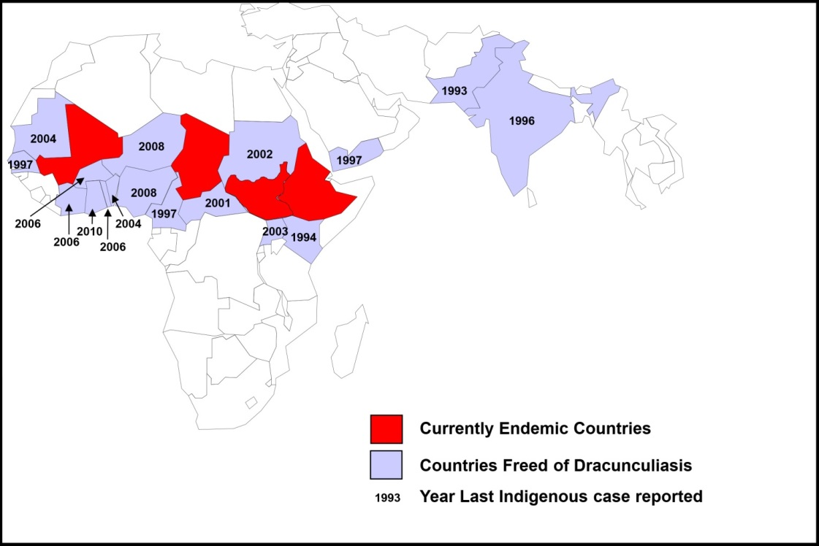

Reported cases of GWD by country, January-August 2014 and January-August 2015

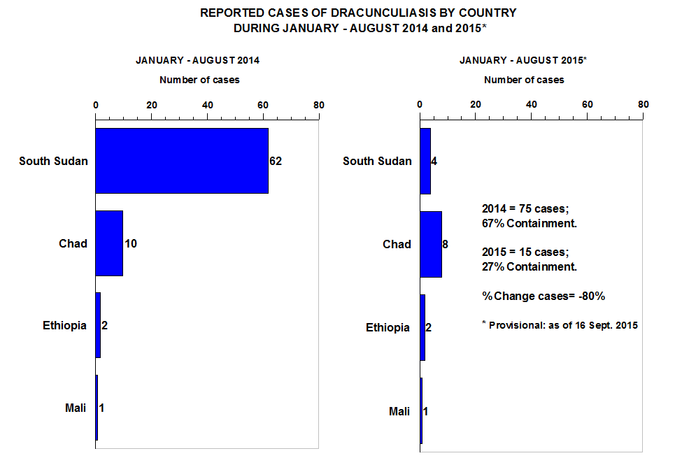

Chad
GWD was rediscovered in Chad in 2010 after an apparent absence of 10 years. Chad did not sustain adequate surveillance during the pre-certification period after it seemed to have interrupted transmission in 2000. Chad may now become the last country to interrupt transmission of the disease. The unexpected outbreak in 2010 occurred in an area that had never seen GWD before. TCC programme staff have enhanced surveillance by training more than 1,800 village volunteers in more than 700 villages. In 2014, Chad had 13 known cases, one less than in 2013.

The atypical epidemiology of GWD in Chad, given the large number of infected dogs and the cases in humans has required research and new strategies.

Insecurity makes it particularly difficult to reach the district of Kyabe, Haraze, and other areas bordering Central African Republic.

Distribution of GWD in Chad, 2014

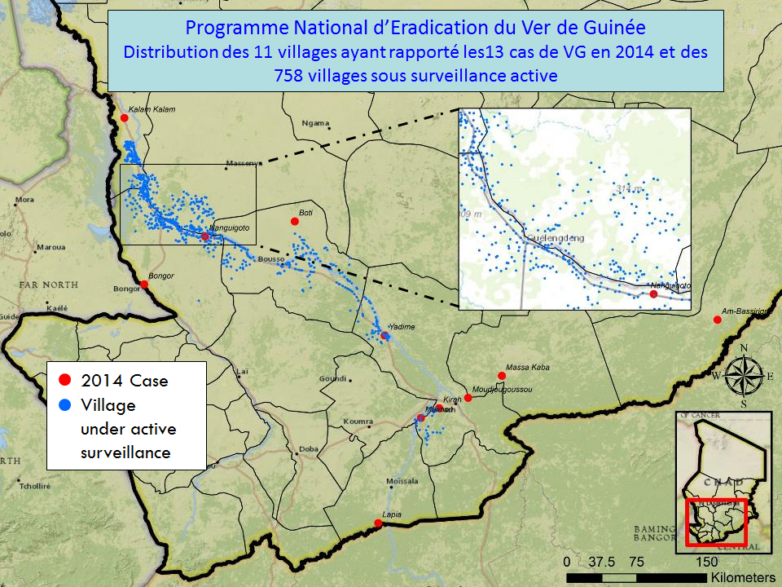

Mali
The number of cases in Mali have reduced from 16,024 in 1992 (when TCC started working with the government on GWD eradication) to 40 in 2014. The majority of the remaining cases are in the north, where migratory communities travel. To improve surveillance of populations living in GWD-endemic areas, 32 supervisory zones have been established.

In March 2012, rebels seized three northern regions, which are the most endemic areas in Mali. As a result, activities largely ceased until 2013. In 2014, the programme has managed to operate in some areas, although challenges remain in accessing Gao, Kidal and Timbuktu Regions due to major conflict.

Figure 6. Distribution of GWD in Mali, 2013-14

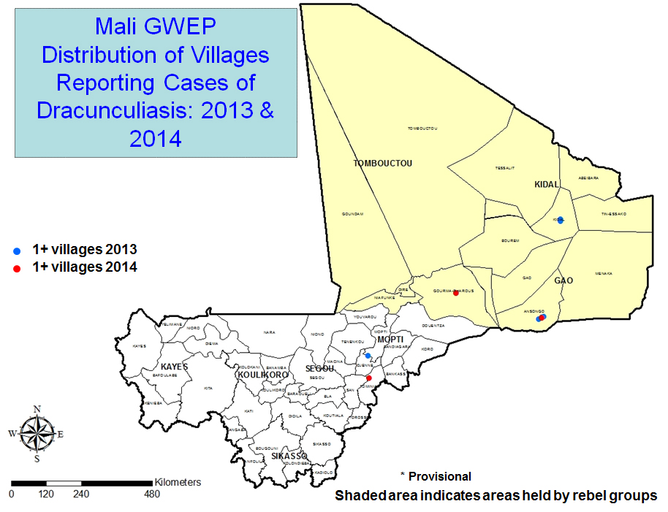

Ethiopia
Most transmission of GWD in Ethiopia was interrupted in 2001, but has continued in the Gambella Region. In 2014, three cases of GWD were reported.

Specimens obtained from a dog in January 2015, and from a dead baboon in June 2015, were both confirmed to be guinea worms. This brings the total known Guinea worm infections in Ethiopia as of July this year to one human, one baboon, and one dog. All three infections were associated with four closely linked villages in Gog district where cases were reported in 2014: since last year, they have had Larvicide applied to surface sources of water every 28 days.

Maintaining surveillance throughout the Gambella Region is challenging, with districts periodically becoming inaccessible due to insecurity and heavy rains during the peak transmission season; and migration of people between South Sudan and Ethiopia posing a risk for continued disease transmission.

Distribution of GWD in Ethiopia 2012-14

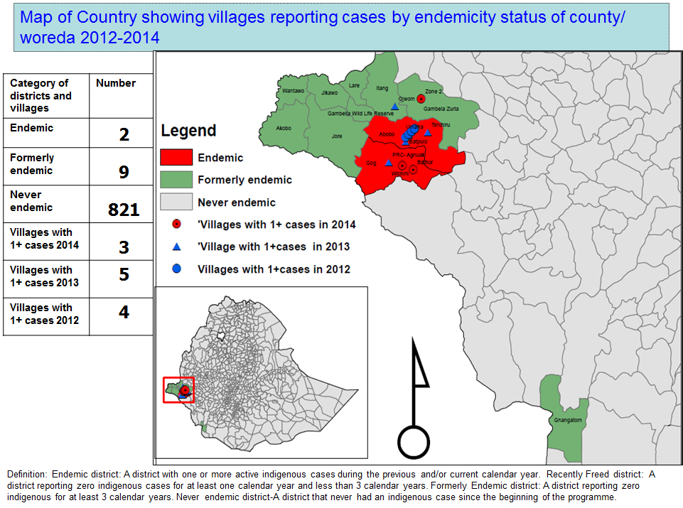

South Sudan
Since 2006, the overall number of Guinea worm cases in South Sudan has been reduced by 99%. South Sudan reported 70 cases in 2014, compared to 113 cases in 2013, which is considered a remarkable success given the political and ethnic hostilities during this period. Reaching Pibor County, parts of Jonglei State, and Unity State remain particularly difficult due to insecurity.

Figure 8. Distribution of GWD in South Sudan, 2014

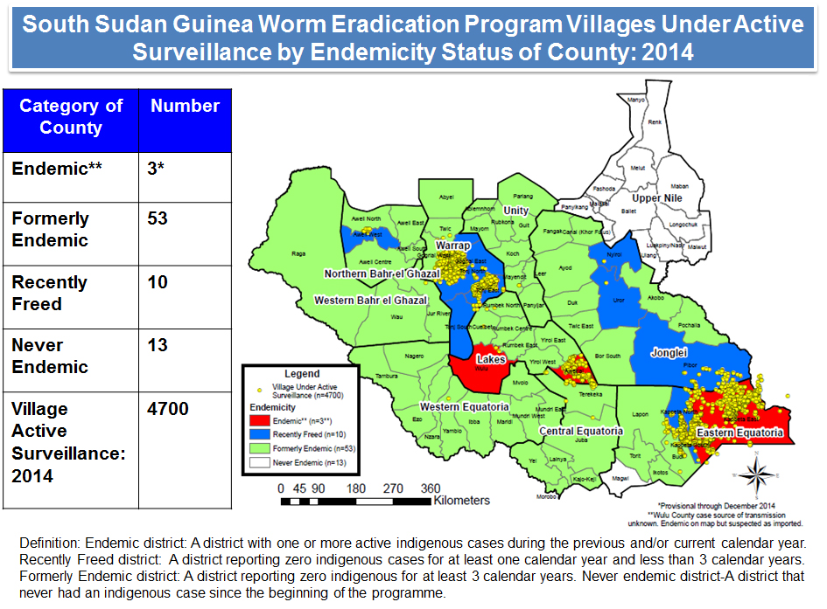

https://www.gov.uk/government/speeches/pms-speech-to-the-un-sustainable-development-goals-summit-2015
Currently over 4,000 villages are under active surveillance in Chad, Ethiopia, Mali and South Sudan. As the number of endemic villages declines, villages will move towards more passive surveillance.
http://www.who.int/neglected_diseases/diseases/en/
See ‘How to Slay a Dragon’, Al Jazeera film by C. Bestall, 19/11/2014, available at: http://www.aljazeera.com/programmes/lifelines/2014/04/how-slay-dragon-2014429133319221182.html
In 2014, of the 126 cases of GWD, 62 were female and 64 were male.
Tayeh et al. 1996. The impact of dracunculiasis on the nutritional status of children in South Kordofan, Sudan. Ann. Trop. Paediatr. 16:221-226.)
Cairncross, S., R. Muller and N. Zagaria. 2002. Dracunculiasis and the Eradication Initiative. Clinical Microbiology Reviews, April 2002, P. 223-246.)
Whitty, C.J,M, (2015) Political, social and technical risks in the last stages of disease eradication campaigns. Int. Health 7 (5): 302-303. doi: 10.1093/inthealth/ihv049
See Carter Center website, available at http://www.cartercenter.org/health/guinea_worm/index.html
Eradication occurs when transmission of disease ceases in every country of the world.
Health education and social mobilisation; filtering of drinking water through cloth or pipe filters; treating sources of drinking water with ABATE® (temephos) larvicide; provision of safe drinking water supply.
WHO’s Weekly Epidemiological Record 83:163-164 (2 May 2008).
Canada, Denmark, Finland, Japan, Kuwait, Norway, Nigeria, Netherlands, Oman, Qatar, Saudi Arabia, United States.
As the goal of eradication becomes closer, the cost per case of GWD increases for the following reasons: -The one year-long incubation period makes it difficult to identify infected carriers. This requires an extensive and intensive surveillance system that detects cases within 24 hours of worm emergence and then an immediate response to prevent transmission. This surveillance must be maintained for at least one year beyond the report of the last case. -Cases must be followed at least every fortnight throughout the calendar year to ensure detection and immediate containment of transmission from additional emerging guinea worms. -There is an absence of infrastructure, such as primary health care facilities, in areas where guinea worm remains prevalent.
https://www.gov.uk/government/speeches/pms-speech-to-the-un-sustainable-development-goals-summit-2015
Britain to protect more than 140 million in global effort to rid the world of neglected tropical diseases. Press Release. 21 January 2011.
As of 2014, this was seen as a move to eradicate GWD from 17 of 21 formerly endemic countries.
Four endemic countries (South Sudan, Mali, Chad and Ethiopia), two formerly endemic countries in the pre-certification phase (Kenya and Sudan), and two countries without a recent history of the disease (Angola and the Democratic Republic of Congo).
Sixty Fourth World health Assembly WHA resolution 64.16, “Eradication of dracunculiasis” (24 May 2011) is available at http://www.who.int/entity/neglected_diseases/mediacentre/WHA_64.16_Eng.pdf
See Carter Center website, available at http://www.cartercenter.org/health/guinea_worm/index.html
As outlined in Table 1, in 2015 so far (January-July) 12 cases had been detected. Full data for the year 2015 will be available in February 2016, at which point DFID will be able to identify the exact number of cases that DFID will have contributed towards reducing during the funding period (November 2015 – December 2016).
In 2014, 76% of cases were contained within 24 hours.
Callahan, K. et al (2013). Contributions of the Guinea Worm Disease Eradication Campaign toward Achievement of the Millennium Development Goals. Plos Neglected Tropical Diseases. 7 (5). Available from: http://www.cartercenter.org/resources/pdfs/news/health_publications/guinea_worm/plos-contributions-of-gw-eradication-toward-achievement-of-MDG.pdf
Belcher DW, Wurapa FK, Ward WB, Lourie IM (1975) Guinea worm in southern Ghana: its epidemiology and impact on agricultural productivity. Am J Trop Med Hyg 24: 243–249. Cited in Callahan, K. et al (2013). Contributions of the Guinea Worm Disease Eradication Campaign toward Achievement of the Millennium Development Goals. Plos Neglected Tropical Diseases. 7 (5). Available from: http://www.cartercenter.org/resources/pdfs/news/health_publications/guinea_worm/plos-contributions-of-gw-eradication-toward-achievement-of-MDG.pdf
This estimated cost includes three meals a day, occlusive bandages, topical antibiotic, a bed mat, a mosquito net, and bed sheets. It does not include worm extraction, since, in most of the endemic countries, public health clinics (not TCC) bear the direct treatment costs for GWD cases.
Belcher DW, Wurapa FK, Ward WB, Lourie IM (1975) Guinea worm in southern Ghana: its epidemiology and impact on agricultural productivity. Am J Trop Med Hyg 24: 243–249. Cited in Callahan, K. et al (2013). Contributions of the Guinea Worm Disease Eradication Campaign toward Achievement of the Millennium Development Goals. Plos Neglected Tropical Diseases. 7 (5). Available from: http://www.cartercenter.org/resources/pdfs/news/health_publications/guinea_worm/plos-contributions-of-gw-eradication-toward-achievement-of-MDG.pdf
The Carter Center (2012) Guinea Worm Wrap Up Reports.
Tayeh et al. 1996. The impact of dracunculiasis on the nutritional status of children in South Kordofan, Sudan. Ann. Trop. Paediatr. 16:221-226.
These costs fall under the ‘Consultants’ budget line.
-Interrupting transmission requires intensified operations during the last phase of the national eradication effort -The one-year-long incubation period makes infected carriers of the disease impossible to pre-identify. The extensive and intensive surveillance system must be maintained for at least three years beyond the report of the last indigenous case. -Surveillance must encompass all places where infected people may be when the GW emerges. -The surveillance system must detect cases of the disease within 24 hours of worm emergence and respond immediately. -Patients must be monitored at least every fortnight for 12 months to detect additional worms that may emerge. The lack of public health infrastructure in areas where GWD is endemic may require national GWEPs to install and operate case containment centres where patients with GWD admit themselves for health care and prevention of transmission.
President Carter Meeting, February 3rd 2015.
WHO, Dracunculiasis Fact Sheet. May 2015. Available on: http://www.who.int/mediacentre/factsheets/fs359/en/
Callahan K, Bolton B, Hopkins DR, Ruiz-Tiben E, Wither PC, et al. (2013) Contributions of the Guinea Worm Eradication Campaign toward Achievement of the Millennium Development Goals. PLoS Negl Trop Dis 7 (5): e2160. Doi :10.1371/journal.pntd.0002160. Available on: http://www.cartercenter.org/resources/pdfs/news/health_publications/guinea_worm/plos-contributions-of-gw-eradication-toward-achievement-of-MDG.pdf
During the course of the campaign to eradicate dracunculiasis, there has never been a single incident of human toxicity related to the use of ABATE larvicide (Temephos).The ABATE larvicide formulation for GWEPs is the 50% emulsifiable concentrate, and the standard dose used for control of cope-pod populations in stagnant sources of drinking water is one part per million, as recommended by the WHO Expert Committee on Insecticides. Assurance of safety of use of ABATE larvicide in actual or potential sources of drinking water is a function of the thorough training of ABATE larvicide application teams, adherence to the CDC Guidelines for Chemical Control of Copepod Populations in Dracunculiasis Eradication Programs, and the experience of ABATE larvicide application cadres in its use (Am J Trop Med Hyg July 2006 vol. 75 no. 1 3-8).
Half-life of approximately 30 days at pH5, 7, and 9 at 25 °C or 20 days on average at various field conditions.
DFID GWEP Environmental Screening Note, 2009.
See within the 2013-2014 CC Annual Report, available at http://www.cartercenter.org/resources/pdfs/news/annual_reports/annual-report-14.pdf
Indirect costs cover overhead expenses incurred in three of TCC’s five departments: Administration, Events, and Facilities. Examples of costs include management salaries, core finance and human resource costs.The subgrant to the WHO was excluded from this calculation, ensuring DFID are not paying twice for indirect costs.
This was evidenced by TCC in the follow up monitoring plan for the due diligence, with documents provided by 23 October 2015.
The most recent of which is included within the Carter Center’s Annual Report 2013-2014.
All biographies of staff involved in the programme are available on TCC website - See for example https://www.cartercenter.org/news/experts/index.html
This will not disaggregate spend by donor on each programme. However, financial reports from TCC to DFID will do so, and in line with the Accountable Grant a statement showing DFID project funding that is certified by an independent and appropriately qualified auditor will accompany the annual audited accounts sent to DFID.
See for example, Eberhard ML, & E., R.-T. (2014). Case Report: Cutaneous Emergence of Eustrongylides in Two Persons from South Sudan. Am J Trop Med Hyg, 90(2), 315-317; Hopkins DR, Ruiz-Tiben E, Eberhard ML, & SL., R. (2014). Progress toward global eradication of dracunculiasis - january 2013-june 2014. MMWR, 63(46), 1050-1054; Jones AH, Becknell S, Withers PC, Ruiz-Tiben E, Hopkins DR, Stobbelaar D, & SY., M. (2014). Logistics of Guinea Worm Disease Eradication in South Sudan. Am J Trop Med Hyg; Mark L. Eberhard, M., Ruiz Tiben, E., Hopkins, D., Farrell, C., Toe, F., Weiss, A.,Hance, Z. (2014). The Peculiar Epidemiology of Dracunculiasis in Chad. Am. J. Trop. Med. Hyg., 90(1), 61-70; DRAFT (PENDING PUBLICATION), Legacy of Ghana’s Effort to Eradicate Guinea Worm Disease and How to Slay a Dragon, Al Jazeera film by C. Bestall, 19/11/2014.
For example, the Ghana Community Based Surveillance System (CBSS) – noted in Nyonator et al, ‘The Ghana Community-based Health Planning and Services Initiative for scaling up service delivery innovation’, Health policy and Planning, 20(1), 25-34.

