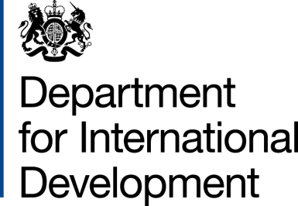 |  |  | 
 | Xxx xxx  Royal Danish Embassy Office  Address: xxx xxx | T:  DFID Zimbabwe
23 January 2014

Amendment Number 2 to the Delegated Cooperation Agreement (DCA) between the Government of United Kingdom of Great Britain and Northern Ireland acting through DFID, and the Royal Danish Government acting through the Royal Danish Embassy Office in Harare.

- I refer to the DCA signed by DFID and the Royal Danish Embassy Office on 12 December 2011 and the subsequent Amendment Letter Number 1 of 15 January 2014 for the Zimbabwe Agricultural Development Trust (ZADT) project. Following recent discussions, DFID proposes to change the end date to 31 December 2015.
- I therefore propose that the end date of 31 December 2013 in section one on page 1, and paragraphs II and VII on pages 2 and 6 respectively of the original DCA as amended by Amendment Letter Number 1 of 15 January 2014 be deleted and replaced by 31 December 2015.
- This letter of amendment will place on record our common understanding of the above change and will come into operation on the date you sign your confirmation below. This note will be known as Amendment No. 2 of 2014.
- Please sign both copies of this letter; return one to me and retain the other for your own records.

Signed for DFID:

_____________________________________
Head of Office: DFID Zimbabwe

Confirmed by:

__________________________________________________
Counsellor / Deputy Head of Mission: Royal Danish Embassy Office

Date: _____________________

