DFID, 22 Whitehall, London SW1A 2EG | www.gov.uk/dfid | +44 (0)20 7023 0000
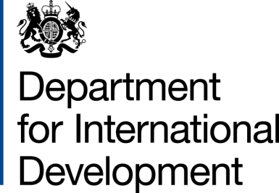 |  |  | 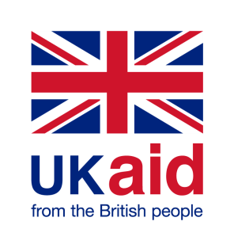
 | USDA/ARS/AFM  5601 Sunnyside Avenue,  Room 3-2168B  Beltsville, MD 2070 | T +44 (0)207 023 0924  a-leslie@dfid.gov.uk
 | 11 December 2014

Dear Madam
MEMORANDUM OF UNDERSTANDING - AMENDMENT
(AgMIP) Agricultural Model Intercomparison and Improvement Project. The Future of Food and Farming in South Asia and Sub Saharan Africa (202108)
1. I refer to the Memorandum of Understanding (MOU) for the above project signed by DFID and the United States Department of Agriculture Agricultural Research Service (USDA-ARS) on 6 June 2012. Following recent discussions and correspondence, DFID propose to increase the amount made available to the USDA-ARS by up to £1,831,812, (One Million, Eight Hundred and Thirty One Thousand Eight Hundred and Twelve pounds sterling pounds sterling and to change the end date to 30 October 2016.
2. I propose that the figures and words "£6,640,252 (Six Million, six hundred and forty thousand, two hundred and fifty two pounds sterling)" in paragraph 1 of the original MOU be deleted and replaced by the figures and words "£8,472,064 (Eight Million, four hundred and seventy two thousand, and sixty four pounds sterling)”.
3. I also propose that the end date of 31 December 2014 in paragraph 2 of the original MOU be deleted and replaced by 30 October 2016.

4. As soon as this amendment to Memorandum of Understanding comes into operation, DFID will make payments in accordance with the following payment schedule:
(A) By March 15, 2015 – three hundred thousand British Pound Sterling (£300,000);
(B) By June 15, 2015 – two hundred thousand British Pound Sterling (£200,000);
(C) By September 15, 2015 – two hundred thousand British Pound Sterling (£200,000); and
(D) By December 15, 2015 – four hundred thousand British Pound Sterling (£400,000)
(E) By June 15, 2016 – two hundred thousand British Pound Sterling (£200,000)
(F) By September 15, 2016 – up to five hundred and thirty one thousand, eight hundred and twelve British Pound Sterling (£531,812)
Note : 1. Payment value and timing subject to reconciliation of previously disbursed funds and adjustments to forecasting reported Payments will be made in Pounds Sterling. The Total is subject to and dependent on the agreed budget drawn up by the AGMIP Principal Investigators for Phase 2 of this project. The agreed budget shall not exceed £3,761,349 and is subject to amendment by DFID.
Amounts disbursed to AgMIP under previous Memorandum of Understanding: £6,640,252.
Total Amount to be disbursed through this amendment agreement: Up to £1,831,812 (see Note 1).
5. This letter of amendment will place on record our common understanding of the above change and will come into operation on the date you sign your confirmation below. This note will be known as Amendment No.2 2014.
6. Please sign both copies of this letter; return one to me and retain the other for your own records.

Signed for DFID: Confirmed by USDA-URS:
Name: Name:
Position: Team Leader Position: Authorized Departmental Officer
Climate and Environment Research Team USDA/ARS/AFM
Research and Evidence Division
Department for International Development
Date: Date:

