Annual Review - Summary Sheet

This Summary Sheet captures the headlines on programme performance, agreed actions and learning over the course of the review period. It should be attached to all subsequent reviews to build a complete picture of actions and learning throughout the life of the programme.

Title: State Accountability & Voice Initiative

Programme Value: £28,878,066 (present contract, 2013); £34,683,499 (proposed extension, 2014) |  | Review Date: 24th Nov – 5th Dec 2014
Programme Code: | Start Date: Aug 2008 | End Date: July 2015 (present contract); 30th April 2016 (proposed extension)

Summary of Programme Performance
Year | 2009 | 2010 | 2011 | 2012 | 2013 | 2014
Programme Score | n/a | 2 | 2 | A | A+ | A+
Risk Rating | med/high | med/high | med/high | med/high | med/high | low

Summary of progress and lessons learnt since last review

SAVI has made good progress over the past year, and has achieved results moderately above expectation giving the programme an A+ performance rating. Its success in promoting more accountable governance has led to increasingly tangible results in terms of improvements to public policy and service delivery. SAVI has documented 89 cases where its partners have played a role in influencing the design and delivery of public policy and programmes. SAVI has been able to deliver these changes by mobilising actors in civil society, the media and State Houses of Assembly to advocate for change. Its particular value added has been to build confidence and capacity amongst these actors and to build connections between them. The results of this work have had a powerful demonstration effect that is increasingly generating cases of replication where practices promoted by SAVI have spread beyond its immediate partners and states.

Over the past year the benefits of SAVI’s expansion into three additional northern states (Zamfara, Katsina and Yobe) which started in 2011/12 have become increasingly clear. Rather than overstretching SAVI’s capacity (a risk identified in earlier reviews), SAVI’s expansion appears to have spurred a valuable process of innovation and adaptation, which has resulted in SAVI achieving more rapid results (and at lower cost) in the new states than in the original five. SAVI attributes this success to a more hands-off approach to civil society development incorporating a broader set of partners, as well as a greater focus on the media as an instrument to mobilise citizens and civil society around governance issues.

Over the past year SAVI has commenced full implementation in another two states: Anambra and Niger. It is still too early to assess results in these states. With only 16 months of the programme remaining (until April 2016) the results that will be delivered in Anambra and Niger before programme completion will be quite modest. As argued in the 2013 annual review, SAVI’s work in Anambra and Niger can only be justified if there is a commitment to continued engagement in these states through the successor programme.

This review has been conducted jointly with the 2014 Annual Review of the State Partnership for Accountability, Responsiveness and Capability (SPARC). Generally, coordination between the programmes has been found to be strong, and there is substantial case study evidence showing that the results of both programmes have been enhanced by effective joint working. Specific findings relating to SAVI/SPARC collaboration are covered in a separate narrative report.

This review has also taken place in parallel to design work on successor programmes for SAVI, SPARC and FEPAR. The narrative report will also discuss key issues for SAVI in terms of managing the transition, including measures to strengthen the programme’s federal dimension.

Summary of recommendations for the next year

The recommendations for the coming year are focussed on three main challenges: (1) preparing and responding to the February 2015 elections, (2) lesson learning on the relative effectiveness of different approaches that SAVI has experimented with, and (3) consolidating progress while responding to new priorities anticipated in the design of the successor programme. The main recommendations are as follows:

1) Complete an internal evaluation of key aspects of SAVI’s performance by end June 2015 including comparison of the approaches used to promote issue-based advocacy in different states and their relative effectiveness.

2) Include in the internal evaluation a study of the relative effectiveness of different approaches to replication.

3) Conduct a review of the extent to which members of Advocacy Partnerships have benefitted from per diem payments and low rate consultancy fees, and whether this has distorted incentives and undermined group independence and sustainability. Develop clear guidelines on the use of such payments.

4) Undertake a review post-elections of whether new issues have gained political traction and popular interest and whether it will be possible to address these through existing, modified or new advocacy partnerships. This should be part of a broader revision of state level political economy analyses to be undertaken jointly with SPARC.

5) Continue exploring opportunities to strengthen civil society engagement in monitoring downstream budget and policy implementation including expenditure tracking, monitoring the delivery of services on the ground and completion of public works. Include an assessment of the relative effectiveness of alternative approaches in the proposed internal evaluation.

6) Step up SAVI’s work linking community level groups and service user groups to state level policy, budget and planning processes. This should usually be conducted in partnership with other programmes. There is a particular opportunity for joint working with M4D, which should be urgently explored.

7) Step up engagement with the media in the pre-and post-election period to train and mentor media houses on covering election processes, and encourage additional programming on key policy questions, including interviews and phone ins with prospective candidates and incoming administrations (possibly following the model of the Public Policy Dialogues).

8) Investigate the reasons for the large jump in civic education scores recorded under indicator 3.3.

9) As part of the proposed internal evaluation conduct a study on different approaches used by SAVI and partners to promote civic education, and their relative effectiveness. Consider opportunities to apply techniques of social marketing to civic education.

10) Explore options for further development of federal level work in support of State Houses of Assembly including through joint programming with FEPAR and DDiN 2.

11). Continue to follow-up progress on the constitutional review process with respect to SHoA autonomy.

12) Within three months of the February elections conduct an assessment of the political makeup of the legislatures, identifying opportunities and constraints for SAVI support. Undertake this work as part of broader state level political economy updates to be conducted jointly with SPARC.

13) Work with DFID to develop a common set of cross programme guidelines on good practice in promoting voice and accountability in order to promote more harmonised approaches.

14) Continue to develop knowledge management products on the SAVI website. Ensure that online material is organised in a form that can easily be transferred to the successor programme.

A. Introduction and Context

DevTracker Link to Business Case:
DevTracker Link to Log frame:
Outline of the programme

Unaccountable governance and attendant corruption are major reasons for Nigeria’s growing inequality and lack of progress in poverty reduction. Public policy and public expenditure tend to be oriented towards serving patronage networks and winning elections rather than the provision of public goods and services. One of the main reasons for this is the lack of citizen demand for more accountable governance. Change agents who could act as potential reform constituencies tend to be disconnected, disorganised, lacking capacity, lacking voice and lacking connections to political processes.

The State Accountability and Voice Initiative (SAVI) works at state level to build the capacity of constituencies who can create pressure for more accountable governance. It aims to deliver the following outcome: State houses of assembly, civil society, media and citizens demonstrate more effectiveness in demanding better performance from government and holding government to account.

SAVI works to deliver five outputs:

- Civil society demonstrates a replicable and sustainable approach to issue-based policy advocacy and monitoring.
- Civil society demonstrates a replicable and sustainable approach to facilitating public involvement in government budget and planning processes.
- More open and inclusive systems of communication and improved understanding between citizens, CS, media, SHoA and government.
- Improved systems of transparency, public engagement and financial oversight in state houses of assembly
- Other development partners take a more sustainable and replicable approach to strengthening voice and accountability.

By strengthening the demand-side of governance reform, SAVI complements the supply-side work of the State Partnership for Accountability, Responsiveness and Capacity (SPARC), which provides technical assistance to strengthen systems and processes in state governments, which can help to deliver more accountable governance. SAVI was also designed to support the work of the other State Level Programmes (SLPs) including the Partnership for Transforming Health Systems [PATHS], Education Sector Support Programme in Nigeria [ESSPIN]) and Growth and Employment in States [GEMS]) at state level.

SAVI began work in 2008 in 5 States (Enugu, Jigawa, Kaduna, Kano and Lagos), and in 2011 extended its reach to three additional states (Zamfara, Katsina and Yobe). In 2013 SAVI began inception activities in Anambra and Niger, where in 2014 it began full implementation.

SAVI had been due to end in July 2015, but it is now proposed to extend the programme to the end of April 2016. The time extension (linked to a £6 million additional budget) will enable SAVI to consolidate and embed results, fully document lessons learned, and enable a smoother transition to the successor programme including a two month overlap period.

B: PERFORMANCE AND CONCLUSIONS

Annual outcome assessment

SAVI has made good progress against its outcome indicators, with most of the scores having moderately or substantially exceeded expectation. An overall rating of A+ appears justified at outcome level.

Outcome indicator 1 measures the level of functionality of State Houses of Assembly as agents of voice and accountability as measured by the SAVI Governance Index. The scores are derived from expert ratings (measured on a five point scale) provided by the ‘friends of SAVI’ group in each state.

Outcome indicator 2 measures the level of functionality of civil society as agents of voice and accountability as measured by SAVI’s Governance Index.

Outcome indicator 3 measures the level of functionality of the media as agents of voice and accountability, again measured by the SAVI Governance Index.

Outcome indicator 4 measures the cumulative number of demonstrable changes in policy and implementation by state government in response to public demand where there is evidence of attribution to SAVI's approach.

Outcome Indicator | Late 2013 score | Late 2014 score | Late 2014 target | Best performing states (change in ratings 2013-14) | Worst performing states (change in ratings 2013-14) | Rating
#1  (SHoA) | SLP states 3.3  ZKY states 3.2 | SLP states 3.5  ZKY states 3.5 | SLP states 3.47  ZKY states 2.62 | Strongest gains in Katsina (+1.6),  Yobe (+0.9), Zamfara (+1.1) | Weakest gains in  Lagos (+0.0),  Jigawa (+0.2) Enugu (+0.1) | A+
#2  (CS) | SLP states 3.5  ZKY states 2.2 | SLP states 4.1  ZKY states 3.2 | SLP states 3.33  ZKY states 2.13 | Strongest gains in Katsina (+0.9),  Yobe (+0.9), Zamfara (+1.1)  Lagos (+1.0) | Weakest gains in  Jigawa (+0.1)  Kano (+0.4) | A++
#3  (Media) | SLP states 3.5  ZKY states 2.8 | SLP states 3.7  ZKY states 3.4 | SLP states 3.47  ZKY states 3.17 | Strongest gains in Katsina (+0.6),  Enugu (+0.7) Zamfara (+0.8) | Weakest gains in  Lagos (+0.0)  Jigawa (+0.1)  Kano (+0.1) | A+
#4 | 75 | 89 | 45 | Greatest number of demonstrable changes reported in Jigawa, Lagos and Kano | Least number of demonstrable changes reported in Zamfara, Katsina and Enugu | A++

Overall output score and description

Overall output score: A+ outputs moderately exceeded expectation.

Individual output scores (see part C for details):
Output 1: A++ (20%); Output 2: A+ (20%); Output 3: A+ (20%); Output 4: A+ (30%); Output 5: A+ (10%)
Key lessons

Over the past year there has been a solid improvement in governance index scores (outcome indicators 1-3) measuring the functionality of State Houses of Assembly, civil society and the media. As shown in the above table the strongest improvements have been in the new states (Zamfara, Katsina and Yobe), whereas in the original five SLP states the gains have been more modest. There are three likely explanations for this difference: (1) SAVI has learned from experience in the original five states and has used this to work more efficiently in the new states, (2) early engagement in the new states may have focussed on quick wins (which have mostly been exhausted in the original states), and (3) SAVI has employed more effective ways of working in the new states, including better staff recruitment and performance assessments. The third explanation is in line with SAVI’s own assessment that it has achieved more rapid results in the new states by working with a wider range of partners in a more flexible and hands-off manner, and has utilised the media more effectively to mobilise citizen engagement through the Public Policy Dialogues. This has raised a question as to whether the approach followed in the original five states may have been too internally focussed on immediate partners, and not sufficiently engaged with broader civil society. The emerging results may support this assessment, but further evidence will be needed in order to draw a robust conclusion. For this reason a key recommendation of this Annual Review is that SAVI should conduct a detailed internal evaluation within the next six months including an assessment of the comparative effectiveness of the approaches used in the original five states and the new states. There is still some time remaining in the SAVI programme for the conclusions of this work to be applied. However, mostly the findings will be of benefit to the successor programme.

Under outcome indicator 4, SAVI is increasingly able to demonstrate that it has supported partners whose advocacy work has contributed to tangible changes in policy and service delivery. SAVI has recorded 89 case studies of ‘demonstrable changes in policy and implementation by state government in response to public demand where there is evidence of attribution to SAVI's approach.’ In 2013 SAVI recorded 75 case studies, although the Annual Review was rather critical of the standard of documentation and possible inflation in claims. The 2014 Annual Review finds that SAVI has substantially improved the quality of documentation supporting these case studies and has responded to the recommendations of the 2013 Annual Review. SAVI has also been able to categorise the case studies according to the type, scope and scale of the changes and whether these are one off events or part of a trend. Summary findings are reported below:

- The majority of reported changes (54%) relate to announced changes in policy. There are fewer instances of changes in budget allocations (9%), budget releases (12%) or evidence of changes at the level of policy implementation (17%).

- Most of the reported changes (63%) reflect cases where issues have been addressed using existing processes of policymaking, budget and planning, procurement and service delivery without reforms being made to these processes. There was evidence of reform to these processes in 37% of the reported changes.

- Half of the reported changes describe one-off actions, which are the first example of a particular type of change occurring in a state. 23% of reported cases reflect a change building on earlier changes, and 28% describe a process of scaling up or scaling out changes to include more across-the-board reforms and extension into other sectors.

- 56% of the reported changes are relevant to gender and social inclusion issues and are reported to have strengthened the voice of women and other socially excluded groups.

- There are important differences between states in the number of reported changes. There are many more cases reported in the more established SLP states where SAVI has had more time to deliver results. Jigawa, Lagos and Kano and notable leaders. However, the newer ZKY (Zamfara, Katsina and Yobe) states are also reporting an encouraging level of results, including at the level of implementation.

Further analysis of the types of changes recorded, including an assessment of the significance of the changes, demonstrates that SAVI’s most important results relate to downstream changes in policy implementation and budget allocations and releases. Some significant examples that are reported to have occurred during 2014 are presented below:

- Jigawa (case study JG 5.3). The Jigawa State Ministry of Health creates a separate budget line for Free Maternal Neonatal and Child Healthcare (FMNCH). MNCH analysis of the 2013 Ministry of health budget found that FMNCH funding was lumped together with nutrition and the Drug Revolving Fund. They recommended setting up a separate FMNCH budget line. The Ministry of Health followed this recommendation and it was reflected in the 2014 Appropriation Bill.

- Kano (case study KN 4.3). The Kano State Government creates a budget line and allocated NGN600M (£2.4M) in the 2014 budget for persons with disability (PWDs) following a public hearing during which SAVI-supported GSI Advocacy Partnership and other CS groups made well-articulated and evidence-based presentations. The governor thereafter launched a 'development roadmap for PWDs’ in March 2014.

- Kano (case study KN 6.2). Kano State Ministry of Education increases the number of female principals in secondary schools in response to advocacy SAVI-supported Education Support Group. This represents a change in policy by the Ministry of Education to improve the retention of female teachers in schools located in rural areas.

- Lagos (case study LG 4.1). The Lagos State Government commences the implementation of the Special Peoples Law on Disability by mainstreaming disability issues into the 2013 budgets of three key Ministries. After signing the bill into law in 2012, the Governor established the Lagos State Office of Disability Affairs (LASODA).

- Lagos (case study LG 2.3). The Lagos State Government demonstrates a more open, inclusive, accountable and an institutionalised approach to governance with the inauguration of a Board for the Procurement Agency following consistent advocacies by civil society groups.

- Zamfara (case study ZM R2). State Government approved payment of NGN 100 million monthly to settle pension arrears for retired civil servants following evidence-based advocacy by CS groups. The state government responded and approves the monthly release of NGN100 million to pensioners after three years of battle.

- Katsina (case study KT 2.1). Katsina State Government released NGN196.5M (£786,000) as pension arrears in February 2014 following a call made by SAVI-supported Katsina Budget Awareness Initiative (KBAI) during the presentation of its Position Paper to the Katsina State House of Assembly after observing the 2014 Budget process.

Key actions (for outcome level only)

Progress of 2013 Annual Review Recommendations

Recommendation | Action taken by SAVI
Investigate apparent discrepancies between output and outcome scores, notably for the functionality of civil society in Katsina, the functionality of State Houses of Assembly in Kaduna and Kano, and the functionality of the media in Zamfara | Investigations were undertaken in all 3 states and revealed problems stemming from the composition and group dynamics of the ‘Friends of SAVI’ monitoring groups, as well as the quality of their orientation, the guidance given them, and oversight of their work. Corrective actions have been taken, and new guidance issued to all states.
Fully implement the recommendation of the 2012 Annual Review to strengthen the documentation of case studies supporting outcome indicator 4. Conduct an urgent quality review of the existing results evidence sheets | The 'results evidence sheet' (RES) for capturing, qualifying, evidencing and analysing outcome indicator 4 results has been substantially modified. The new format was field-tested and finalised in early 2014, and rolled-out for use in all SAVI states in subsequent quarters, with extensive national TA support to ensure effective utilisation. The 2014 Annual Review finds that the quality of documentation for the case studies has markedly improved over the past year.

Recommendations of the 2014 Annual Review

No specific recommendations at outcome level. All recommendations follow in section C.

Has the logframe been updated since the last review?

SAVI has made a few changes to output 5 indicators since the last review to enable more disaggregated monitoring of the uptake of SAVI’s approach by other development partners. The main changes have been:
- Rewording of Indicators 5.1 and 5.2 to differentiate between the process of influencing other development partners as ‘individuals’ (5.1) and as ‘organisations’ (5.3).
- Disaggregation of the milestones and targets for Indicators 5.1 and 5.2 to reflect SAVI’s disaggregation of the influencing process into measurable stages of progress.
- Introduction of a new indicator, Indicator 5.3, to measure the depth of learning by other programmes in terms of the aspects of SAVI’s approach they attempt to replicate.

These changes were acknowledged and endorsed by the review team in the 2013 ARIES report. As a result of this, new retrospective baselines and mid-2015 targets (raised above previous levels) were established by each state team for the newly disaggregated aspects of Indicators 5.1 and 5.2.

C: DETAILED OUTPUT SCORING

Output Title | Civil society demonstrates a replicable and sustainable approach to issue-based policy advocacy and monitoring
Output number per LF |  | Output 1 | Output Score | A++
Risk: |  | Low | Impact weighting (%): | 20%
Risk revised since last AR? |  | No | Impact weighting % revised since last AR? | No

Indicator(s) | Milestones | Progress
Indicator 1.1 measures the strength of civil society partnerships in terms of their internal capacity, external relations and skills in policy advocacy and monitoring.  The indicator is based on a self-assessment tool completed by the Advocacy Partnerships (Partnership Capacity Assessment). | On a five-point scale the late 2014 target for the average PCA score for all Output 1 APs was set at:  SLP states: 3.53 ZKY states: 2.17 | The average PCA score rose to 4.1 (from 3.3 in late 2013) in the original five SLP states (Enugu, Jigawa, Kaduna, Kano, Lagos) by the end of 2014, and to 2.9 (from 1.5) in the 3 new ZKY states (Zamfara, Katsina and Yobe).  Improvements for this indicator have been most pronounced in Katsina and Enugu this year. In no state was there any regression or stagnation of scores for this indicator.  Rating A++
Indicator 1.2 measures the level of independence of the Advocacy Partnerships from SAVI using the same PCA tool as for indicator 1.1. | This was set at:  SLP states: 3.70 ZKY states: 2.07 | The average score across the APs for this indicator at the end of 2014 was 4.0 (up from 3.4) in the original 5 SLP states and 2.9 (up from 1.3) in the 3 new ZKY states.  Improvements for this indicator have been most evident in Katsina and Yobe this year. All states recorded an increment except for Kano where there was a slight regression (-0.1).  Rating A++

Indicator 1.3 records cases of replication where civil society partnerships that are not directly supported by SAVI have adopted aspects of the approach used by SAVI supported partners. Each count is recorded & evidenced in state replication diaries. | The target for all 8 states was set at 25 | SAVI reports 61 replication cases so far across all 8 states (SLP & ZKY), up from 38 in late 2013.  Improvements for this indicator have been most evident in Enugu and Lagos this year. All states recorded an increment except for Katsina.  Rating A++

SAVI has made good progress against all three output indicators, with all the scores having substantially exceeded expectation. A rating of A++ appears justified for this output.

Key Points
There has been very good progress against output 1 over the past year. The large increase in scores in Zamfara, Katsina and Yobe are encouraging given that only limited progress had been recorded in these states in 2013. Advocacy Partners in these states are now at the stage of building linkages with media and State Houses of Assembly (the triangle state in SAVI’s theory of change). In the original SLP states most of the Advocacy Partnerships are longer established and have reached the stage of demonstrating results and promoting replication of their approaches.

SAVI considers that its approach to delivering output 1 has been substantially different in the new states to the original model used in the five SLP states. In the new states SAVI appears to have reached out to a broader range of potential partners, and more actively used processes of media engagement (the Public Policy Dialogues) to identify potential issues and coalitions. Reflecting this broader engagement, the Advocacy Partnerships supported by SAVI in the new states have tended to cover a more diverse and fluid set of issues. There appears to be a difference in SAVI’s style of working with Advocacy Partnerships between the two groups of states with greater focus on organisational development and detailed work planning in the original five states, and greater focus on network building in the newer states.

There are also questions about the level of dependence of some of the more established Advocacy Partnerships on SAVI. While SAVI does not provide grants to these organisations, it does provide financial assistance for specific activities, and members of Advocacy Partnerships also benefit from per diem payments for participation in workshops and sometimes consultancy fees paid by SAVI. The significant use of low rate National TA payments by some state teams had not been fully appreciated, but has come to light following the establishment of a SAVI TA database (a consequence of a 2013 Annual Review recommendation). Low rate technical assistance payments appear to have been most significant in Lagos raising questions about the sustainability of Advocacy Partnerships and motivations of their members.

As SAVI’s approach to supporting Advocacy Partnerships evolves, it will be necessary to consider whether changes are required to monitoring tools, and whether indicators 1.1 and 1.2 are still suited to the approach that SAVI has put in place in the new states. The key question is whether the Partnership Capacity Assessment tool (a self-assessment exercise requiring a level of organisation and self-identification) is fully appropriate for the looser and more fluid coalitions in the new states, and whether a greater emphasis on measuring broader connections and networks between wider sets of partners is warranted. This question should be addressed by the proposed internal evaluation.

Summary of responses to issues raised in previous annual reviews

Recommendation | Action taken by SAVI
Conduct a review of training and other forms of capacity building support offered to members of Advocacy Partnerships … | Development of an M&E and quality control system for short term TA. This has yet to be extended to LT-TA inputs to partners, although an external review of all LT-TA 'facilitation skills' has also been conducted.
Fully document existing training packages and approaches before programme closure, and make these available online to civil society in Nigeria and abroad …
Introduce systematic quality controls for training activities …
Develop and deploy 2-3 more specialist training modules focussed on policy advocacy for specific subject areas … | The core technical team have begun 'packaging' the primary elements of SAVI's broader approach to 'empowering' partners: i.e. use of 'self-assessment' followed by 'strategic planning' and 'process engagement' inputs to identify and plan appropriate capacity building, mentoring and hands-on learning support as well as specific training inputs, separately for CS, Media, SHoA, G&SI and Federal. They have yet to begin packaging specific training inputs provided by ST-TA that stand out as critical elements within this overall capacity building process. This will commence in 2015.
Introduce a structured programme for the more regular mentoring of Advocacy Partnerships in state by specialists recruited in Nigeria with sectoral expertise and policy advocacy …

Strengthen the monitoring of indicator 1.3 through the use of more complete replication diaries …. | This annual review has verified the improved quality of replication diaries. SAVI staff have improved and are making use of more comprehensive evidence-based replication diaries to document how civil society partnerships that are not supported by SAVI have adopted elements of SAVI’s approach, including documentation of specific events and processes that indicate the influence of SAVI.
Include in next year’s Annual Review or Project Completion Review an online or telephone questionnaire sent to organisations that SAVI claims are replicating the approach demonstrated by SAVI and its supported partners. | Not yet done. Recommendation to undertake this study as part of the proposed internal evaluation.

Recommendations for the 2014 Annual Review

R1) Complete an internal evaluation of key aspects of SAVI’s performance by end June 2015 including comparison of the approaches used to promote issue-based advocacy in different states and their relative effectiveness focussing particular on apparent differences between the original 5 SLP states and the new states (Zamfara, Katsina and Yobe). Consider whether output indicators 1.1 and 1.2 require modification in the light of adaptations to SAVI’s approach.

R2) Include in the internal evaluation a study of the relative effectiveness of different approaches to replication. One source of evidence could be an online or telephone questionnaire sent to organisations who may have been influenced by SAVI (repeat of 2013 recommendation).

R3) Conduct a review of the extent to which members of Advocacy Partnerships have benefitted from per diem payments and low rate consultancy fees, and whether this has distorted incentives and undermined group independence and sustainability. Develop clear guidelines on the use of such payments.

R4) Undertake a review post-elections of whether new issues have gained political traction and popular interest and whether it will be possible to address these through existing, modified or new advocacy partnerships. This should be part of a broader revision of state level political economy analyses to be undertaken jointly with SPARC.

Output Title | Civil society demonstrates a replicable and sustainable approach to facilitating public involvement in government budget and planning processes.
Output number per LF |  | Output 2 | Output Score | A+
Risk: |  | low | Impact weighting (%): | 20%
Risk revised since last AR? |  | No | Impact weighting % revised since last AR? | No

Indicator(s) | Milestones | Progress
Indicator 2.1 measures the strength of Output 2 Advocacy Partnerships in terms of their internal capacity, external relations and skills in engaging state budget and planning processes.  The indicator is based on the same Partnership Capacity Assessment tool used for Output 1. | On a five-point scale the late 2014 target for the average PCA score for all Output 2 APs was set at:  SLP states: 3.50 ZKY states: 2.20 | The average PCA score rose to 3.9 (from 3.2 in late 2013) in the original five SLP states (Enugu, Jigawa, Kaduna, Kano, Lagos) by the end of 2014, and to 3.3 (from 1.7) in the 3 new ZKY states (Zamfara, Katsina and Yobe).  Improvements for this indicator have been most pronounced in Katsina and Enugu this year. In no state was there any regression or stagnation of scores for this indicator.  Rating A++
Indicator 2.2 measures the level of independence of the Advocacy Partnerships from SAVI using the same PCA tool as for indicator 2.1. | This was set at:  SLP states: 3.77 ZKY states: 2.03 | The average score across the APs for this indicator at the end of 2014 was 3.8 (from 3.4 in late 2013) in the original five SLP states and 3.0 (up from 2.7 in later 2013) in the 3 ZKY states.  Improvements for this indicator have been most evident in Katsina and Yobe this year. All states recorded an increment except for Kano where there was a slight regression (-0.1).  Rating A+
Indicator 2.3 records cases of demonstration and replication where civil society partners supported by SAVI under Output 2 provide direct support to partnerships and platforms supported and replicated under Output 1 to engage state budget and planning processes. Each count is recorded & evidenced in state replication diaries. | The target for all 8 states was set at 43.3 | SAVI reports 59 replication cases so far across all 8 states (SLP & ZKY), up from 39 in late 2013.  Improvements for this indicator have been most evident in Enugu and Lagos this year. All states recorded an increment except for Katsina.  Rating A+

SAVI has made good progress against all three output indicators, with most of the scores having moderately or substantially exceeded expectation. A rating of A+ appears justified for this output.

Key Points

Following the recommendation in the 2013 Annual Review, SAVI has increased its focus on downstream issues of policy implementation under output 2. This includes work on expenditure tracking, monitoring the delivery of services on the ground and completion of public works. The original model developed by the Project Monitoring Partnership in Jigawa is increasingly being replicated (e.g. the APaGG group in Enugu). SAVI continues to support civil society participation in upstream budget and planning processes (e.g. MTSS) in partnership with SPARC. However, opportunities for engagement in these processes may be limited during election year.

SAVI has been experimenting with innovative models to link community level organisations to higher level budget and planning processes at LGA or state level. This includes the work of the Know Your Budget partnership in Kaduna which is organising a series of zonal town hall meetings to discuss local development priorities, which are then fed into state level advocacy processes. In Anambra SAVI has entered into a partnership with the Voices to the People (V2P project) working with Town Unions to develop Community Action Plans that will feed into state level budget and planning processes.

These experiences indicate an important opportunity for SAVI to step up its work in linking community level groups and service user groups to state level policy, budget and planning processes. While SAVI is not equipped to undertake community level advocacy on its own, there are an increasing opportunities to partner with other organisations to forge such linkages. There is a particular opportunity to strengthen collaboration with the Mobilising for Development (M4D) project, which operates in Kaduna, Kano and Jigawa on LGA governance issues. Although there are obvious complementarities between SAVI and M4D (and both are implemented by the same contractor), collaboration between the two programmes is not yet well developed (exploratory discussions are underway).

Summary of responses to issues raised in previous annual reviews (where relevant)

Under the 2013 Annual Review the recommendations for output 1 were also applicable to output 2. See the preceding section for details on the extent of adoption of these recommendations.

One additional recommendation was proposed for output 2.

Recommendation | Action taken by SAVI
The model developed by the Project Monitoring Partnership in Jigawa should be encouraged and extended to more other states where alignment of interest exists. This should include further efforts to share experiences and lesson learning between states, and to make available required technical expertise on monitoring of construction standards and budget adherence. | This was incorporated into routine work on cross-state learning under sub-output 2.3 by the Jigawa team and the national TA. Additional National TA were also recruited and inducted in early 2014 and are now providing additional support to states in this field of budget engagement. SAVI's general approach (in all states) to budget engagement is also currently being drafted in a joint paper with SPARC, as well as for SAVI alone for online dissemination. Facilitation of deliberate cross-state learning will commence in Q2 of 2014/15 to capture and compare the various models developed by partners in other states.

Recommendations for the 2014 Annual Review

R5) Continue exploring opportunities to strengthen civil society engagement in monitoring downstream budget and policy implementation including expenditure tracking, monitoring the delivery of services on the ground and completion of public works. Include an assessment of the relative effectiveness of alternative approaches in the proposed internal evaluation.

R6) Step up SAVI’s work linking community level groups and service user groups to state level policy, budget and planning processes. This should usually be conducted in partnership with other programmes. There is a particular opportunity for joint working with M4D, which should be urgently explored.

Output Title | More open and inclusive systems of communication and improved understanding between citizens, CS, media, SHoA and government
Output number per LF |  | Output 3 | Output Score | A+
Risk: |  | Medium | Impact weighting (%): | 20%
Risk revised since last AR? |  | No | Impact weighting % revised since last AR? | No

Indicator(s) | Milestones | Progress
Indicator 3.1 measures the cumulative number of partnerships using SAVI approaches that are supported by leadership in civil society, the media, State Houses of Assembly and government. This is now measured by SAVI partners through use of their PCA self-assessment tools (which included a supplementary sub-indicator). | The targets were set for all 8 states at:  permitting: 63.3  facilitating: 45.0  promoting: 35.0  institutionalising: 17.3 | SAVI reports that only 11 partnerships and platforms now receive a level of leadership support strong enough to be viewed as ‘institutionalising’. On lower levels of leadership support all targets were exceeded with 50 partnerships receiving promotional support, 71 partnerships receiving facilitative support and 76 partnerships receiving promotional support.  Improvements for this indicator have been most pronounced in Katsina and Enugu this year. In no state was there any regression or stagnation of scores for this indicator.  Rating A
Indicator 3.2 measures the cumulative number of partnerships and platforms using SAVI approaches (including SHoAs and directly supported media houses) that are progressively including the voice of women and other socially excluded groups in the context of their work. This is now measured through use of a supplementary PCA tool administered by partners engaged in promoting gender and social inclusion. | The targets were set for all 8 states at:  permitting: 55.0  facilitating: 41.7  promoting: 31.7  institutionalising: 21.7 | Progress against this indicator appears to be on target at the lower levels, but falls short at the highest level. SAVI reports that only 6 partnerships and platforms in 2014 had ‘institutionalised’ the voice of women and other socially excluded groups; while 42 partnerships were ‘promoting’ their voice; 61 were providing facilitative support; and 73 were providing ‘permitting’ support.  Improvements for this indicator have been most evident in Zamfara and Yobe this year. All states recorded an increment but with minimal improvement (+1) in Kano.  Rating A
Indicator 3.3 measures the extent of public understanding of the expected roles and responsibilities of civil society, the media, state houses of assembly, government and citizens in improving voice and accountability. This is now measured by partners through use of their PCA self-assessment tools, and through a standardised ‘civic education’ data collection and analysis tool for citizens. | The targets were set at:  SLP states: 71% for partners and 41.9% for citizens  ZKY states: 63.9% for partners and 42.8% for citizens | SAVI reports that 85% of partners (up from 76% in 2013) and 82% of citizens (up from 60% in 2013) in the 5 SLP states have an acceptable level of understanding. While in the 3 ZKY states, 74% of partners (up from 43% in 2013) and 71% of citizens (up from 27% in 2013) are reported to have an acceptable level of understanding.  Improvements for this indicator have been most evident in Zamfara and Yobe this year. All states recorded an increment, but with minimal improvement (+0.5%) in Jigawa.  Rating A+ (but large jump in scores between 2013 and 2014 appears unrealistic).

Indicator 3.4 measures the strength of SAVI supported media partners’ internal capacity, external relations and programing skills in supporting other partners’ achievement of their objectives under all 5 outputs through use of media. Baselines were established in 2012 using a media OCA tool. | On a five-point scale the late 2014 target for the average Media OCA score was set at:  SLP states: 4.02 ZKY states: 2.67 | The average media OCA score for all SAVI-supported media partners at the end of 2014 was 4.0 (5 SLP states), up from 3.7 in late 2013, and 3.6 (3 ZKY states), up from 2.5 in late 2013.  Improvements for this indicator have been most evident in Zamfara and Katsina this year. All states recorded an increment except for Kano where there was a slight regression (-0.2).  Rating A+
SAVI has made good progress against these output indicators, with all scores meeting or exceeding targets. A rating of A+ appears justified for this output.

Key Points

SAVI has achieved good results in all states under output 3. As with other outputs, the rate of progress has been faster in the newer states (Zamfara, Katsina and Yobe) than in the original five SLP states.

Progress under output 3 has been driven by SAVI’s engagement with the media, which has strengthened year on year since the Mid Term Review. Additional media development specialists have been recruited in the past year. In Zamfara, Katsina, Yobe, Niger and Anambra, SAVI has engaged the media in orchestrating a series of Public Policy Dialogues. These have proven to be an effective tool to encourage civic participation in policy discussions. They have also proven invaluable to identify issues with political traction and potential coalitions in the new states.

SAVI continues to support civic education through output 3 mainly through media work and its direct contacts with partners. The indicators (3.3) suggest a marked improvement in citizen awareness and understanding of key governance processes. However, there are doubts as to whether the massive jump in citizens’ understanding recorded in Zamfara, Katsina and Yobe are real or an artefact of the survey method and statistical uncertainties. It is also apparent that SAVI has not developed an evidence base on the relative effectiveness of different approaches to civic education, including different media messaging strategies.

Summary of responses to issues raised in previous annual reviews (where relevant)

Recommendation | Action taken by SAVI
Focus media development activities training journalists on advocacy issues, working with media houses to strengthen coverage of governance issues, promoting higher standards in editorial policy, and promoting innovative and interactive programming on governance issues. SAVI should continue to work with media houses on Organisational Capacity Assessments and strategic planning tools to address the weaknesses identified in the OCAs. SAVI should not be directly engaged in operational/business planning with media houses (except for jointly implemented activities), but should be ready to help media houses to source advice in business development and marketing from suitable providers. | Collaboration with ENABLE2 to cover work related to business development and marketing has been explored. SAVI is waiting for feedback on proposed plans by ENABLE2 as they complete their inception.
Undertake remedial measures to correct deficiencies in the monitoring of indicators 3.1, 3.2 and 3.3. This requires SAVI Abuja to work with state teams to ensure that agreed assessment frameworks are used, and the development of a standard approach to assess civic awareness of governance roles under indicator 3.3. | Improvements have been made to all tools used for this: OCA/PCA supplements and a standard tool for data collection and analysis of citizens’ level of civic education. Support has been given to all State Teams to utilise these tools with full understanding and compliance.

Recommendations of the 2014 Annual Review

R7) Step up engagement with the media in the pre-and post-election period to train and mentor media houses on covering election processes, and encourage additional programming on key policy questions, including interviews and phone ins with prospective candidates and incoming administrations (possibly following the model of the Public Policy Dialogues). SAVI may opt for a big push in media engagement in the election period, which may require budget and staff reallocation (in particular as SAVI has just lost one Media Development Specialist). In working with the media during this sensitive period, SAVI will need to stress its apolitical role, and encourage responsible discussion of issues of policy substance rather than personalities and political intrigue.

R8) Investigate the reasons for the large jump in civic education scores recorded under indicator 3.3.

R9) As part of the proposed internal evaluation conduct a study on different approaches used by SAVI and partners to promote civic education, and their relative effectiveness. Consider opportunities to apply techniques of social marketing to civic education.

Output Title | Improved systems of transparency, public engagement and financial oversight in state houses of assembly
Output number per LF |  | Output 4 | Output Score | A+
Risk: |  | Medium | Impact weighting (%): | 30%
Risk revised since last AR? |  | No | Impact weighting % revised since last AR? | No

Indicator(s) | Milestones | Progress
Indicator 4.1 measures the level and quality of systems for recruitment and retention of house support staff and aides.  Scores are derived from an annual Organisational Capacity Assessment (OCA) for this indicator and 4.2, 4.3 and 4.4. | On a five-point scale the late 2014 target for the average OCA score for SHoAs was set at:  SLP states: 2.87 ZKY states: 2.20 | The average OCA score for this indicator in 2014 was 3.3 (5 SLP states) and 3.8 (3 ZKY states), up from 3.0 and 2.7 respectively in 2013. There are important variations between states with the greatest progress reported in Katsina, Yobe and Jigawa over the past year. Least progress was reported in Enugu with a regression (-0.5) and in Lagos with stagnation (no improvement).  Rating A+
Indicator 4.2 measures the level of quality of systems for induction and monitoring of compliance with House rules and procedures. | This was set at:  SLP states: 2.90 ZKY states: 2.63 | The average OCA score for this indicator in 2014 was 4.3 (5 SLP states) and 4.3 (3 ZKY states), up from 4.1 and 3.0 respectively in 2013. There are important variations between states with the greatest progress reported in Yobe, Katsina and Zamfara over the past year. Least were reported in Enugu and Kano where there was stagnation.  Rating A++
Indicator 4.3 measures the level and quality of systems for public access to information and processes in the House and representation of public interests by members. | This was set at:  SLP states: 2.87 ZKY states: 2.23 | The average OCA score for this indicator in 2014 was 3.5 (5 SLP states) and 3.7 (3 ZKY states), up from 2.8 and 2.3 respectively in 2013. All states recorded an improvement on this indicator over the past year, with the greatest progress being recorded in Katsina, Yobe and Kano.  Rating A++
Indicator 4.4 measures the level and quality of systems for scrutinising public financial documents in the House. | This was set at:  SLP states: 2.87 ZKY states: 2.27 | The average OCA score for this indicator in 2014 was 3.5 (5 SLP states) and 3.5 (3 ZKY states), up from 3.1 and 2.2 respectively in 2013. The greatest progress on this indicator over the past year were recorded in Katsina, Yobe and Kano. Least was reported in Kaduna with a slight regression (-0.1).  Rating A++
Indicator 4.5 measures the cumulative number of house committees and state houses improving the quality of their systems based on approaches initially demonstrated with SAVI support. Each count is recorded and evidenced in state replication diaries. | The target for all 8 states was set at:  55.0 committees and 23.3 houses | As of late 2014 SAVI reports improvements in 65 house committees and 38 state houses, up from 48 and 24 respectively in late 2013.  Rating A+
SAVI has made good progress against all five sub-output indicators, with most of the scores having moderately or substantially exceeded expectation. Strict interpretation of performance against target would result in a score of A++. However, this score would exaggerate the progress that has been made over the past year. It is noticeable that for most indicators the 2014 targets had already been exceeded in 2013. Given the situation in 2013, the 2014 targets were not at all challenging. In hindsight, the targets should have been raised following the 2013 annual review. Based on a simple comparison of 2014 and 2013 scores the progress achieved still appears very positive. However, a score of A+ is probably more realistic than A++.

Key Points

SAVI has achieved solid progress under output 4 over the course of the past year. There have been substantial increases in self-assessment scores for most of the State Houses of Assembly with particularly rapid progress noted in Zamfara, Katsina and Yobe.

Against a general picture of strong progress, there appears to have been a loss of momentum in some sub-outputs of Output 4 in Enugu, Lagos, Kaduna and to some extent Kano. Progress has stagnated in Lagos on sub-output 4.1 (human resource management) and in Enugu and Kano on sub-output 4.2 (induction and compliance), and even regressed in Enugu on sub-output 4.1 (human resource management) and in Kaduna on sub-output 4.4 (financial oversight). These cases require investigation to ascertain the key factors for this partial loss of momentum in these 4 states.

Summary of responses to issues raised in previous annual reviews

Recommendation | Action taken by SAVI
Conduct an urgent review of working relationships with the State Houses of Assembly in Kano and Kaduna, and identify measures to strengthen SAVI’s engagement, including providing backstopping support from other SAVI offices, requests to DFID for higher level political engagement, and a plan of action with close monitoring of quarterly targets … | A three-stage investigation was conducted in early 2014 and the underlying problems have been identified in each state. Remedial measures were agreed with both state teams and the concerned national TA and collective action taken. Progress has been be closely monitored by SAVI management through regular state visits and scrutiny of M&E data over the past 6 months. In Kano this resulted in the resignation of the State Team Leader. In Kaduna engagement with the House has been re-established.
Begin a forward planning process for engagement with State Houses of Assembly in the run up to the 2015 elections …. | Key opportunities and challenges have been identified by SAVI's Parliamentary Advisers and discussed with the majority of state teams. State workplans and budgets for Output 4 have been adjusted accordingly up to end of 2014. SAVI, SPARC, FEPAR and V4C are coordinating programme response with DDiN pre-, during and post-election, and will continue to monitor the impact of SAVI’s engagement with the state legislature.
From mid-2014 develop ‘transition plans including supporting the various Houses in preparing the Legislative support staff required induction process for new Members’ with the State Houses of Assembly to manage the likely change of administration and leadership in their Houses following the 2015 elections. | A broad plan of action was developed by SAVI's Parliamentary Advisers and discussed with all state teams for incorporation into their workplans & budgets. Detailed discussions were held with key SHoA, Media and CS partners in all states and 'transition plans' incorporated into their own plans linked to OCA findings and the changing political context. Steps are being taken by partners in the majority of SAVI states to implement the agreed plans.

Recommendations

R10) Explore options for further development of federal level work in support of State Houses of Assembly. In the light of possible engagement with the National Assembly through the successor programme explore options for joint programming with FEPAR and DDiN relating to the National Assembly.

R11). Continue to follow-up progress on the constitutional review process with respect to SHoA autonomy, and draw on the lessons learnt from those SHoAs that have already established their own budget lines on challenges and opportunities to strengthen systems for self-accounting and financial transparency.

R12) Within three months of the February elections conduct an assessment of the political makeup of the legislatures, identifying opportunities and constraints for SAVI support. Undertake this work as part of broader state level political economy updates to be conducted jointly with SPARC.

Output Title | Other development partners take a more sustainable and replicable approach to strengthening voice and accountability
Output number per LF |  | Output 5 | Output Score | A+
Risk: |  | Medium | Impact weighting (%): | 10%
Risk revised since last AR? |  | No | Impact weighting % revised since last AR? | No

Indicator(s) | Milestones | Progress
Indicator 5.1 measures the cumulative number of other development partners (as individuals) accessing and taking-up relevant and useful lessons learnt by SAVI and its local partners. Each count is recorded and evidenced in state replication diaries against a 5-point scale. | Late 2014 targets for all SAVI teams (including Abuja and UK teams) were set at total:  interested: 136.7 participating: 73.7  planning: 46.7 attempting: 38.7 | SAVI reports that in late 2014 there were 56 organisations in which individuals were taking-up relevant and useful lessons from SAVI to the level of ‘attempting’ to apply the learning/approach in the context of their own activities. On lower levels of uptake – planning to apply the learning/ approach, participating in the learning/approach, interested in the learning/approach – all targets were exceeded with 67, 103 and 174 organisations respectively.  Improvements for this indicator have been most pronounced in Jigawa, Katsina and Kano this year. All states recorded an increase on last year’s total scores for all levels, except for Enugu where there was a significant regression (-13) due to rigorous use of replication diaries for scoring.  Rating A++

Indicator 5.2 measures the cumulative number of firm commitments by other development partners (as organisations) to replicate key aspects of SAVI and its local partners’ approaches. Each count is recorded and evidenced in state replication diaries against a 5-point scale. | Late 2014 targets were set at total:  permitting: 67.3 facilitating: 37.3  promoting: 22.3 institutionalising: 9.3 | SAVI reports that in late 2014 there were 13 firm commitments made by other organisations (as whole organisations) to institutionalise the learning/approach taken-up from SAVI. On lower levels of commitment – promoting the uptake of learning/approach within the organisation, facilitating the uptake, permitting the uptake – all targets were exceeded with 32, 57 and 82 organisations respectively.  Improvements for this indicator at the highest level have been most evident in Katsina, Jigawa and Kaduna this year. All states recorded an increase on last year’s total scores for all levels combined.  Rating A+
Indicator 5.3 measures the depth of each commitment reported under Indicator 5.2. Each count is recorded and evidenced in state replication diaries against a 5-point scale. | Late 2014 targets were set at total:  practical tools/ strategies (‘twigs’): 46.3  whole practical aspects (‘branches’): 36.3  core strategic aspects (‘trunk’): 13.3  core values underpinning every aspect (‘roots’): 4.0 | SAVI reports that in late 2014 there were 6 firm commitments made by other organisations (as whole organisations) that reflect the core values underpinning every aspect of SAVI’s learning/ approach. On lower levels of depth of commitment – core strategic aspects, whole practical aspects, practical tools/strategies – all targets were exceeded with 18, 43 and 61 commitments respectively at these levels.  Improvements for this indicator at the highest level have been most evident in Jigawa and Kaduna this year. All states recorded an increase on last year’s total scores for all levels combined.  Rating A+

SAVI has made good progress against all three output indicators, with most of the scores having moderately or substantially exceeded expectation. A rating of A+ appears justified for this output.

Key Points

Under output 5 SAVI has strengthened it communications work and achieved greater influence with other development partners. In the past year SAVI has launched a high quality website (www.savi-nigeria.org) with good communications materials. More active communication work in the UK has earned the programme much greater international attention. SAVI has participated in recent discussions on ‘new direction in governance’ and ‘doing development differently’ as an example of politically smart, locally led, problem driven iteratively adaptive development practice, backed by a growing community of thinkers and practitioners spanning the UK and US (led by the ODI and Harvard University). SAVI has also been favourably reviewed by an independent ODI team collecting case study evidence on ‘politically smart, locally led development’.

Output 5 indicators point to an increasing number of development partners in Nigeria adopting elements of SAVI’s approach. This is particularly evident in Katsina, Lagos, Jigawa and Kaduna. Where there has been the greatest number of organisational commitments to replicate SAVI’s learning and approach.

Summary of responses to issues raised in previous annual reviews (where relevant)

Recommendation | Action taken by SAVI
Fully implement the recommendation from the 2012 annual review that replication events should be fully documented, logged and analysed. | SAVI has systematised the use of replication diaries to record all replication events.
Strengthen communication efforts geared towards a Nigerian audience. This should be strategic, targeted and selective, and should work through key influencers, as well as through direct communication | Staffing and activity on national level external communications have been stepped up and greater use is being made of new and existing platforms and types of media: including interactive radio programmes and use of Whatsapp, Twitter, Facebook at state level; the SPGN (now PING) http://sharepoint.ping.com.ng/SitePages/About%20PING.aspx) website & partners links, plus direct engagement with key agencies at the national level; and SAVI's own website and Twitter accounts at the UK/international level.

Recommendations

R13) Work with DFID to develop a common set of cross programme guidelines on good practice in promoting voice and accountability in order to promote more harmonised approaches and avoid programmes working at cross purposes.

R14) Continue to develop knowledge management products on the SAVI website. Ensure that online material is organised in a form that can easily be transferred to the successor programme.

D: VALUE FOR MONEY & FINANCIAL PERFORMANCE

Key cost drivers and performance

Consulting fees for short-term and long-term technical assistance are the major cost driver, representing 49% of the total expenditure to date (see summary table below). While this proportion is high compared to direct service delivery programmes, it reflects the nature of SAVI’s work, which is highly staff intensive. SAVI has ensured economy throughout by limiting the use of short-term international TA wherever possible and continuing to reduce the unit costs for long and short-term TA. SAVI’s use of international TA is strikingly low.

The evolution of SAVI’s major cost categories are shown in the chart below:

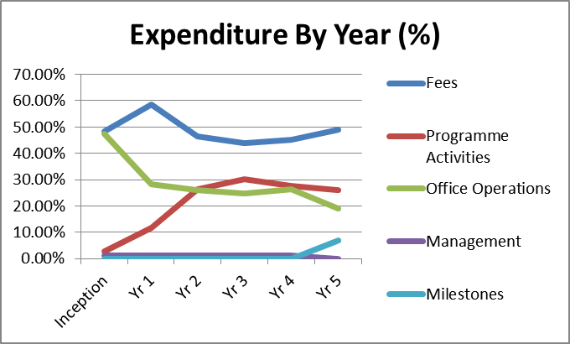

In 2013-14 a system of milestone base payments was introduced to cover SAVI’s management costs. These were paid in full over the past year.

Additional security costs have driven up costs to a limited extent. Annually these costs are estimated at around £80,000.

VfM performance compared to the original VfM proposition in the business case

Nine performance measures were identified in the 2012 Business Case for SAVI’s Scale-Up & Extension to 2015. These are now routinely monitored, updated and reported quarterly by the programme. Progress in summarised below under the headings economy, efficiency and effectiveness.

Economy (cost of inputs)

SAVI has continued to make valuable efforts to economise in the year under review by making use of and updating systems and processes put in place in 2012 for competitive economical procurement. SAVI has made further progress in reducing unit costs for technical assistance, and switching from the use of relatively expensive short-term international TA (see table below) – now at roughly 50% that of short-term national TA. The ratio of international TA days to national TA days is very low at 5:95. A database of short term TA use including quality and price data has been established.

SAVI - Average Daily TA costs / £s
 | Inception | Year 1 | Year 2 | Year 3 | Year 4 | Year 5 | Average
Long term TA | £188 | £143 | £152 | £150 | £140 | £137 | £146
Short term TA: international | £483 | £504 | £546 | £598 | £600 | £504 | £536
Short term TA: national | £490 | £277 | £151 | £241 | £292 | £252 | £266
% of STTA days out of total TA | 7% | 9% | 5% | 6% | 6% | 5% | 6%
% of international TA in STTA days | 62% | 37% | 31% | 35% | 28% | 31% | 34%

In terms of ‘commercial improvement and value for money’, SAVI appears to continue to be recruiting technical assistance at rates that are competitive within the industry, based on a comparison with the other SLPs.

SAVI continues to procure most of its supplies through a procurement contract with Crown Agents Nigeria, and reports no major challenges with this arrangement. The Procurement Plan & Detailed Item Specification document was adhered to (with the exception of some small delays in payment and procurement reporting creating difficulties in subsequent planned procurement, but within a general trend of improvement). SAVI worked with Crown Agents Nigeria to identify cost savings for several purchases, for example the decision to purchase a lower cost printer and commercial scanner.

Efficiency (cost of outputs)

The most important measure of programme efficiency is the cost of achieving outputs. SAVI’s ability to measure VFM efficiency has improved over the last few years as a result of the classification of expenditure by sub-output. The availability of several years’ data makes it possible to display this information graphically. The following charts indicate progress against output scores (averaged between sub-indicators) against cumulative spending since the start of the programme for each output and state. The data points (diamond shaped) indicate the point of measurement at the end of each monitoring year. VFM efficiency for the last year can be ascertained by observing the gradient of the line between the last two data points (a steeper line indicates a greater improvement in scores per unit expenditure). This can readily be compared with previous years and over the five year period for which data is available.

The graphs reinforce the earlier findings in part C that results have generally been achieved more quickly in the newer states (Zamfara, Katsina and Yobe) than in the original 5 SLP states. In addition, the charts demonstrate that results in the newer states have been achieved at substantially lower cost. The differences are particularly striking for outputs 3 and 4.

The observation of stronger VFM efficiency in the newer states is a highly significant finding with implications for SAVI’s future work and the design of the successor programme. The recommendations in part C are geared towards understanding better why these apparent VFM differences have emerged between states, and what operational recommendations should follow:

Output 1 VFM efficiency curves by state

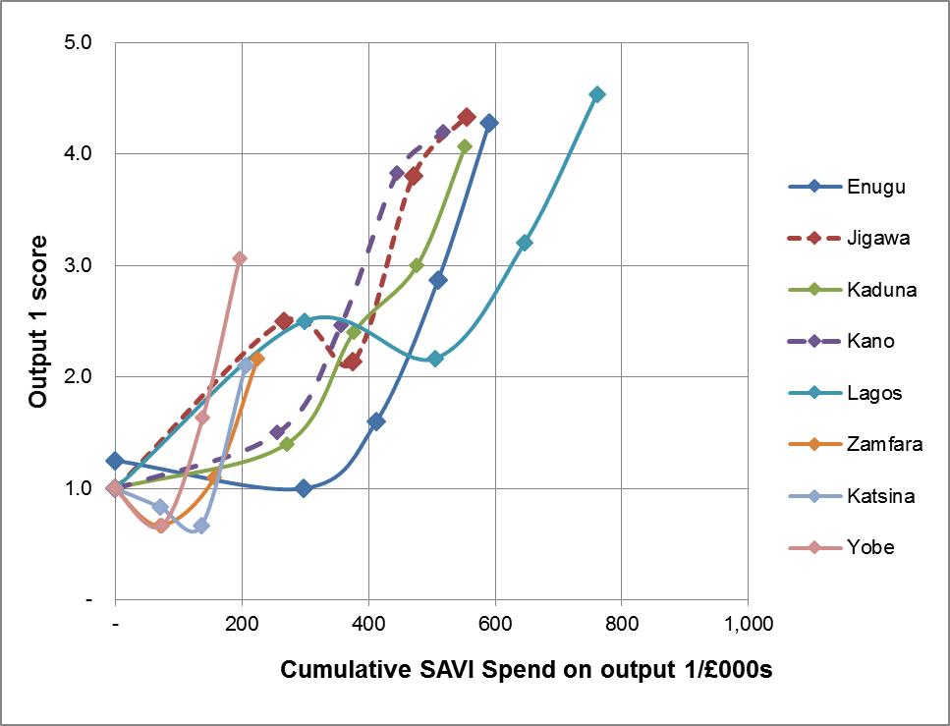

Output 2 VFM efficiency curves by state

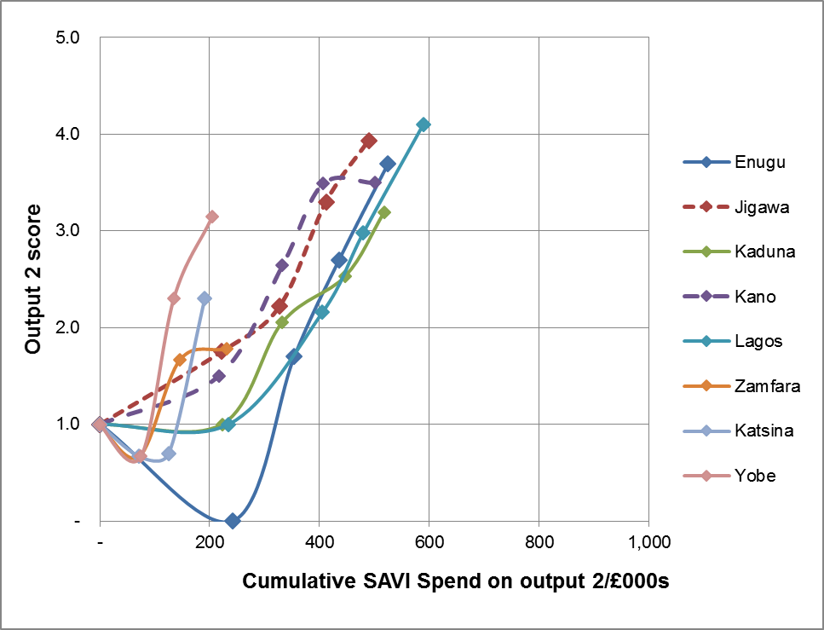

Output 3 – VFM efficiency curves by state

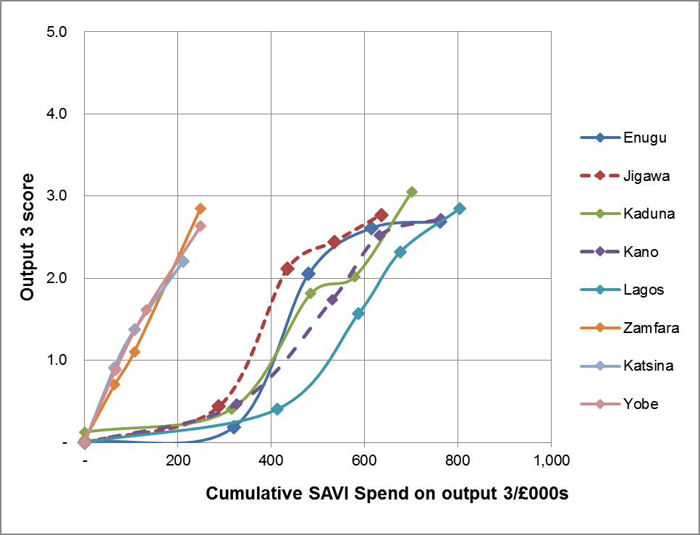

Output 4 VFM efficiency curves by state

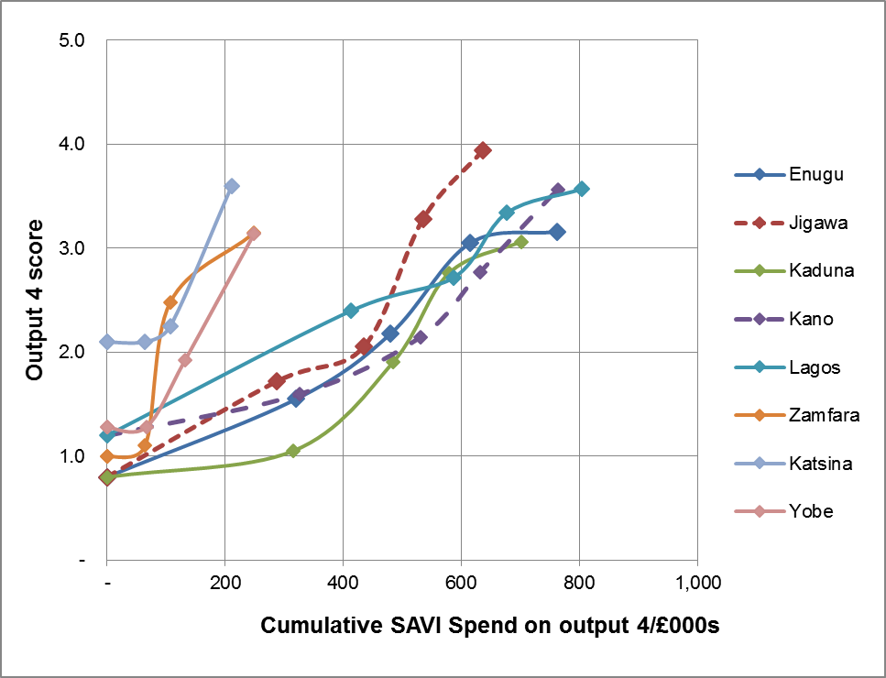

Effectiveness (cost of outcomes)

In SAVI two methods are used to measure VFM at effectiveness level: (1) comparison of changes in the Governance Index scores against spend over time and across states, and (2) use of data on costs and benefits from the Results Case Studies of ‘demonstrable changes in policy and implementation’. Both methods are subject to serious measurement and attribution problems.

The VFM effectiveness scores based on changes in the Governance Index are shown graphically as VFM effectiveness curves in the graphic below. This again provides evidence that SAVI has been able to achieve more rapid results at lower cost in the newer states (Zamfara, Katsina and Yobe) than in the original five SLP states.

VFM effectiveness curves by state

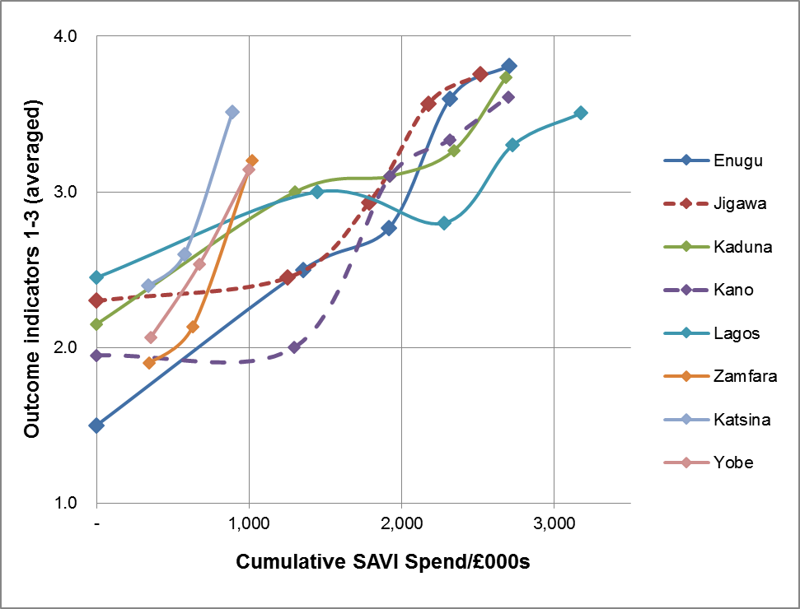

The Results Case Studies supporting outcome indicator 4 provide some information on the costs and benefits of ‘demonstrable changes in policy and implementation by government in response to citizen’s demands where there is evidence of attribution to SAVI’.

Assessment of whether the programme continues to represent value for money

SAVI offers good value for money by virtue of the economy measures that it has put in place and increasing evidence of results at efficiency and effectiveness levels. The differences in VFM efficiency and effectiveness observed between the original five SLP states and the newer states are an indication that the programme is achieving further VFM gains. As the programme becomes increasingly influential in Nigeria and abroad, there is a good prospect of further VFM gains as additional results are achieved through low cost replication.

Quality of financial management

From an approved budget of £6,115,129.00 for the 2014/15 DFID financial year (April – March), SAVI has spent an average of £503,193.02 per month since April 2014 (7 months period) totalling £3,522,351.17. A higher average spend was recorded in the last 3 months (July – September 2014) with an average of £571, 974.00. With a balance in budget of about £2,592,778.00 for the next 5 months (November 2014 – March 2015) and an expected average spend of about £518, 555.57, financing constraints are not anticipated in the near future.

Compared to Year 4, SAVI had a reduced budget performance (i.e. accuracy of spend against budget) in Year 5. SAVI under-spent against its budget on Fees and Programme Activities by 20% and 35.3% respectively.

SAVI reports that all requirements, ranging from monthly DFID requirements of unit costs of expenditure on staff costs – which includes travels and hotels – to invoicing, revised monthly financial forecasts, updated procurement plan, quarterly assets and conflict of interest declaration, have been adhered to, are all done, agreed and approved by DFID.

The last audit was conducted mid-2014 by PKF Auditors (appointed by DFID) for the last financial year (April 2013 – March 2014). All recommendations from financial year 2012/13 audits were met. A similar process is being followed to implement the agreed recommendations from the last audit.

Date of last narrative financial report | April 2014 (updated October 2014).
Date of last audited annual statement | 31st March 2014 (signed off September 2014).

E: RISK

Overall risk rating: Low/Medium

Overview of programme risk

Building on SAVI’s own risk assessment, the Annual Review team would like to highlight the following points:
- Security risks are judged to be high, particularly in the north of Nigeria, but also in Lagos, Enugu and Anambra, where instances of kidnapping and carjacking have become more frequent. Violence associated with Boko Haram in Northern Nigeria has disrupted SAVI’s operations in several Northern states since early 2012. The security situation in Borno, Adamawa and Yobe has worsened over the past 6 to 9 months with Boko Haram now in control of most of Borno State. Sporadic, but very serious terrorist attacks have affected Kano, Kaduna and Abuja in recent months. Despite an increase in the strength of the Joint Task Force in the north-east, the security services have not been able to tackle Boko Haram effectively.
SAVI has generally coped well with the difficult security environment and has adapted its working practices accordingly. It has managed to continue working in Yobe (the state team are based in Jigawa and maintain a large number of contacts in state) and have managed to achieve promising results in spite of serious security problems. Although SAVI continues to operate effectively, it must be recognised that its programmes in the most insecure states are close to limit of viability. This applies to Yobe and Kano where attacks are already frequent, and a further worsening would jeopardise SAVI’s ability to continue working.
- Political risks are increasing as the National and State elections approach in early 2015. Although there has not been significant disorder in the pre-election period, there is still a high chance of violence during and post elections. This may particularly affect SAVI’s ability to work with State Houses of Assembly, and to work with the media.
- Macroeconomic risks. The rapid decline in the oil price will place government budgets under severe strain and may cause political instability when sources of patronage dry up. Fiscal adjustment to declining revenues could provide an important opportunity for state governance reform. However, there is also a risk for SAVI that the issues that it works on will be pushed down the political agenda by the urgency of addressing the fiscal crisis.
- The institutional risks raised in the 2014 Annual Review surrounding SAVI’s expansion into 2 more new states have declined to “low / medium” (in line with other SAVI States at a similar stage of implementation). The concerns expressed in the 2013 AR with expanding into potentially insecure new states, but also possibly engaging in new sectors where SAVI has limited experience have not manifested.
- Risk of funds not being used as intended: This risk is low as SAVI does not provide sub-grants to its partners and manages all of its funds itself according to DFID’s accounting and audit standards (as noted in the independent Audit Report and Management letter for the period April 2013 to March 2014).

F: COMMERCIAL CONSIDERATIONS

Delivery against planned timeframe: Yes SAVI is on target against all of its output and outcome indicators and is on schedule against its financing plan.

Performance of partnership (s)

This annual review has been conducted jointly with SPARC. Collaboration and joint working between the two programmes has been assessed as being generally strong. However, there is still a need for more joint strategic thinking and timelier joint planning. A complete discussion of issues relating to the SAVI/SPARC partnership is included in an accompanying narrative report.
Although not a focus of this annual review, there are indications of improving coordination between SAVI and other SLPs. Significant challenges remain and there are instances of programmes working at cross-purposes. However, the broad picture (demonstrated by output 5 indicators) shows that the other SLPs are increasingly recognising the value of SAVI’s approach, adopting elements of it themselves or requesting direct SAVI support.

G: CONDITIONALITY

Update on partnership principles (if relevant) N/A

H: MONITORING & EVALUATION

Evidence and evaluation

There were no major changes in the external evidence base used for evaluation in 2014. SAVI has significantly improved the quality of its evidence gathering and documentation for outcome indicator (demonstrable changes in policy and implementation) and cases of replication.

A fuller, final evaluation of SAVI in the form of a Project Completion Review (PCR) is now scheduled for early 2016. This is due to be combined with the 2015 Annual Review.

Monitoring progress throughout the review period

This review was carried out by the Independent Monitoring and Evaluation Project (IMEP) as part of a joint review of the SPARC and SAVI programmes in 2014. The SAVI review was led by Gareth Williams with support from Emmanuel Adegbe. This ensures continuity, as the same consultants have led SAVI reviews since early 2011.

This review draws on documentary evidence and interviews conducted in Abuja over a two-week period. The annual review mission was instructed by DFID not to carry out state visits for this review. However, it was possible to interview SAVI state teams and partners who were called to Abuja to participate in a series of four half day state level workshops covering Enugu, Kaduna, Kano and Katsina. Extensive meetings were held with the SAVI core team in Abuja.

Smart Guide

The Annual Review is part of a continuous process of review and improvement throughout the programme cycle. At each formal review, the performance and ongoing relevance of the programme are assessed with decisions taken by the spending team as to whether the programme should continue, be reset or stopped.

The Annual Review includes specific, time-bound recommendations for action, consistent with the key findings. These actions – which in the case of poor performance will include improvement measures – are elaborated in further detail in delivery plans. Teams should refer to the Smart Rules quality standards for annual reviews.

The Annual Review assesses and rates outputs using the following rating scale. ARIES and the separate programme scoring calculation sheet will calculate the overall output score taking account of the weightings and individual outputs scores

Description | Scale
Outputs substantially exceeded expectation | A++
Outputs moderately exceeded expectation | A+
Outputs met expectation | A
Outputs moderately did not meet expectation | B
Outputs substantially did not meet expectation | C

Teams should refer to the considerations below as a guide to completing the annual review template.

Summary Sheet
Complete the summary sheet with highlights of progress, lessons learnt and action on previous recommendations
Introduction and Context
Briefly outline the programme, expected results and contribution to the overall Operational Plan and DFID’s international development objectives (including corporate results targets). Where the context supporting the intervention has changed from that outlined in the original programme documents explain what this will mean for UK support
B: Performance and conclusions
Annual Outcome Assessment
Brief assessment of whether we expect to achieve the outcome by the end of the programme
Overall Output Score and Description
Progress against the milestones and results achieved that were expected as at the time of this review.
Key lessons
Any key lessons you and your partners have learned from this programme
Have assumptions changed since design? Would you do differently if re-designing this programme?
How will you and your partners share the lessons learned more widely in your team, across DFID and externally
Key actions
Any further information on actions (not covered in Summary Sheet) including timelines for completion and team member responsible
Has the logframe been updated since the last review? What/if any are the key changes and what does this mean for the programme?
C: Detailed Output Scoring
Output
Set out the Output, Output Score
Score
Enter a rating using the rating scale A++ to C.
Impact Weighting (%)
Enter the %age number which cannot be less than 10%.
The figure here should match the Impact Weight currently shown on the logframe (and which will need to be entered on ARIES as part of loading the Annual Review for approval).
Revised since last Annual Review (Y/N).
Risk Rating
Risk Rating: Low/Medium/High
Enter Low, Medium or High
The Risk Rating here should match the Risk currently shown on the logframe (and which will need to be entered on ARIES as part of loading the Annual Review for approval).
Where the Risk for this Output been revised since the last review (or since inception, if this is the first review) or if the review identifies that it needs revision explain why, referring to section B Risk Assessment
Key points
Summary of response to programme issues raised in previous annual reviews (where relevant)
Recommendations
Repeat above for each Output.
D Value for Money and Financial Performance
Key cost drivers and performance
Consider the specific costs and cost drivers identified in the Business Case
Have there been changes from those identified in previous reviews or at programme approval. If so, why?
VfM performance compared to the original VfM proposition in the business case? Performance against vfm measures and any trigger points that were identified to track through the programme
Assessment of whether the programme continues to represent value for money?
Overall view on whether the programme is good value for money. If not, why, and what actions need to be taken?
Quality of Financial Management
Consider our best estimate of future costs against the current approved budget and forecasting profile
Have narrative and financial reporting requirements been adhered to. Include details of last report
Have auditing requirements been met. Include details of last report
E Risk
Output Risk Rating: L/M/H
Enter Low, Medium or High, taken from the overall Output risk score calculated in ARIES
Overview of Programme Risk
What are the changes to the overall risk environment/ context and why?
Review the key risks that affect the successful delivery of the expected results.
Are there any different or new mitigating actions that will be required to address these risks and whether the existing mitigating actions are directly addressing the identifiable risks?
Any additional checks and controls are required to ensure that UK funds are not lost, for example to fraud or corruption.
Outstanding actions from risk assessment
Describe outstanding actions from Due Diligence/ Fiduciary Risk Assessment/ Programme risk matrix
Describe follow up actions from departmental anti-corruption strategies to which Business Case assumptions and risk tolerances stand
F: Commercial Considerations
Delivery against planned timeframe. Y/N
Compare actual progress against the approved timescales in the Business Case. If timescales are off track provide an explanation including what this means for the cost of the programme and any remedial action.
Performance of partnership
How well are formal partnerships/ contracts working
Are we learning and applying lessons from partner experience
How could DFID be a more effective partner

Asset monitoring and control
Level of confidence in the management of programme assets, including information any monitoring or spot checks
G: Conditionality
Update on Partnership Principles and specific conditions.
For programmes for where it has been decided (when the programme was approved or at the last Annual Review) to use the PPs for management and monitoring, provide details on:
  - Were there any concerns about the four Partnership Principles over the past year, including on human rights?
  - If yes, what were they?
  - Did you notify the government of our concerns?
  - If Yes, what was the government response? Did it take remedial actions? If yes, explain how.
  - If No, was disbursement suspended during the review period? Date suspended (dd/mm/yyyy)
  - What were the consequences?

For all programmes, you should make a judgement on what role, if any, the Partnership Principles should play in the management and monitoring of the programme going forward. This applies even if when the BC was approved for this programme the PPs were not intended to play a role. Your decision may depend on the extent to which the delivery mechanism used by the programme works with the partner government and uses their systems.
H: Monitoring and Evaluation
Evidence and evaluation
Changes in evidence and implications for the programme
Where an evaluation is planned what progress has been made
How is the Theory of Change and the assumptions used in the programme design working out in practice in this programme? Are modifications to the programme design required?
Is there any new evidence available which challenges the programme design or rationale? How does the evidence from the implementation of this programme contribute to the wider evidence base? How is evidence disaggregated by sex and age, and by other variables?
Where an evaluation is planned set out what progress has been made.
Monitoring process throughout the review period.
Direct feedback you have had from stakeholders, including beneficiaries
Monitoring activities throughout review period (field visits, reviews, engagement etc.)
The Annual Review process

The SAVI programme in Nigeria: Towards politically smart, locally led development,’ David Booth and Victoria Chambers, ODI discussion paper October 2014.

