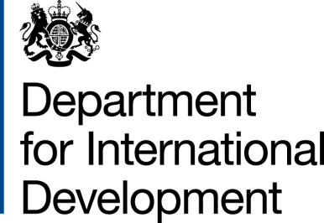 | 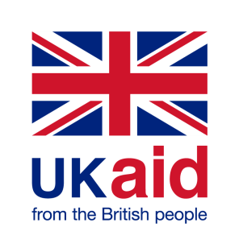

MOU Amendment Letter

ARIES Code 204903-106
Purchase Order 40107094

- I refer to the Memorandum of Understanding (MOU) for the above project signed by DFID and UNICEF on 25 August 2017 and subsequent amendment on 30 August 2018. Following recent discussions, DFID proposes to amend the agreement Somali EPHS Commodity Security Programme.
- DFID proposes to increase the amount made available to UNICEF by £8,000,000 (Eight Million pounds sterling).
- I propose that the figures and words £1,440,000 (One Million, four hundred forty thousand pounds sterling)" in paragraph one (1e) of the original MoU be deleted and replaced by the figures and words £9,440,000 (Nine Million, four hundred forty thousand pounds sterling).
- DFID proposes to change the end date of the project. I therefore propose that the end date of 31 December 2018 in paragraph Two of Amendment No. 1/2018 be deleted and replaced by 31 March 2021.
- The terms of the Framework Arragnement and Contribution Arrangement will apply except as otherwise provided herein/in this Amendment.
- This letter of amendment will place on record our common understanding of the above change and will come into operation on the date you sign your confirmation below. This note will be known as Amendment No. 2/2018.

- Please sign both copies of this letter; return one to me and retain the other for your own records.

Signed for DFID: | Confirmed by UNICEF:
Name: | Name:
Position: | Position:
Date: | Date:

