Project Completion Review - Top Sheet

This Top Sheet captures the headlines on the programmes performance over the course of its lifetime. Teams should attach summary sheets from each annual review over the life of the programme.

Review Date: | May 24-26, 2017

Title: The Agricultural Model Intercomparison and Improvement Project (AgMIP)
Programme Code: 202108 | Start Date: 01/03/2010 | End Date: 31/03/2017
If programme was closed >1 month early please describe in a few words why. | N/A the project finished right on schedule.

Summary of Programme Performance

Year | 2011 | 2012 | 2013 | 2014 | 2015 | 2016 | 2017
Programme Score | - | A | A | A+ | A+ | A | A+
Risk Rating | - | Medium | Medium | Low | Low | Low | Minor

Financial Position

Original Programme Value | £6.4 million
Extensions/ amendments | £3.2 million
Log-frame revisions (with dates) | 11/03/2011  28/08/2012  01/05/2013  01/03/2014  18/06/2015  01/02/2016
Total programme spend | £9.6 million

Follow up actions required following closure

- Finalise the remaining details of the legacy plan for AgMIP Impacts Explorer (to be completed by 30 Sept. 207);
- Closure of accounts and financial invoices in line with DFID requirements (to be complete by 30 Sept. 2017);
- Completion of final audited project financial report by USDA and ICRISAT, and submission to DFID for final review (to be completed by 30 Sept. 2017);
- Communications activities to follow up closure and publication of results, including: at least two Insight articles for DFID intranet, one article for external dissemination and social media circulation;
- Organise final AgMIP project event in London, to officially launch AgMIP-IE and present project results and main findings and to wider academic community and policy practitioners (By 30 Oct 2017);
- Provide links to key publications and products for upload into EPE platform (By 30 Sept. 2017).

A. Introduction and Context (1 page)

DevTracker Link to Business Case: | https://devtracker.dfid.gov.uk/projects/GB-1-202108/documents
DevTracker Link to Log frame: | https://devtracker.dfid.gov.uk/projects/GB-1-202108/documents

Outline of programme and what it has achieved

Context
The world food system is challenged to become sustainable in multiple ways. It needs to produce adequate nutritious food for the rising global population, provide sustainable livelihoods for farmers all over the world, and reduce detrimental environmental effects, all while addressing the challenge of climate change. These challenges provided the context and motivation for the DFID-funded component of the AgMIP Project, which focused on Sub-Saharan Africa (SSA) and South Asia (SA).

AgMIP has been a unique international collaborative effort to assess the state of global and regional agriculture, with a specific focus to understand the impacts of climate variability and climate change. AgMIP’s mission was to improve substantially the characterisation and understanding of how food security in SSA and SA will be affected by future climate variability and change. The project also aimed to enhance the capacity of developing countries to adapt to current and future climate stresses. In this respect, DFID funding has enabled the AgMIP project to develop new fundamental innovative protocol-based methodologies for Regional Integrated Assessments (RIA), which focus on enhancing the capacity of developing countries to address the challenges brought on by current and future climate stresses.

Structure and scope of project
The project was structured around two main components. The first component (i.e. component 1) involved several regional research teams made up of over one hundred and fifty crop modellers, economists, and climate scientists from around the world who focused on improving the capacity and reliability of computer-based models to predict the impact of current and future climate conditions on a number of agricultural regions growing major staple and cash crops (e.g. wheat, maize, rice, sorghum, millet, groundnut and cotton).
The second component (i.e. component 2) focused on the development of a range of products and outputs, which were based on the hard data and scientific findings made by the regional modelling teams and scientists who worked under component 1 of the project. Component 2 included seven competitively selected Regional Integrated Assessment (RIA) Teams, which analysed small-holder farming systems throughout SSA and SA and tried to assess the impacts that climate will have on farming systems across various locations and regions. These assessments were based on a range of scenarios called “Representative Agricultural Pathways” (RAPs), which tried to provide a realistic picture of how the farming systems may evolve over the next few decades, taking into account a number of factors such as: economic growth projections, price changes, technology transfer and uptake, socio-economic development, and governance issues. Using the RAPs, the RIA teams conducted comparative analyses of current and future farming systems with and without climate change, and with and without adaptation packages. Each team was multidisciplinary and consisted of climate scientists, crop and livestock experts, economists, IT specialists, and stakeholder engagement specialists.

Most previous studies of regional climate change impacts on agriculture suffered from paucity of data and contradictory results from different models, separation from stakeholder concerns, lack of integration between their various elements, and lack of realism or relation to problems faced by policymakers, planners and farmers on the ground. The methods and approaches used for the “Regional Integrated Assessments” and ‘”Representative Agricultural Pathways” that were developed under AgMIP addressed these shortcomings by applying innovative solutions, which consisted of the following elements:

- Stakeholder Engagement
Each AgMIP RIA team had an embedded Stakeholder Liaison, who was trained in initiating and sustaining stakeholder interactions by the ‘Stakeholder Unit’, which set the standards for stakeholder engagement activities across the whole project. This enabled on-going interaction and engagement with a range of stakeholders on the ground, who informed the framing of the main research questions. The feedback from end-users of AgMIP products has also substantially influenced the decision making process of the science and modelling teams within each region.

- Farming Systems
Previous climate impact studies usually considered only one aspect of farming (e.g. crops or livestock). The new AgMIP RIA approach takes as its primary unit of analysis the ‘small-holder farming system’, recognizing that these systems often consist of multiple crops and livestock, as well as off-farm income. All of these are taken into account in the new approach, allowing for a much more realistic assessment of likely changes to future farming systems and the range of plausible adaptations to be tested.

- Interdisciplinary Collaboration
The AgMIP RIA approach recognises that no one discipline can address the complexities of climate impacts. Therefore, the RIA Teams consisted of climate scientists, crop and livestock experts, economists, information technologies specialists, and social scientists with expertise in stakeholder interactions.

- Vulnerability
Small-holder farming systems within any of the study regions are highly heterogeneous with regard to biophysical and economic conditions. The AgMIP RIA approach incorporates the high degree of heterogeneity and thereby avoids the assumption of universal impacts, enabling identification of the most vulnerable farmers and ways they can respond to climate stresses most effectively. Impacts on poverty are included explicitly.

- Multi-Scale/Multi-Model Protocols
The AgMIP RIA is done across field, farm, regional, and national scales, with inputs from global data and models. Multiple climate scenarios and crop models are used in order to characterize and reduce uncertainty. This enhances the clarity and reliability of results that are presented to stakeholders on the ground, and strengthens the use of the results as evidence for decision-making.

Main project outputs
AgMIP activities in Sub-Saharan Africa and South Asia have substantially improved our understanding of the likely impacts of future climate on agricultural production and farming systems in SSA and SA. They also characterised the main challenges that will be faced by government planners and farmers on the ground. The main outputs delivered by the project include the following:

- The AgMIP project has significantly improved the capability and reliability for integrating major crop models with climate, livestock and agricultural economic models to produce the best possible characterization of smallholder farming systems analyses available globally. As a result of this effort, we now have a much more detailed understanding of how current and future climate conditions can affect the physiology and productivity of various staple crops across a number of regions through SSA and SA and how this will affect food security for millions of people.
- The AgMIP project has created a global community of practice, which includes several hundred among the most notable and internationally renowned crop modellers and scientists. This global community will continue to operate virtually beyond the life of the project, thus ensuring a substantial legacy and continuing impact on the advancement of scientific understanding in this field of research.
- The AgMIP project created 35 peer-reviewed Regional Integrated Assessments (RIAs) and Regional Agricultural Pathways (RAPs), which examined the interactions between future climate change, technological and socioeconomic development in 10 countries, as well as testing the effectiveness of various agricultural adaptation interventions and packages in each country (See fig.1-2 below).
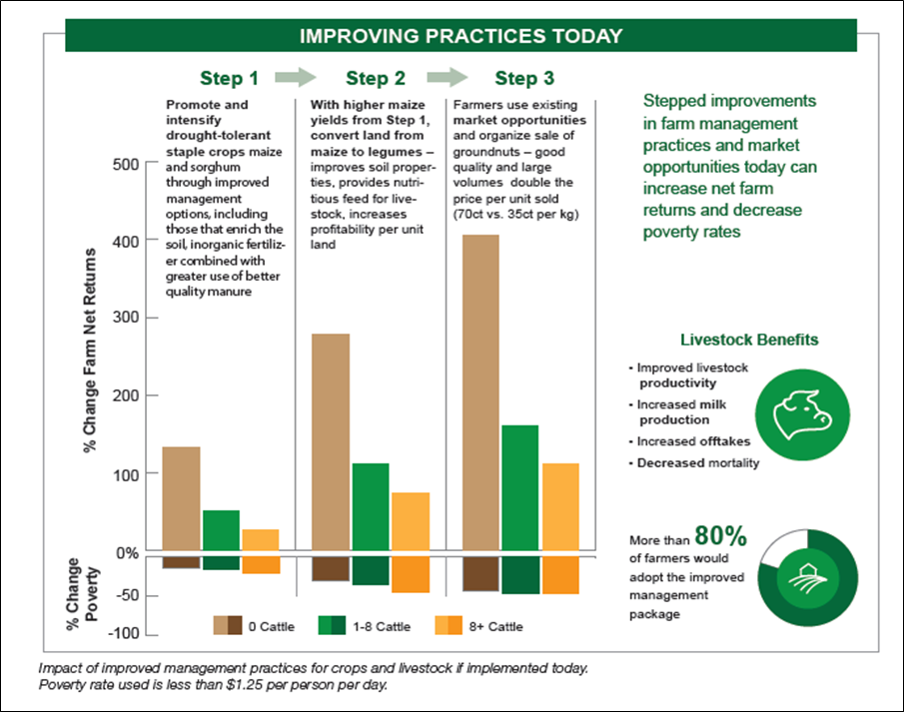
Fig.1: Infographic showing intervention package for Nkay-Zimbabwe (Source: AgMIP RIAs and model simulations)

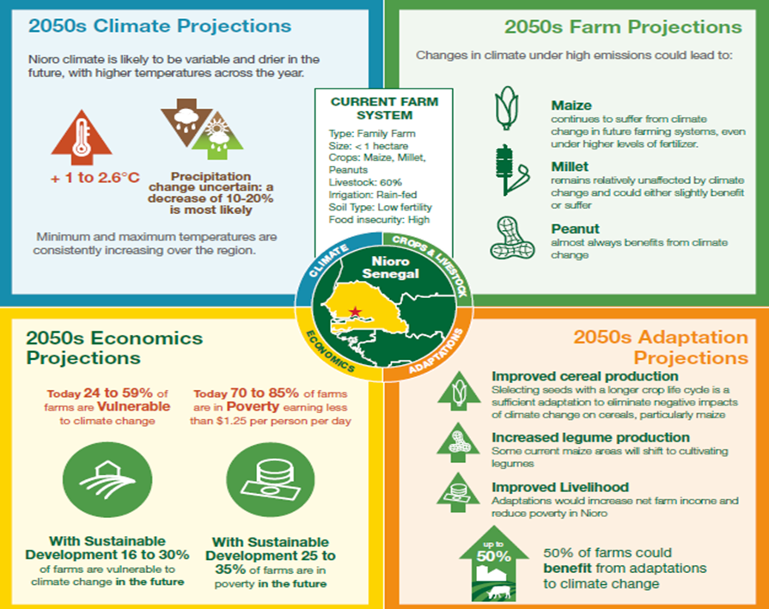
Fig.2: Infographic showing projections for Nioro region in 2050 (Source: AgMIP models simulations and RIAs)

- AgMIP scientists are now situated and recognised within regional networks of key decision makers and government agencies advancing climate-related policy processes across SSA and SA.
- A major highlight of the AgMIP project is the development of the “AgMIP Impacts Explorer” (AgMIP- IE). This is an on-line tool that is being used to present complex results from crop, climate and economic models, as well as the RIAs and RAPs, in a way that is easily accessible and understandable (Fig.3). The main users of the AgMIP-IE are intended to be officials from government departments, international development agencies and other stakeholders, who have an interest or need to access this kind of information to plan agricultural interventions and policies.

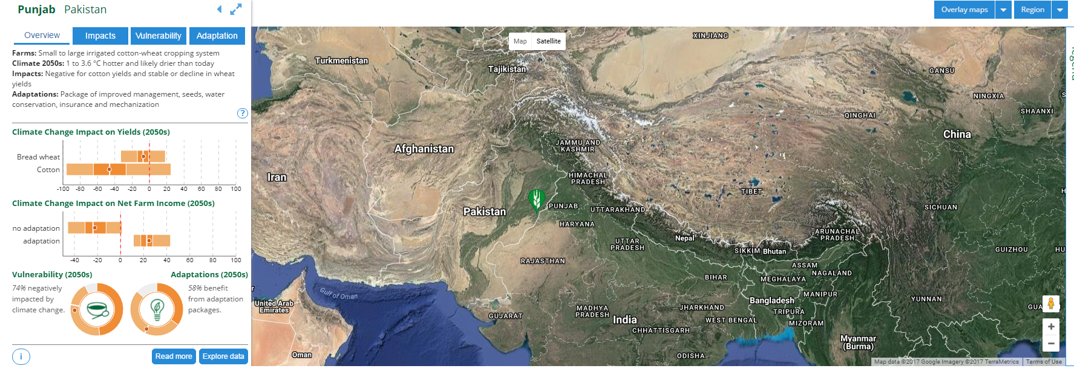
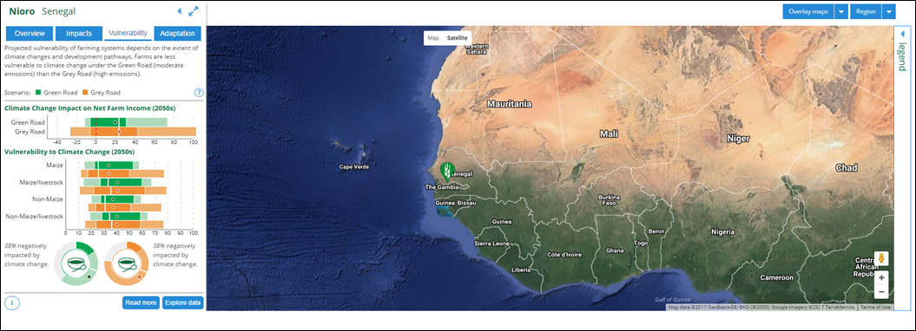
Fig.3: Screenshot samples of RIAs data visualisation and representation from the AgMIP-IE prototype.

- A range of communications products were also created by each AgMIP team to translate technical findings into accessible information that will support evidence-based decision-making. These included: policy briefs, fact sheets, a webpage and a number of blog posts, which were circulated among relevant stakeholders in the regions.

Evidence of current impact
- A number of stakeholders from international, national, and regional organisations (e.g. World Bank, DFID, CGIAR, UNDP, Govt. of India, Govt. of Zimbabwe, Govt. of Pakistan, Govt. of Ghana, Govt. of Uganda) have been involved in the development of AgMIP outputs and products. Several of these are now also using AgMIP findings to inform their policies and investments.
- By participating in AgMIP, over fifty researchers and crop modellers from SSA and SA have significantly improved their capacity to use agricultural models, generate scientific evidence and develop interdisciplinary research applications in ways that will leave a lasting legacy of good practice.
- AgMIP protocols and tools have been taken up for wide use in national and international research programmes, translating into a large number of leveraged outcomes and broad overall impact.
- AgMIP Regional Research Teams have undertaken intensive engagement with regional stakeholders to define and characterise the socioeconomic and environmental changes, vulnerabilities, and challenges that will shape the future of agricultural production and farming practices in various regions and locations across SSA and SA.
- AgMIP findings and results were also included in the South Africa section of the 2017 FAO report on methodologies for crop yield forecasting.

Some direct evidence of impact follows involving examples of situations where AgMIP influenced policy and/or decision making directly. This evidence is reinforced by quotes from partner government official and policymakers who were enaged with the AgMIP project in various roles:

- The Makueni County local government in Kenya was seeking scientific information, case studies and recommendations on options for climate change adaptation to help its citizens develop resilience to the changing climate. Partly influenced by evidence and information provided by AgMIP, the county passed a law that sets aside one per cent of its KES 5 billion annual development budget towards climate change adaptation. The County Climate Change Fund (CCCF) regulation passed by the Makueni County Assembly was the first of its kind in Kenya and Africa. In this context, the Head of Sustainable Economic Development Team from DFID Kenya lauded Makueni for setting the pace for other counties to follow. The Chief Officer for Agriculture, Livestock and Fisheries in Makueni County also noted:” Research on appropriate farming technologies including viable crop varieties and livestock breeds thatw as developed and carried out under AgMIP is central in helping Makueni County achieve food security and alleviate poverty”.
- Along similar lines, the Principal Researcher for the Climate Change Management Department (CCM Dpt), at the Ministry of Environment, Water and Climate in Zimbabwe provided extensive commentary on the utility of AgMIP findings for decision-making: “AgMIP research, scenarios and impacts assessments can meaningfully inform national priorities for policy, research and development. The project raised awareness on the possible impacts of technology options for farming systems, in the context of future uncertainties, associated opportunities and limitations”. The department has direct access to the Ministry, and through solid evidence can influence national decision processes.”
- In Pakistan, the Pakistan AgMIP team supported stakeholder groups to reformulate criteria and processes for decisions on land use planning. This led also to the creation of new Agro-Ecological zones that will facilitate more informed decision making about crop selection, water allocation, fertilizer subsidies, development of new seeds, post-harvest facilities, and marketing strategies. In this conext, the Planning Director from the Land Use Planning Office – Department of Agriculture, observed that: “In AgMIP meetings the Punjab Agricultural Secretory raised the issue of redefining Agro-Ecological zones. The existing zones have become outdated, limiting their use for guiding agricultural decision making in the province.

High-level findings

Across the entire project, several new key findings and major messages emerged:

- In the current climate, integrated strategies including management and market interventions, such as improved cultivars, switches in cropping systems, and market development can significantly improve smallholder farming livelihoods in many locations.

- Regions with minimal fertilizer applications are often more limited by soil fertility than by climate factors. Improving fertility is essential in these regions.

- In the future, even with anticipated agricultural development, climate change generally will exert negative pressure on farmer livelihoods in most locations.

- Furthermore, the changing climate will not affect all farmers in the same way. Aggregated reporting of impacts hides significant variability in vulnerability and impacts to poverty among different groups of farmers.

- Climate change is more detrimental to some crops than others and these differences need to be taken into account in developing adaptation packages.

- Future adaptations are able to overcome a portion of negative climate change impacts on smallholder farmers, but will not compensate completely in many locations. Targeted adaptations for future climate change include improved heat and drought-tolerant crop and livestock varieties, sowing practices, and fertilizer applications.

Examples of geographically specific findings from key locations analysed for RIAs

Sub-Saharan Africa
In Kenya, smallholder rain-fed farms that currently cultivate maize and livestock in the South-East of the country are characterised by differing producing capabilities and levels of resilience. Over the next few decades, maize is expected to decline in yield because of the effects of climate change, with up to 70% of households vulnerable to decreased per-capita income and increased poverty. However, adaptations and sustainable development can help. AgMIP economic simulations currently predict that increased fertilizer and manure application, coupled with the provision of 2-3 improved breed cows to each farm, can improve the economic wellbeing of a large majority (>70%) of current and future Kenyan farms (Fig.4).

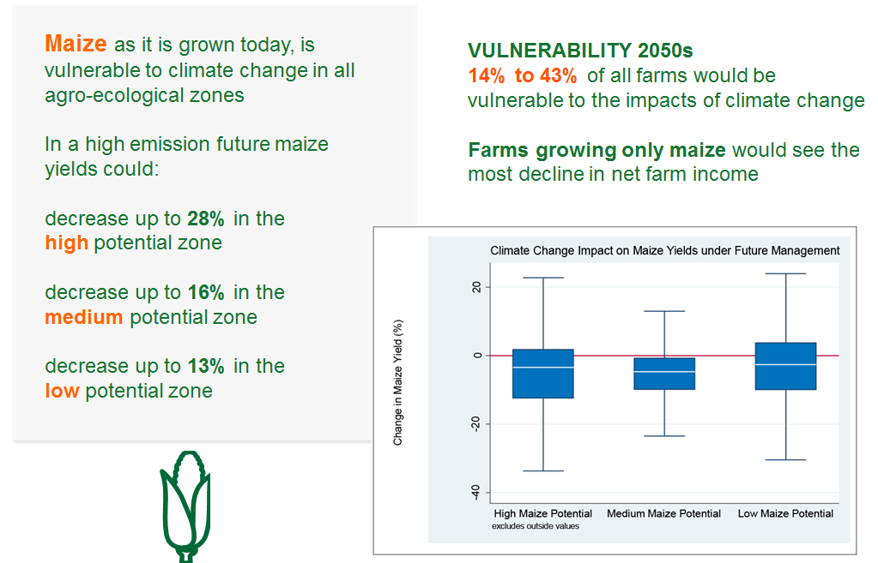
Fig.4: Visualisation of results summary from national level assessment fo farming systems in Kenya.

Small-holder farms in Nkayi, Zimbabwe are presently characterized by low productivity, high poverty, and food insecurity. Management interventions can improve Nkayi farms today and increase resilience to climate change in the future (i.e. up to 2050). A stepwise approach of soil improvement, greater cultivation of groundnuts that benefit from higher CO2, and improved market coordination can reduce poverty now and in the future (Fig.5).
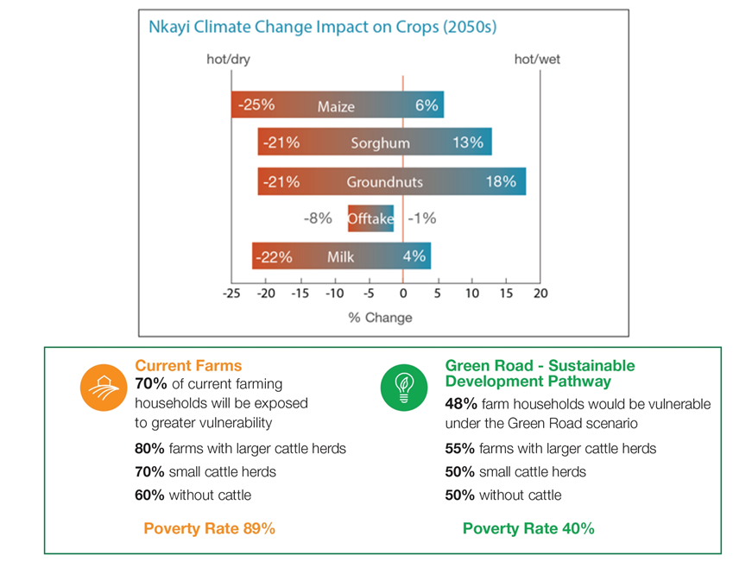
Fig.5: Visualisation of results summary from national level assessment fo farming systems in Zimbabwe.

The farmers in the Nioro district of Senegal currently struggle with poverty and food insecurity. AgMIP models’ projections show that traditional crops such as maize will decline in yield due to the future impacts of climate change. However, a future that includes sustainable development practices such as organic soil fertilization and better water management, along with adaptations such as heat tolerant cultivars and a narrower planting windows can improve cereal yields. Increased peanut production, naturally resilient to climate change, will benefit from increased CO2 and help decrease poverty (Fig.6).
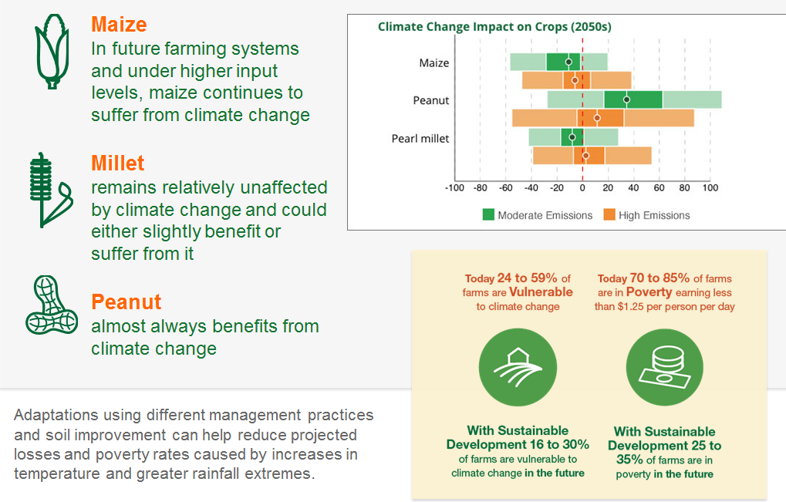
Fig.6: Visualisation of results summary from national level assessment fo farming systems in Senegal.

The Free State in South Africa is currently one of Africa’s breadbaskets, where large-scale commercial farms growing predominantly wheat, maize and sorghum contribute to regional economic stability and food security. Maize and wheat systems are both vulnerable to climate change with yield revenue projected to decrease between 9% and 28% between now and 2050. Higher risks of crop losses and below normal yields will also increase financial risks due to projected higher inputs costs. Moving planting dates, introducing more heat tolerant varieties and higher yielding cultivars can mitigate the impacts of climate change that were identified under this integrated assessment (Fig.7).
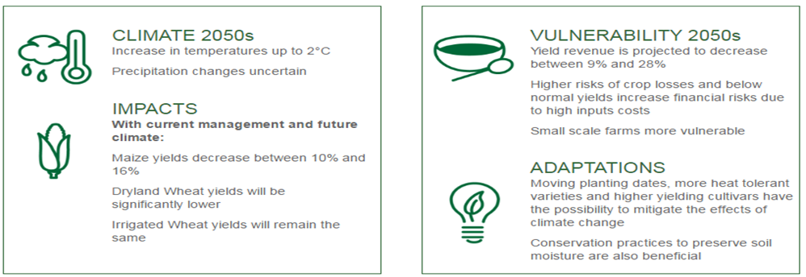
Fig.7: Visualisation of results summary from national level assessment fo farming systems in South Africa.

South Asia
The rice-wheat cropping system is currently the predominant agricultural system in the Meerut District of India, which lies in the Indo-Gangetic Plain that provides about 40% of agricultural production for India's 1.2 billion people. Due to continuous cultivation of these crops, along with imbalanced use of chemical fertilizers, the soil health has deteriorated and yield levels have declined or stagnated. Future climate change would reduce yield even further, putting up to 74% of farms at risk of decreased income and greater poverty by 2050. Implementing an adaptation package of better crop varieties (already developed) and earlier sowing of wheat could offset these losses both now and in the future. A sustainable pathway of more efficient use of farm resources would decrease costs and slow down soil degradation.

Currently, the farms of the Punjab region of Pakistan predominantly adopt a cotton-wheat cropping system that is vital to food security and Pakistan’s textile industry. Cotton is vulnerable to both higher temperatures and changes in precipitation and yields are projected to decrease by up to 47% in the coming decades due to the effects of climate change. Without any changes in farm practices net farm returns and per capita income would both decrease while the percentage of farmers in poverty would increase by up to 17% by 2050. Going forward, sustainable farming practices, which include improved management and timely sowing dates can reduce losses, but the most promising adaptation would be the development of short duration and early maturing cultivars of cotton (Fig.8).

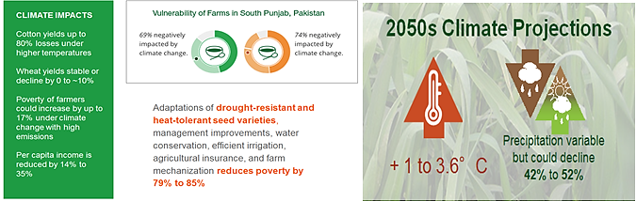
Fig.8: Visualisation of results summary from national level assessment fo farming systems in Pakistan.

Forthcoming work and ongoing/future impact

Some of the work strands that were initiated under AgMIP with DFID funding will continue for a period of time beyond the life of the project. Examples of these work strands include:

- The RIA approach and methods that were developed under AgMIP are currently being incorporated into new research and planning processes across South Asia and Sub-Saharan Africa. Some of these will also be led by AgMIP regional research team members, with additional applications for regions in development around the world.

- These regional assessments will also form a major building block for the Coordinated Global and Regional Assessments that AgMIP is undertaking for the Intergovernmental Panel on Climate Change (IPCC) Sixth Assessment Report (AR6).

- Scientific evidence generated under AgMIP is also being used in the AgMIP 1.5C Assessment for the IPCC Special Report on 1.5C.

- AgMIP RIA Approach will also contribute to the Global Alliance on Climate-Smart Agriculture and the CGIAR Climate Change Agriculture and Food Security (CCAFS) Program.

- The AgMIP community of scientists and crop modellers will continue to update and develop the AgMIP-IE with new data from crop models as it becomes available (Fig.3). The quality of future impacts will be assured by the ‘quality assurance framework’ and ‘data management infrastructure’ that were put in place as part of AgMIP and will be maintained in its current form September 2018. Further funding is being sought to continue this further into the future.

B: PERFORMANCE AND CONCLUSIONS (1-2 pages)

Overall Outcome Assessment

The outcome of the project is: “Development of tools, accurate estimates and detailed scenarios of how climate change will affect agricultural productivity and food security in SSA and SA, in a format that is relevant to the needs of stakeholders in partner countries”.

The final overall outcome assessment for this project is very positive. The project achieved a combined “output quality score” of 140, which translates as an overall (A+) marking. This reflects a strong final year, in which AgMIP has responded well to the recommendations in the annual review from last year when the project scored an (A). The project has achieved full compliance and delivery against all milestones set against the outcome in the logframe.

Outcome Indicator | Target (by end of project)
1. Stakeholders engage in development of policies and adaptation packages to be tested by AgMIP regional integrated assessment modeling framework. | 3 policy scenarios and 3 adaptation packages developed and evaluated with stakeholders for each target region using Phase 2 AgMIP Modeling framew
2. Stakeholders collaborate with regional research teams in utilizing AgMIP multi-model integrated assessment framework to test and prioritize adaptation and policy options to prepare for climate change impacts | 5 adaptation and policy options tested and prioritised
3. Documented evidence of Stakeholder decisions informed by AgMIP results. | 12 decisions documented within SSA and SA that are directly informed by AgMIP results

The project performed very well against the outcome targets set in the logframe by substantially exceeding all of them. More specifically, the following results were achieved:

Under outcome indicator 1 the project generated 35 policy scenarios and 35 adaptation packages which were co-designed and co-developed by the regional research teams (RRTs) in close collaboration with key stakeholders in each target region. The latter included government officials in relevant line ministries (e.g. ministry of agriculture, economic development, environment etc.).

Under outcome indicator 2, the project delivered 60+ adaptation packages tested against policy options, which were also co-designed by key stakeholders and researchers from the RRTs.

Finally, under outcome indicator 3 the evidence and scientific results generated by the RRTs directly influenced at least 18 policy and planning decisions. It should be emphasized that these 18 were documented, but it is likely that there are additional examples that were not captured by project reporting. This is due to the fact that, because of the way policy making is conducted in some regions, there is a likelihood that results applied to decisions in one area of policymaking or planning would have been applied to other decision contexts of pertinence to the same ministers or government agencies that were involved with AgMIP.

In addition, the project also realised a number of significant achievements that do not fit under any indicators listed above, but should be mentioned because of the value they add to the overall project. These were as follows:

- AgMIP has created a new culture of stakeholder engagement to drive applications-oriented research and informed decision-making in 10 countries across sub-Saharan Africa and South Asia.
- Stakeholders played an active role in setting the parameters and areas of focus for AgMIP Regional Integrated Assessments (RIAs), most notably in the development of RAPs, Intervention Packages and Adaptation Packages, which covered a number of regions and locations within each of the ten countries where the project worked;

- A large and diverse cross-section of stakeholders have been engaged in shaping and developing the RIAs, RAPs and adaptation packages, which are reflective of realities and challenges faced by people on the ground;
- A number of AgMIP researchers (both from developed and developing countries) have become key actors in the adaptation planning processes and risk management interventions related to the countries and regions where they worked;
- Policies and adaptation packages developed for these projects are understood as the beginning of a sustained conversation, whereby the latest science and ideas for intervention will be combined to determine priority actions;

- More the 15 institutions who collaborated or allowed members of staff to work with the AgMIP Regional Research Teams (RRTs) now have the ability to operate complex crop models and utilise AgMIP protocols to conduct RIAs and RAPs;
- AgMIP researchers, methods, tools, and data are now in high demand across the academic and scientific community for continuing and parallel projects and applications.

We also observed that the project has already supported some progress against the two impact indicators set in the logframe, namely: 1. Target stakeholders in Sub-Saharan Africa and South Asia make more informed policy and planning decisions based on AgMIP assessments; 2. AgMIP's improved regional projections of climate impacts and adaptation options integrated into policy and decision‐making process in at least 10 countries across all AgMIP regions. Given the progress made so far and the continuing level of activity we expect to see in this area of work, we are confident that over the next few years the project will have fostered developments exceeding the level of ambition that was set in the logframe.

Output Score and Description

Over the course of its final year, AgMIP has maintained a robust level of performance and achieved an overall improvement against the delivery of outputs set in the logframe, leading to an aggregate score of A+. A summary of the key points and accomplishments for all outputs is provided below.

The project has continued to deliver strongly against output 1 and improved its performance compared to last year’s Annual Review (AR). AgMIP is now providing international leadership on coordinated global and regional assessments of the impacts of climate change on agriculture and food security. This work is expected to feed directly into the Intergovernmental Panel on Climate Change (IPCC) Sixth Assessment Report (AR6) and the IPCC Special Report on adaptation and mitigation challenges of a +1.5 oC World.

Recognition of climate extremes and the need to manage the risk of this uncertain challenge featured prominently in the AgMIP protocols and the conduct of the project. These advances were novel to the teams and proved to be very useful in understanding future challenges from a science and stakeholder perspective. AgMIP protocols included several new parameters for regional integrated assessment, which were published in a peer-reviewed book (Imperial College Press). Teams tailored their research to suit local data availability, capabilities and stakeholder needs. This resulted in new features and an expanded scope for each RRT. These are now recognized as the new standard in the region and have heightened expectations for integrated assessments around the world.

Overall, the research conducted under this output has made a substantial contribution to the advancement of science and academic knowledge in this area and generated cutting-edge methodological advances and results, which will continue to be valid until at least 2028.

The project has also delivered very strongly against output 2 meeting and/or exceeding all expectations that were set at the last AR.

The Regional Research Teams (RRTs) undertook several activities to better represent extreme events in their models and projections. This included characterization of extreme weather events their frequency and duration, as well as their probability under different climate scenarios. RRTs also conducted stress tests to understand system responses to increasing temperature and rainfall extremes as well as their interactions with Nitrogen and CO2. Policy storylines were developed into qualitative trends and the quantitative indicators for scenario-based simulations. Each RRT developed more sustainable and more growth-oriented agricultural pathways, as well as variants for high and low global prices.

In total of over 60 adaptation packages were configured and developed to create more optimized systems for current climate and to respond to future climate challenges. These included regionally tailored combinations of improved crop varieties (genetic traits including heat- and drought-resistance), sowing practices, planting windows, input management, land allocation, and/or farm diversification.

Stakeholders expressed a keen interest in the process of policy and adaptation package development, as well as in the evaluation of regional integrated assessments and stress testing of the systems they co-identified. AgMIP has initiated a sustained process by which modelling tools and scientist-stakeholder engagement can lead to more informed identification and prioritization of development policies and adaptation strategies, thereby assisting in decision-making related to planning and investment.

The project has continued to deliver well against all milestones in output 3 and met and/or exceeded all expectations set for the end point of the project.

The AgMIP-IE prototype is now fully functional and has been significantly improved based upon user feedback. We also observed that all the comments we made by the AgMIP-IE User Panel over the past six months, were fully taken into account and were impressed by the added functionalities, as well as its structure and the resultant user experience (including design and graphics). Scientific (hard) data and results from the integrated crop, climate and agricultural models simulations, which were performed by the AgMIP research teams, are still being uploaded and will be completed over the next couple of months. This is in line with our expectations and complies with the strict quality assurance procedure set in the AgMIP protocols, which require that all data is verified and cross-checked before being uploaded onto the AgMIP-IE. In addition to dynamically generated information summaries in dashboard form and raw data exploration, key messages, decision maker contexts, and results from components of the multi-model analyses have been rendered in a jump-page document experience that provides appealing and important supporting material for the rest of the site. We have also ensured continuing technical and content development support for the online platform to be launched in October 2017 until at least September 2018 (possibly to be extended further, pending ongoing discussions) thus ensuring that all data will be updated correctly and in line with agreed standards.

Performance against output 4 has remained even since the last AR and although the project has exceeded expectations against all of its indicators, the overall output scoring remained the same compared to last year’s AR. At least 50 scientists originating or based in developing countries, who were involved with the crop modelling and regional research teams have demonstrated evidence of capacity gains in a number of areas, including: development of climate-based scenarios and adaptation-packages, modeling techniques (including multi-model ensemble analysis), interdisciplinary collaboration, international collaboration, project leadership, IT tool applications for data translation, and communication of results to diverse audiences through multiple media.
As already outlined, the project scaled its communications efforts significantly and produced a range of high-quality outputs, which were also reflected in the noticeable improvements made on the presentation and illustration of complex results in the AgMIP-IE.
AgMIP’s ‘Stakeholder Needs Assessment’, was adapted to support a sustained engagement felt to be most appropriate to the RIA approach. Needs were established through co-developed RAPs, Intervention and Adaptation Packages subsequently tested and iterated upon using the RIA methodology. The RAPs and packages themselves are the contextualized expression of stakeholder need or solution-space to be addressed by the research. The process of engagement and co-development has further been captured as Stakeholder Engagement Guidelines, a Stakeholder Liaison co-authored document that will help others interested in RIA approach to learn how effectively co-develop Packages with stakeholders. The result was a research process with outputs with a high degree of relevance to regional and national stakeholders. Those co-generated research results, now visualized in the AgMIP-IE, contribute to making this tool vital and highly relevant.

Lessons and how these have been shared

This final review of the AgMIP project was useful to reflect on some of the lessons learnt throughout the life of the project. At the last AR we reflected how effective stakeholder engagement was critical to the success of the project, especially with regard to the development and uptake of products and outputs aimed at sharing results from models and research more widely.
We also reflected on the importance of being able to communicate, present and share complex technical messages with wider audiences that go beyond the academic/scientific community to involve decision-makers and planners in order to maximise impact.
At this review we observed an improvement in the breadth and quality of stakeholder engagement activities, even though we still found room for improvement in some areas. Most notably we observed how the project continued to actively push the boundaries of stakeholder engagement and communication, focusing on potential user communities. We also saw evidence of broader and deeper engagement and interaction with key line ministries and regional agencies, who are key actors in implementing agricultural development and climate adaptation plans.

In spite of these improvement we reflected whether the results achieved by the end of the projects could have been achieved sooner and with less intensive use of resources. In particular we reflected on the pros and cons of using “boundary agents” and whether a simpler and leaner structure for the stakeholder engagement unit of the project may have delivered the same or even better results a less cost.

At the last AR we also noted how the generation of relevant RAPs, adaptation packages, key messages and other products needed to be underpinned by an iterative process of co-development and co-analysis, supported by targeted capacity development. In this review we found that our advice was heeded in full and the results were really noticeable.
Overall we feel that the AgMIP community of scientists has really grown and evolved with the project. This was reflected in their significantly improved ability to work in partnership with a broad range of partners. We also noted how the Leadership Team responded positively to our advice and input and steered the project in directions and areas that were outside its traditional remit or comfort zone. In this respect we feel that AgMIP set a great example for others to follow and demonstrated how pro-active listening and effective engagement can lead to substantially improved results and achievements.

C: DETAILED OUTPUT SCORING (1 page per output)
Output Title | Improved crop, livestock, and agricultural economic models linked into calibrated framework capable of evaluating climate impacts and the potential benefits of adaptation and policy strategies.
Output number per LF |  | 1 | Output Score | A+
Risk: |  | Minor | Impact weighting (%): | 30%
Risk revised since last AR? |  | No | Impact weighting % revised since last AR? | No

Indicator(s) | Milestones | Progress
Improved representation of extreme events in decision-supporting modelling framework. | Apply improved models as part of climate-crop-livestock-economics integrated assessment with future scenarios including shifts in climate extremes. | The Regional Research Teams (RRTs) successfully undertook several activities to better integrate results from improved climate, crop and livestock models into the Regional Integrated Assessments. This included characterization of extreme weather events their frequency and duration, as well as their probability under different climate scenarios. RRTs also conducted stress tests to understand farming system responses to increasing temperature and rainfall extremes as well as their interactions with nitrogen and CO2.
Enhanced scope of regional integrated assessments. | Each team documents increases in three of the following parameters: geographic extent; model types utilized; number of models in ensemble; extreme climate scenarios; elements of the farm system modelled; time frame examined | Each RRT increased the scope of their regional integrated assessments, utilizing additions tailored to data availability and pressing stakeholder needs for their region. These included but were not limited to:  - Present-day intervention packages for all RRTs.  - Mean-and-variability scenarios used by all RRTs  - CTWN sensitivity tests performed by all RRTs  - Use of high- and low-price scenarios and market sensitivity tests for all RRTs  - Use of remote sensing information for the Free State, South Africa  - State and National-level assessments  - Enhanced livestock modelling  - 5 new crops modelled  - RIA process and stakeholder engagement  initiated at new sites in Tanzania, Botswana, Malawi, Mozambique and North/South India
Increased linkages to national and/or global scales. | 1 policy brief on sub-national, national, regional, and global assessment of agricultural impacts of climate change on SSA and SA. | AgMIP produced 2 broader policy briefs providing continental perspective for Sub-Saharan Africa and South Asia. In addition, a further 7 policy briefs were created for a variety of scales covering six countries across East, West, and Southern Africa and South Asia.

Key Points
The project performed really well against this output, meeting all its targets in full and exceeding expectations in some areas.

The results from the improved crop, livestock and economic models were integrated with results from improved climate model ensembles and contributed to the creation of Regional Integrated Assessments (RIAs), which were one of the main highlights of the second phase of AGMIP. The Representative Agricultural Pathways (RAPs) future scenarios, which were created as part of the RIAs were another major highlight and output of the AgMIP project that were produced as part of this output. They incorporated a range of weather pattern and events, including distributional shifts in temperature and the number of rainy days to capture extreme changes in addition to mean changes.

Recognition of climate extremes and the need to manage the risk of this uncertain challenge featured prominently in the AgMIP protocols and the conduct of the project. These advances were novel to the teams and proved to be very useful in understanding future challenges from a science and stakeholder perspective.

AgMIP protocols included several new parameters for regional integrated assessment, which were published in a peer-reviewed book (Imperial College Press). Teams tailored their research to suit local data availability, capabilities and stakeholder needs. This resulted in new features and an expanded scope for each RRT. These are now recognized as the new standard in the region and have heightened expectations for integrated assessments around the world.

AgMIP has substantially advanced connections between local, district, state, national, regional and global assessments of vulnerability and adaptation of present and future farming systems to future climate, taking into account a range of potential socioeconomic development and technological scenarios. It also provided a temporally linked modelling framework and simulations that include cross-scale challenges and decision processes.

AgMIP is now providing international leadership on coordinated global and regional assessments of the impacts of climate change on agriculture and food security. This work is expected to feed directly into the Intergovernmental Panel on Climate Change (IPCC) Sixth Assessment Report (AR6) and the IPCC Special Report on adaptation and mitigation challenges of a +1.5 oC World.

Overall, we assess that AgMIP has made a substantial international contribution to the advancement of science and academic knowledge in this area by generating cutting-edge methodological advances and results which will continue to be valid until at least 2028.

Summary of responses to issues raised in previous annual reviews (where relevant)

There were two recommendations in the 2016 Annual Review:

1) Develop clear messages for multiple stakeholders regarding the nature and impact of the most significant climate hazard for each farming system in the study regions.

2) The scope of additional elements to be carried out by each team should be finalised at the forthcoming AgMIP technical workshop in Dakar.

The project responded satisfactorily to both recommendations. Evaluation of multiple climate scenarios identified the elevated risk of hot and dry scenarios, coupled with clear sensitivity test results that indicate fundamental biophysical vulnerabilities. These messages are central to stakeholder co-analysis and dissemination.

As discussed above, teams made final decisions on the elements of expanded scope that would be most useful and practical given project constraints, resulting in numerous novel elements that added richness and depth to evaluations of policy and adaptation strategies. Protocols developed for these new elements will facilitate wider uptake in future assessments as teams continue to add features to their integrated assessment capabilities. There is evidence that these novel approaches are being incorporated into common practice and new applications within and beyond the AgMIP project.

Recommendations for future programmes
- Curation and updates of a compendium-style document, which contains all the research protocols that were developed and used to deliver the results under this output, will help in repeatability and transferability of novel methods.
- Stakeholders have a strong interest in understanding acute threats and the ability of future systems to withstand climate shocks. We recommend that future climate change assessments evaluate the causes and multi-faceted ramifications of interactions between climate change and climate extremes to develop more robust risk management frameworks.
Output Title | Assessments of food security and economic implications of development policies and adaptation packages co-developed with regional stakeholders.
Output number per LF |  | 2 | Output Score | A++
Risk: |  | Minor | Impact weighting (%): | 40
Risk revised since last AR? |  | No | Impact weighting % revised since last AR? | No

Indicator(s) | Milestones | Progress
Number of development policies configured for model-based assessment in each of the seven study regions co-developed by AgMIP and stakeholders. | 3  [equal to a total of 21] | Each RRT developed and configured policy options for their respective agricultural regions, including input subsidies, subsidies for mechanization, technological adoption, labour policy, household management, agricultural infrastructure building and improvement, social organization, water resources management, gender-sensitive interventions, extension services, and market-oriented interventions. A total of approximately 30 policy options developed across all regions.
Number of adaptation packages configured for model-based assessment in each of the seven study regions co-developed by AgMIP and stakeholders | 3  [equal to a total of 21] | Each RRT configured a number of adaptation options and present-day intervention packages. These included combinations of improved crop varieties (i.e. genetic traits including heat and drought resistance), sowing practices, planting windows, input management, land allocation, and farm diversification. These are often supported by extension services and subsidies, and differ by crop, region, and development pathway. A total of approximately 60 adaptation packages were developed.
Number of assessments of policy and adaptation strategies to inform stakeholder decisions in each of the seven study regions | 3  [equal to a total of 21] | RRTs assessed development policies and adaptation packages using the AgMIP regional integrated assessment protocols under a variety of representative climate change scenarios (30+ assessments). Results were distilled into key findings and messages for stakeholders, including the creation of information briefs and content for the Impacts Explorer.

Key Points

The project significantly exceeded expectations against this output both in quantitative and qualitative terms. The number of outputs produced significantly exceeded targets for all indicators and the impact achieved was substantially above what was originally envisaged. This was partly due to the ‘snow-balling’ effect that the RRTs managed to achieve over the course of the project, which enabled them to significantly enhance the quality and quantity of outputs generated, but also to an underestimation of the potential of the project in this area. The latter was mostly due to the fact that the AgMIP leadership felt the project under Phase II was moving into areas that were beyond the original remit of AgMIP and thus were inherently riskier. This led to more conservative estimates on the potential number of outputs, but we were very pleased with the overall achievement of the project and the fact that the RRTs substantial exceeded expectations about their ability to deliver.

The RRTs conducted an extensive process of stakeholder engagement to envision future farming systems, the policy environments in which they will operate and strategies for climate adaptation.

Policy storylines were developed into qualitative trends and the quantitative indicators for scenario-based simulations. Each RRT developed more sustainable and more growth-oriented agricultural pathways, as well as variants for high and low global prices.

Adaptation packages were configured to create more optimized systems for current climate and to respond to future climate challenges.

Stakeholders expressed a keen interest in the process of policy and adaptation package development, as well as in the evaluation of regional integrated assessments and stress testing of the systems they co-identified. AgMIP has initiated a sustained process by which modelling tools and scientist-stakeholder engagement can lead to more informed identification and prioritization of development policies and adaptation strategies, thereby assisting in decision-making related to planning and investment.

Summary of responses to issues raised in previous annual reviews (where relevant)

There were two recommendations in the 2016 Annual Review:

1) Following discussions with AgMIP partners and leadership team we have agreed that we should revise the text of indicators 1 and 3 for this output. The changes should be aimed at portraying more accurately the processes underpinning the research activities in this area. This should be completed within 6 weeks from the end of this AR.

2) Text for indicator 1 and 3 should also reflect the fact that AgMIP’s RAPs now include more than development policies alone.

Both recommendations were taken into account when updating the log frame following the last annual review.

Recommendations for future programmes

We recommend that future programmes engage stakeholders early and often to foster receptiveness to a broad range of potential options and strategies.

For example, an immediate observation that emerged from reviewing the work processes that underpin this output confirmed that stakeholders valued the quality of policy pathways and adaptation packages more than the actual number of outputs.

Furthermore, we recommend that agricultural adaptation always be considered from both a biophysical and economic perspective, which provides a more accurate sense of the challenge and builds scientists’ credibility with stakeholders who appreciate this complexity. Future vulnerability and adaptation should also be assessed in the context of simultaneously evolving farming systems and policy environments.
Output Title | Development and testing of interactive tool for illustration and access of AgMIP results "AgMIP Impacts Explorer" (IE).
Output number per LF |  | 3 | Output Score | A
Risk: |  | Minor | Impact weighting (%): | 20
Risk revised since last AR? |  | No | Impact weighting % revised since last AR? | No

Indicator(s) | Milestones | Progress
AgMIP Impacts Explorer usage and diffusion | At least 5000 visitors to online version of AgMIP Impacts Explorer | The AgMIP Impacts Explorer has to date received around1200 visitors to the initial prototype version. However, given the level of achievement in terms of functionality and development of the tool, we feel that success against this indicator is fully met (see below for further comments).
AgMIP Impacts Explorer User Panel | AgMIP IE improvements based upon AgMIP panel input. | The AgMIP IE has been significantly improved based upon user feedback with specific reference to the comments made by the IE User Panel. We also observed that all the comments we made over the past six months were fully taken into account and are impressed by the added functionalities as well as its structure and the resultant user experience (including design and graphics).
AgMIP Data Interchange to store project data and results for access by AgMIP Impacts Explorer | Final AgMIP Data Interchange stores all documentation and results from regional integrated assessment and has background data AgMIP Agricultural Impacts Explorer key indicator sets | The current version of the Data Interchange stores quality assured crop and economic data and metadata channeled through a dedicated interface to the Impacts Explorer database. The Data Interchange also stores all AgMIP RRT and other model output data for download and sharing in a range of formats for use by the public. To accomplish this, the AgMIP team has created automated quality assurance tools and processing pipelines.
Key Points
We reflected upon the appropriateness and utility of this indicator and we realized that a vistor-based metric is probably not the most suitable for capturing the progress and developmental effort of the Impacts Explorer. The AgMIP-IE prototype is now fully functional and user-friendly as it was agreed at the beginning of Phase 2 of the project, however we have now decided to push the achievement beyond our initial agreement to add full data and content ahead of an official launch planned in London in October 2017.

The most significant aspect of the AgMIP IE is that it presents outputs from a ground-breaking approach combining improved crop models and an integrated assessment of climate, crop, livestock and economic models. These are presented with multi-model uncertainty and an unprecedented level of detail. It should also be highlighted that the improved multi-crop model approach in itself already provides a level of ground-breaking innovation which has never been achieved before. When combined with the climate, livestock and economics model assessment, we expect these to substantially improve the level, breadth and accuracy of information that will be available to policymakers and adaptation planners.

Furthermore, this information is now presented in an accessible format featuring modern standards for data presentation and different levels of experience to align with user expertise. These include a map-based spatial dashboard which is intuitive and very similar to mainstream products such as Google Maps, a number of infographics which provide a synthesis results, informative summaries of main findings and messages related to vulnerability and adaptation challenges for each location, and a data exploration interface for user-driven intercomparison and results visualization.

Underpinning the visual components of the AgMIP Impacts Explorer is an underlying Data Interchange repository, which provides quality assurance for all results and information presented. This also provides the opportunity for technical users (such as policymakers, planners and researchers from other sectors) to access and interrogate the hard data behind Impacts Explorer graphics. Another key aspect of the Data Interchange is the creation of interoperable data formats and processing tools that allow information to be quickly processed and displayed by interested users. Current plans involve continuing support for the data interchange facility until October 2018, we are currently working on achieveing an agreement with Columbia University to extend this support for a number of additional years yet to be agreed.

The functioning AgMIP-IE prototype has exceeded the project initial aims and is expected to continue to provide lasting impact over the next few years. The three levels of experience (spatial dashboard, summary findings and messages, and data explorer) provide innovative experiences that invite users to wade into complex scientific results with an eye on accessibility and utility. We are also very pleased with the ongoing commitment of AgMIP to continue rigorous data checking and other aspects in anticipation of product launch and use, and to AgMIP partner Alterra to host and maintain the AgMIP-IE for more than a year after the official project completion date.

We were also pleased to see how this specific line of work, which was a DFID priority from the outset but not included in AgMIP’s original plans or priorities was embraced by the AgMIP leadership team, who were willing to expand the scope of the project activities beyond the original focus in order to deliver this.

Summary of responses to issues raised in previous annual reviews (where relevant)

There were two recommendations in the 2016 Annual Review:

1) The AgMIP leadership should explore options to ensure the sustainability and legacy of the IE to facilitate the ongoing development of the tool and to promote its wider use among key stakeholders.

2) The membership of the user panel should be kept under regular review to maintain useful perspective through all stages of development and to ensure relevance to a broad user base.

The project leadership team responded really well to both recommendations and these are the measures that have and are being implemented as a result:

- The AgMIP leadership team, in partnership with DFID and Wageningen/Alterra, are currently finalizing the fine details of a plan to retain the functionalities and maintenance of the AgMIP Impacts Explorer beyond the life of the project. We have already secured Alterra’s technical support and continued development of content up to September, 2018. We have also established a process for consideration of future ownership and development responsibility beyond September, 2018.

- The membership of the User Panel was kept under regular review as required, and produced the very good results highlighted above.
Recommendations for future programmes

We have learned that logframe indicators reflecting online visits during development of the product are not really suitable because they do not reflect effort and quality during the development process and instead should be used for the post-launch phase.

For future programmes it would be worth considering making financial provisions to ensure a successful launch and continued maintenance of products such as the Impacts Explorer beyond the life of the project.
Output Title | Project, stakeholder interaction, and communications support for AgMIP Phase 2.
Output number per LF |  | 4 | Output Score | A
Risk: |  | Medium | Impact weighting (%): | 10
Risk revised since last AR? |  | No | Impact weighting % revised since last AR? | No

Indicator(s) | Milestones | Progress
Stakeholder Needs Assessment | Stakeholder needs assessment reflected in the development of AgMIP Impacts Explorer | The Impacts Explorer provides evaluations of policies and adaptation strategies that were co-developed with stakeholders and presented in a manner that stakeholders indicated would be most useful and accessible. We also felt the AgMIP Impacts Explorer satisfied the need of DFID as a stakeholder, providing the detail and functionality that we indicated we would like to see.
Capacity gains for project participants | RRT survey of capacity at closing/writing workshops documents gains. | We assessed that the project met this milestone in full as we observed that the RRTs have demonstrated evidence of capacity gains in the following areas:  - Sustained stakeholder engagement  - Stakeholder-driven research  - Scenario and adaptation co-development with stakeholders  - Modeling techniques (including multi-model ensemble analysis)  - Interdisciplinary collaboration  - International collaboration  - Project leadership  - IT tool applications for data translation, batch processing,  - Communication of results to diverse audiences through multiple media  - Peer-reviewed publication
Communications | 3 policy briefs/fact sheets, an updated webpage, and 2 blog posts for each RRT | The project achieved this target in full, as it delivered 6 policy briefings and an additional 5 technical briefings that can also be used by policymakers and officials.
Key Points

Performance against this output has encountered some challenges in previous years but we feel that the AgMIP leadership team responded very well to the recommendations and advice provided in previous annual reviews and have managed to maintain overall performance against this output to an aggregated (A) scoring. In spite of concerns noted in previous annual reviews, we now feel that stakeholder needs and concerns are reflected in the AgMIP Impacts Explorer and we are confident that this will have a positive impact in the desired direction.

Capacity building is an area where the AgMIP project has consistently performed well and it has continued to do so until the end of the project. To be noted in this area was a great investment by the AgMIP leadership team, PIs and co-PIs to be personally involved in cultivating capacity within the teams and building relationships with a large number of regional partners. AgMIP conducted exemplary regional workshops and webinars focused on furthering work activities and were very effective on furthering the technical capacity of people in the regions.

The RRTs were successful in addressing stakeholder needs as evidenced by the sustained interest of stakeholders during and beyond the project period as well as the strong impact on stakeholder decision making processes that is already evident within the regions. This was accomplished through (1) assessment of decision-making contexts and processes for stakeholders at various levels of responsibility and authority; (2) sharing preliminary research methods and findings; (3) co-development of Representative Agricultural Pathways, Intervention Packages, and Adaptation Packages to test in follow-on iterations of research; and (4) consolidating AgMIP’s iterative and sustained stakeholder engagement approach into a Handbook for Stakeholder Engagement with guidelines based on learning of the Teams. This document is co-authored by the Stakeholder Liaisons on each Team and will help others interested in RIA approach and related project teams to learn how co-development of RAPs, Intervention Packages, and Adaptation Packages provides an iterative and innovative new method to ‘Needs Assessment’. The result of this process was research outputs with a high degree of relevance to regional and national stakeholders, also visualized in the information briefs and the AgMIP-IE. AgMIP stakeholders have also helped usher in a cultural shift in stakeholder-scientist engagement, with both sides better understanding the benefits of collaboration, a marked increase in the relevance of resultant tools and outputs, and sustained engagement in support of regional investment and policy decisions.

On Communications, at the last annual review we already observed that the AgMIP project had significantly improved its performance and this has continued up to the end of the project with further applications and translations to a broader range of products and media. Of particular note were the infographics and visual aids that substantially improved the aspect and functionality of the Impacts Explorer and a range of print and online material, which included the policy and technical briefs noted above.

Summary of responses to issues raised in previous annual reviews (where relevant)

There were four recommendations in the 2016 Annual Review:

1) The Stakeholder Unit should produce a brief strategy that underpins stakeholder identification and tailored engagement activities. This should be produced in consultation and agreement with RRT and Project leadership.

2) The Stakeholder Unit should continue to expand the range of stakeholders it engages, particularly toward more relevant and influential decision-makers and actors beyond the traditional remit of AgMIP engagement. This should include brokers, intermediaries and similar figures.

3) RRT members’ capacity gains within the project should be measured through a combination of surveys and evaluation of outputs. Related to this, evaluations of developing country researchers’ capacity should be oriented toward ability to create and participate in future regional integrated assessments.

4) Improved communications around the capability of the modelling teams could expand the reach of the information that various categories of stakeholders need.

The overall results against this output were highly satisfactory, although more notably in some areas than others. We felt that by the end of the project the level of stakeholder engagement was satisfactory, but we think there are some lessons to be learned about the methods applied and whether the same results could have been achieved in a more effective way. In summary we thought that recommendations 2, 3 and 4 received a thorough and very satisfactory response and recommendation 1 was partly addressed by the production of two documents submitted for this Project Completion Review.

Recommendations for future programmes

It would be important for other programmes to learn from the experiences accumulated throughout the life of the AgMIP project, with specific reference to stakeholder relations and communications.

On communications, early communications products were aimed largely at a scientific audience. This caused difficulties in sharing the useful computer models’ results and scientific evidence generated by the AgMIP research teams beyond the very specialised academic and scientific community operating in this field. Following our advice, the AgMIP leadership team and communications specialist worked much more closely with the DFID lead adviser over the past 18 months to improve the aim, scope and quality of project communications activities. As a result, later communication products were co-developed with the needs of DFID and a range of other stakeholders in mind and were targeted at wider audience. This change produced very good results and made scientific data and evidence from the project models a lot more accessible for key stakeholders.

On stakeholder engagement, in the end we assessed the results as satisfactory, but we recognise that the same results could have probably been achieved in a more cost effective manner and with a less complex structure in place at the project level. An important lesson to be learnt in this area concerns the use of “boundary agents” and the process of selection that should be employed to recruit them. In the specific case of AgMIP it should be reflected whether the course of action selected was the most appropriate and effective to achieve the desired results.

On the other hand, we also recognised the level and nature of the challenge that faced the RRTs, especially considering that there was not an RIA-tested stakeholder needs assessment methodology in place at the start of Phase 2, and that the co-development processes to establish RAPs, Intervention Packages, and Adaptation Packages render context specific stakeholder needs to be addressed in the RIA method.

In view of these observations we advise that new projects and regional applications carefully assess the current status of stakeholder-scientist engagement, in order to determine the potential utility of boundary agents in helping to establish a more productive community of practice.

D: VALUE FOR MONEY & FINANCIAL PERFORMANCE (1 page)

Key cost drivers and performance

AgMIP activities were predominantly centred around three areas, namely: research, co-design and development of outputs and tools for a wide range of users and capacity building. As the development of the Impact Explorer and associated products and outputs entered its crucial stages they involved a larger portion of spending as compared to Phase I of the project. In addition to these standard elements there were no unanticipated cost drivers since the last AR.

Over the past year there have been some fluctuations in exchange rates, which have generated some variations in income, but these were not deemed to be highly significant for the overall project. We also project finances and noted that there were no financial gains from exchange rate over the last year.

VfM performance compared to the original VfM proposition in the business case

VfM performance for the AgMIP project remained very high through to the end. The project has established a world-class reputation in its field and it is now compared to the highly prestigious and long established Coupled Model Intercomparison Project (CMIP), which focuses solely on Climate Models and is funded under the World Meteorological Organisation (WMO) under the World Climate Research Programme (WCRP).
Over the course of its life AgMIP has been really active in engaging with a number of global partnerships, which included some of the leading international consortia initiatives (e.g. CCAFS, MACSUR, ISIMIP, Global Futures, Harvest Choices, Yield-Gap Atlas) and it now has a wide reach among the climate and agricultural sciences academic communities. Over the past couple of years this reach has also been extended to a number of academic institutions and policy actors across a number of countries.

AgMIP undertook a rigorous open competition for SA and SSA regional components at the beginning and now other partners are examining and contributing to the methodology for use in their regions.

USDA worked effectively throughout the life of the project to accommodate all DFID requirements concerning project management and to meet all corporate reporting requests.

AgMIP partnered with ICRISAT to ensure regional salaries and expenses were kept within appropriate levels and continued to monitor expenditures through the project reporting year.
Phase I of the project managed to achieve all of its objectives within budget and a total of approximately £300,000 in savings, which was accumulated because of exchange rates appreciation and cost efficiency/savings in programme management, was reinvested into Phase II.

Overall we felt that the project exceeded the expectations set in the business case and improved upon the original proposition by continuing to deliver very high VfM. The main elements that contributed to this assessment could be summarised as follows:

- AgMIP project was able to generate a “snowballing effect” through which it manage to leverage the participation of a much larger number of scientists and academics than it would have normally been possible with the level of resources allocated to the project;
- The leadership team was able to access and retain world-class expertise and knowledge among the rank of the research teams throughout the life of the project, which enabled it to deliver the kind of cutting edge science and evidence it produced;
- AgMIP was also effective in leveraging resources and engender collaboration with other projects such as the CCAFS programme (see above). It was also effective in ensuring that AgMIP tools and methods were used more widely in applications run by other projects and programmes;
- Over the course of its lifetime, AgMIP delivered an impressive number of publications (200+) and citations (1000+);
- A number of scientists and modellers involved with AgMIP have also made substantial contributions to advancement in science beyond the remit of AgMIP (IPCC AR5, AR6, 1.5 Land and Food Security), thus ensuring further use of data and evidence produced.

Assessment of whether the programme represented value for money

Yes, the project offered a high VfM proposition particularly because of its ability to source world class expertise in its academic domain and related fields of investigation. In this context it should be highlighted that without AgMIP, it would have been highly unlikely to gather and marshal this level and depth of expertise to tackle the adaptation and resilience issues analysed by the project from a developing country perspective. AgMIP allowed this to happen and is now enabling developing country government to access and use complex information and scientific evidence for decision-making and planning.

The demonstrated project ability to leverage in-kind contributions from a very large pool of researchers and modellers worldwide adds considerable value to the project as a strong and highly yielding investment.

Quality of financial management during programme

The overall quality of financial management for the project continued to be very satisfactory. The project continued meeting all financial targets, as well as producing accurate spending forecasts. The fiduciary risk is covered and monitored very effectively by our partner institutions (i.e. USDA and ICRISAT), who ensure that all due diligence procedures and related DFID requirements are adhered to.

In preparation for this project completion review we received a number of financial reports from our two main delivery partner institutions USDA and ICRISAT and discussed these with representatives from both organisations as well as the AgMIP leadership Team. The latest figures we saw were dated 31 March 2017, which is the official closing date for the project and showed a reconciliation of balances for most of the implementing partners. Two of these had small outstanding amounts, which between them totalled £2,054 and reflected expenses for activities that had taken place before 31 March, but were still being claimed or settled.

On gender and inclusion, we observed that the project continued continued to deliver strongly and improve on performance from previous years. The project featured five female lead Principal Investigators who led the research and stakeholder engagement activities carried out by four out of the seven RRTs. These included one lead researcher from Ghana, one from Tamil Nadu (India), and one from Zimbabwe. Furthermore, three out of the seven stakeholder liaisons were also women originating respectively from Zimbabwe, South Africa, and Pakistan. These were important roles that involved influencing high-level policy makers and decision processes, science communication, stakeholder outreach, and facilitation of evidence-based decision making. On broader inclusion, it should be noted that the AgMIP was led mostly by scientists and stakeholders from sub-Saharan Africa and South Asia. These included more than 200 scientists from 20 countries across the two regions. In terms of developmental impact, it should be noted that agriculture, and especially subsistence agriculture in several countries across the two regions, tends to see a significant participation and involvement of women. This includes decision making, provision of labour, and in some cases management, planning, and investment. AgMIP acknowledged the importance of women’s involvement by tailoring stakeholder engagement toward women stakeholders, customising RAPs to include gender-oriented policies, and enhancing the recognition of differential outcomes across farm households that shed light on the importance of the role played by women, not only in current farming systems but future systems as well.

ICRISAT and USDA are currently finalising the end of project’s audited financial reports, which are expected to reflect a full spend against the original budget and a zero-sum reconciliation. These are due to be submitted by the end of June and will be reviewed by the RED-CET finance manager in due course. This in line with DFID smart rules and requirements which allow for a period of six months after the end of the project (i.e. 30 September 2017) to finalise all financial reporting.

Date of last narrative financial report | 31/03/2017
Date of last audited annual statement | 14/06/2016

E: RISK (½ page)

Quality of risk management over the life of the programme

The risk management for this project was kept in line with DFID standards and procedures throughout its lifetime. The DFID SRO and lead adviser maintained an updated Delivery Plan, which included a risk monitoring tool. This was reviewed regularly with AgMIP delivery and implementing partners and revised as needed.

The risk categories were reviewed at each AR and any changes made were also reflected in the logframe accordingly. The risk levels of specific outputs and project elements (e.g. fiduciary risk, financial management and communications) were also reviewed in between annual reviews at six-monthly progress review meetings with the AgMIP Leadership team. Any changes made during these reviews were also reflected in the delivery plan and logframe.

Our assessment is that we maintained the highest possible standards in this area and exceeded DFID requirements by adopting a very robust approach to risk management in general. A concrete example of this was in the transition from Phase I to Phase II of the project, when we completely redesigned the delivery and financial management structure to address some concerns related to the capacity of one of our delivery partners to adequately manage the fiduciary risk associated with the project. This led to a substantial decrease in the level of risk in this area, as well as an improvement in the accuracy and timeliness of financial reporting.

F: COMMERCIAL CONSIDERATIONS (½ page)

Delivery against planned timeframe

Following last year’s no-cost extension, the project has continued to deliver well against all outputs and outcome and remained on course for a 100% completion rate until the end.

Performance of partnership(s)

Our partnerships with ICRISAT and USDA remained very strong and continued to deliver excellent results and significant improvements in the financial and fiduciary risk management that were described above.

Asset disposal and value obtained by DFID

N/A This project did not have any assets that required disposal.

G: CONDITIONALITY (½ page)

Partnership principles assessment

This was a centrally managed research programme, which we funded in partnership with USDA and implemented through Colombia University and a number of other research institutions in the US, Europe, SSA and SA.

We did not explicitly use the partnership principles in monitoring and managing the programme, but we relied on USDA to monitor the performance of all implementing institutions.

H: MONITORING & EVALUATION (½ page)

Evidence and evaluation

There have been no major changes in the evidence in this area of research since last year to determine any implications for the project or warrant any actions. Having successfully contributed to IPCC AR5 report, AgMIP is now actively contributing to AR6 as well as the 1.5 Land and Food Security assessment.

Monitoring progress throughout the programme

Monitoring activities throughout life of the project consisted of a monthly iterative process by the leadership team to analyse datasets, model configurations and climate impacts results and interpretation. These were discussed regularly with the DFID advisers and any appropriate and relevant actions agreed to improve performance where needed.

Progress of regional research activities was monitored by participation of teams in regular calls, interaction with AgMIP team leaders and resource persons and participation at AgMIP events held on the margins of major international conferences. The results generated by the RRTs continue to be peer reviewed through publications in ISI listed journals (e.g. Nature and Science) and presentations at major events and academic conferences (e.g. America Society of Agronomy; American Geophysical Union).

The project underwent a total of six reviews (i.e. 5 ARs and 1 PCR). The Annual Review process consisted of field visits to Columbia University were the leadership and co-ordination teams of the project are based. This PCR was conducted using the same method and principle as the ARs but with a clear emphasis on the additional specific areas that are included in the PCR exercise. The DFID lead adviser also participated in 5 regional events and global workshops and maintained a direct level of engagement and interaction with the Leadership Team throughout the lifetime of the project.

