DFID, 11 Guanghua Road, Beijing, China | www.gov.uk/dfid | +86 (0)10 51924000
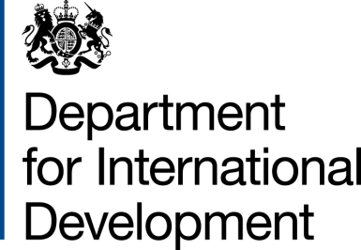 | 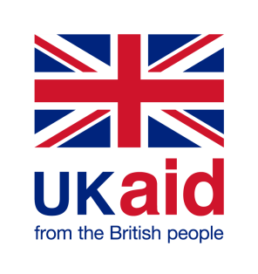

Amendment Letter

Global Health Support Programme

- I refer to the Memorandum of Understanding (MOU) for the above project signed by DFID and the Ministry of Commerce on 12 September 2012. Following recent discussions, DFID propose to change the end date to 30 September 2018.
- I therefore propose that the end date of 30 September 2017 in paragraph 2 of the original MOU be deleted and replaced by 30 September 2018.
- This letter of amendment will place on record our common understanding of the above change and will come into operation on the date you sign your confirmation below. This note will be known as Amendment No. 1 2017.
- Please sign both copies of this letter; return one to me and retain the other for your own records.

